- Sample Requirements: size, polished, known density and chemical composition necessary for calculating penetration depth, etc. The sample should have the analyzed face as parallel as possible to the opposite face.

- Loading the Sample
  - Place a small piece of double-stick tape in the center of the zero-background silicon wafer and stick sample on tape so that sample is flat
  - Mount sample holder inside the system (magnetic)

- Prefix Modules
  - Incident beam: parallel beam mirror
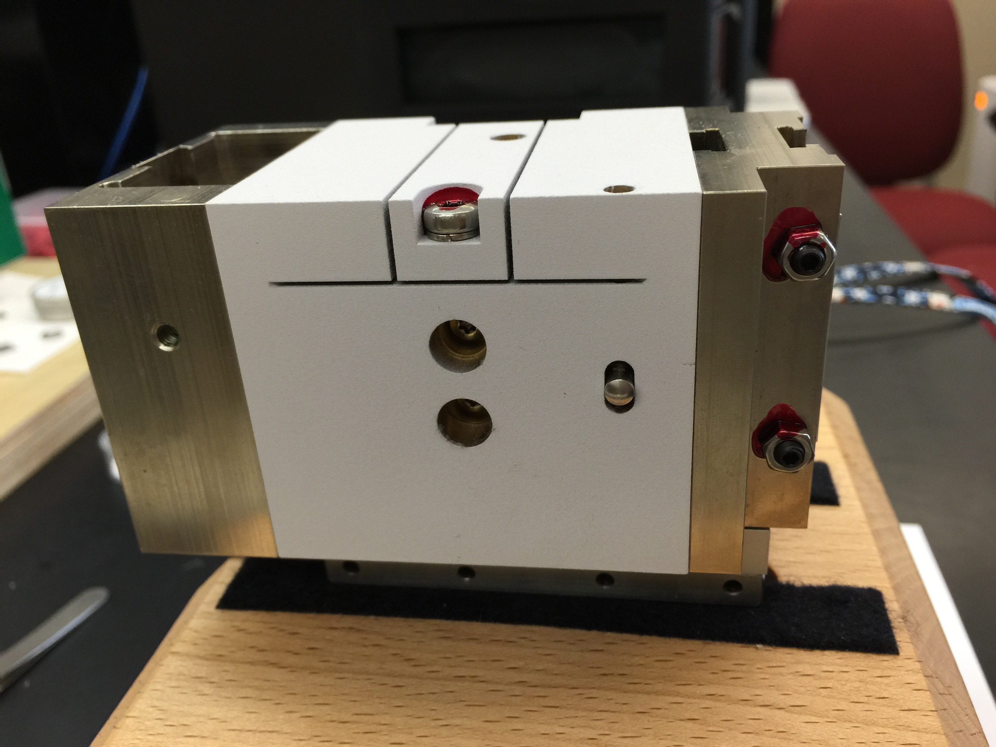
  - Diffracted beam: 0.27 parallel plate collimator (PPC).
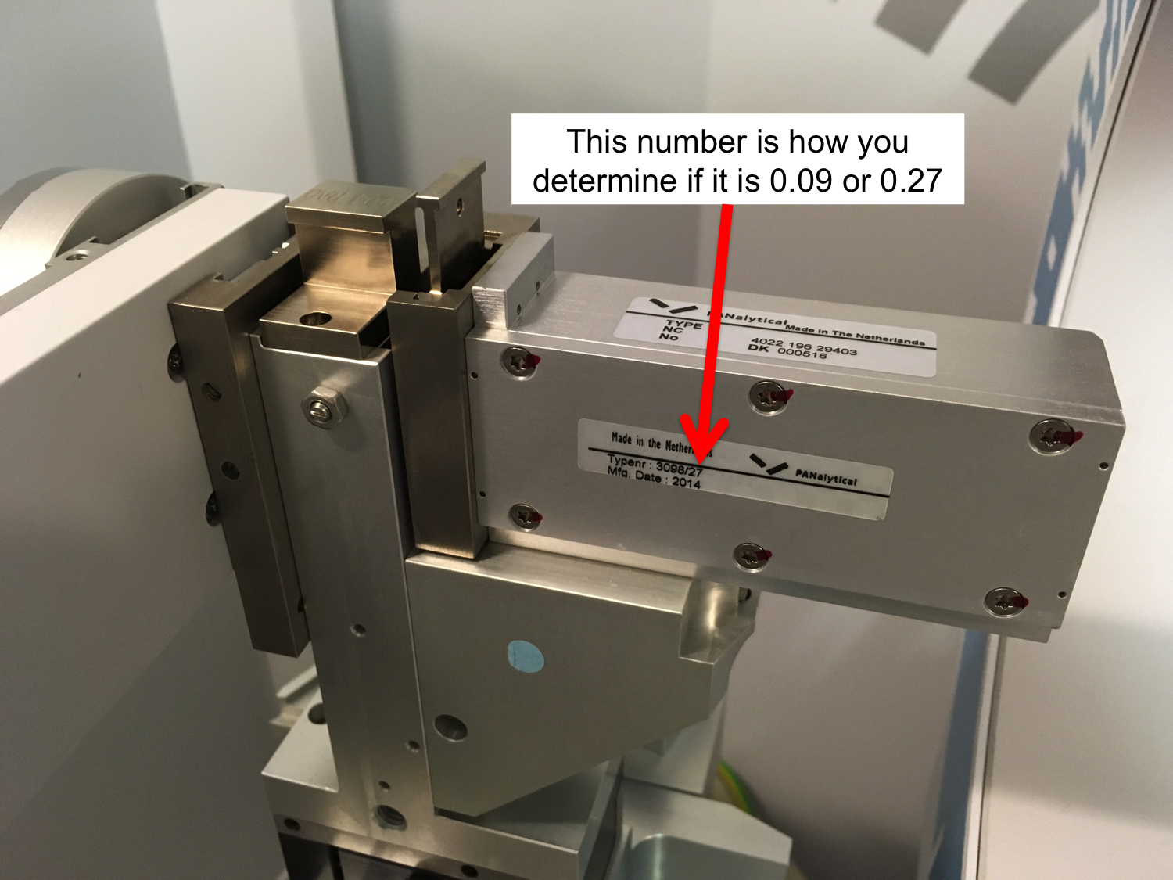

- System setup.
  - Open “Data Collector” (desktop icon) on the X’Pert³ PC. Login with your username and password.
  - Instrument Connect. Choose “Factory Configuration” and “Diffracted beam path1”
  - Say “OK” to warnings that popup.

  - User Settings Fine Calibration Offsets Clear All Offsets

  - User Settings Sample Offsets Clear All Offsets

  - Under Factory Configuration Window, go to Instrument Settings tab and double click “2Theta”
    - Under “X-ray” tab, enter Tension = 45 kV and Current = 40 mA, then click “Apply”
    - Under “Position” tab in popup window, enter “0” for everything and then click “Apply”
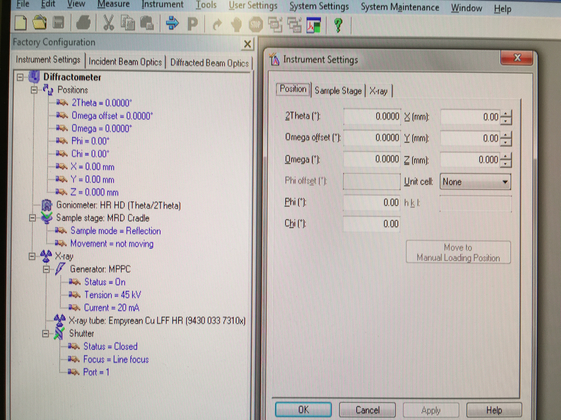

- Align sample in X and Y – for small samples only
  - Attach the alignment gauge as shown below, taking care not to hit your sample as you attach it. If you have put the gauge on correctly, you should have to turn the screw to tighten it quite a few times. If it is not on correctly, the screw will get stuck almost immediately.
  - On the computer, change X and Y as necessary to get your sample aligned with the small piece sticking out of the gauge as shown below. Alignment may be easier if you change Z so that the small piece is closer to your sample, taking care not to move it so far that it impacts your sample and affects the surface. My recommendation is to not increase Z by more than 3 mm at a time.
  - Once your sample is aligned, set Z back to 0 and then remove the position gauge.
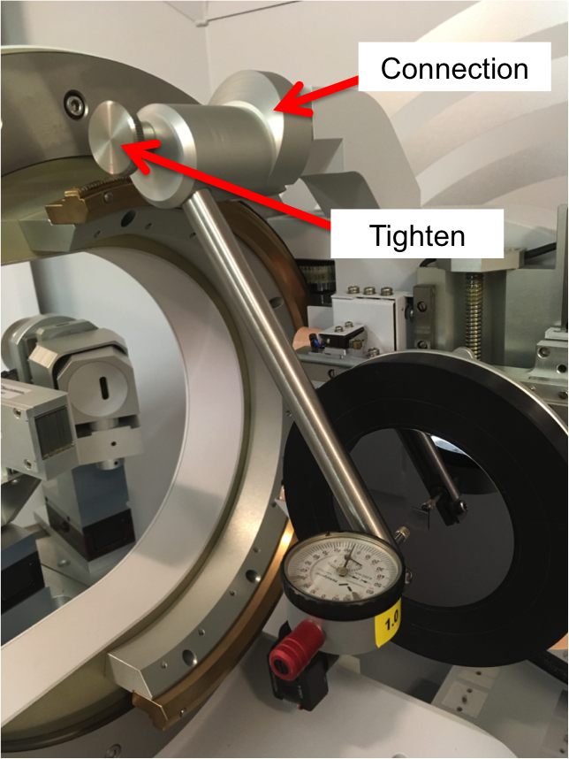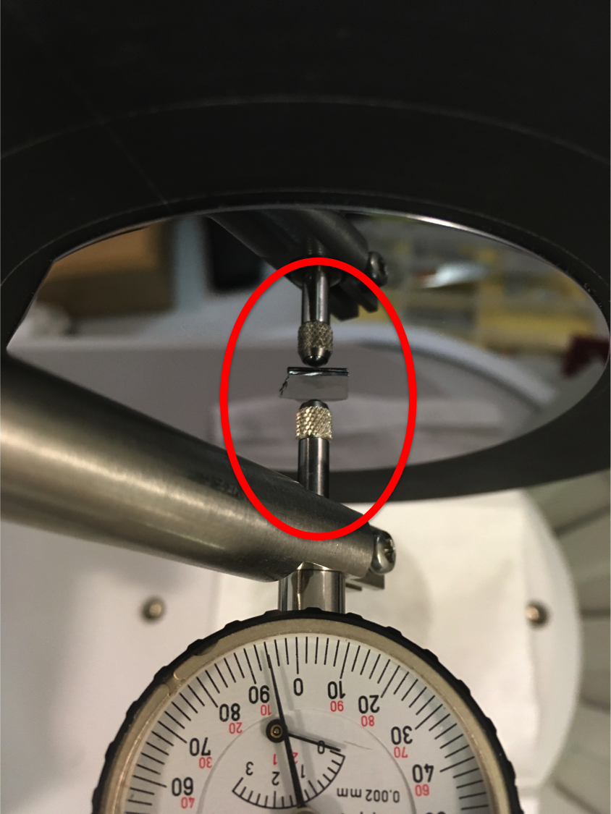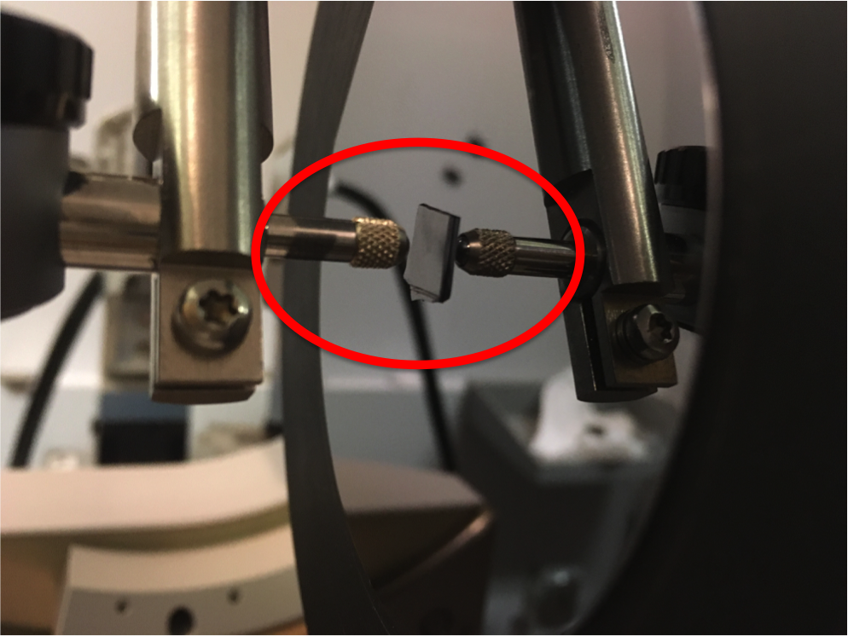
Overview Alignment – top view Alignment – side view

- Incident Beam Optics
  - Insert small 0.04 rad Soller slits – push all the way down
  - Insert 1/32nd divergence slit – push down slowly until it clicks (take care not to push too far). The smooth side should face to the left
  - Choose a mask to match the width of the sample. Refer to 0.04 rad Soller Slit, standard column in table “Beam Masks and Irradiated Width for Parallel Beam X-ray Mirrors” on page 5 – push all the way down, then pull up until it clicks

- Diffracted Beam Optics
  - Insert receiving slit that matches your PPC # - push all the way down, and then pull up a very small amount until it clicks. It only fits in the slot one way, so you can’t put it in the wrong way
  - Insert large 0.04 rad Soller slits – push all the way down
  - Make sure automatic attenuator is present

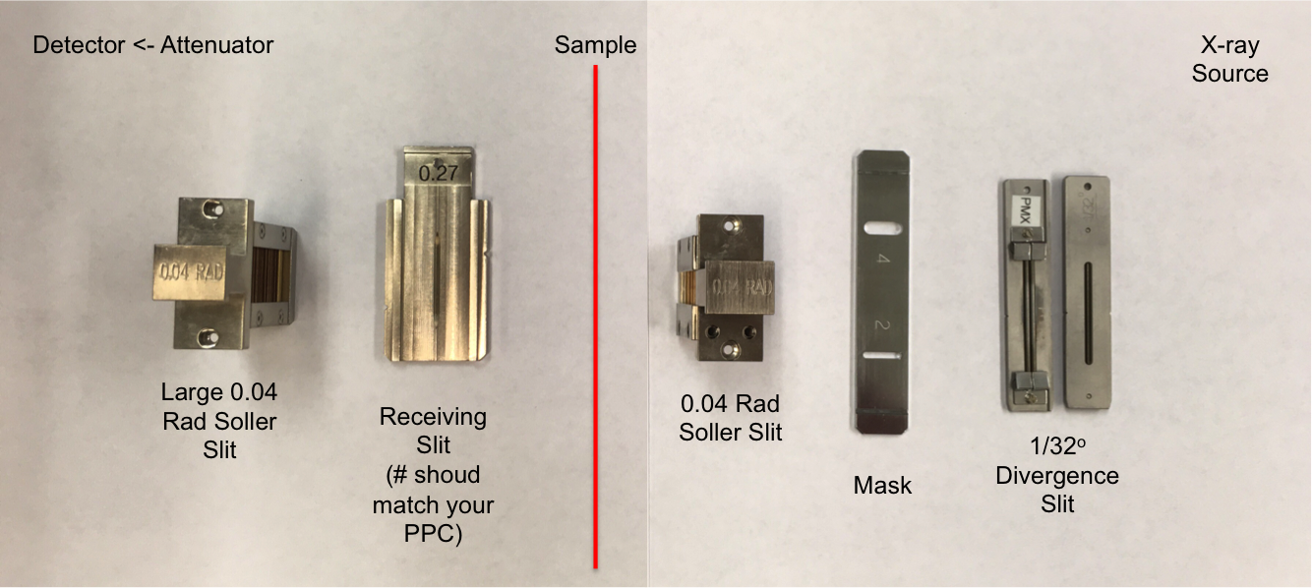

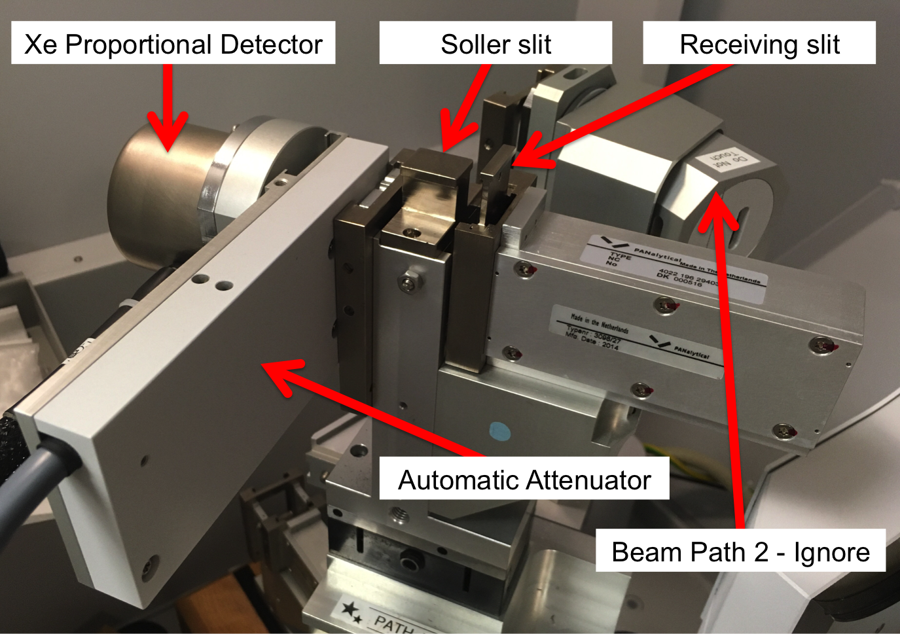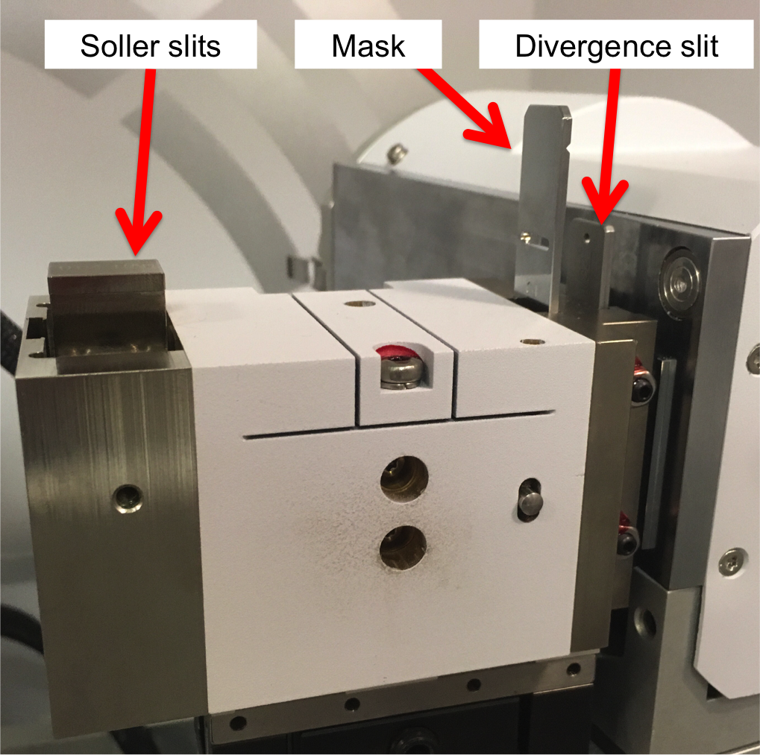

- Using too large of a mask will cause background from the sample holder and possibly cause the X-rays to fall off of your sample at small angles

- Entering the Alignment Instrument Configuration into Computer
  - Under Factory Configuration Window, go to Incident Beam Optics tab and double click “Radius”
  - Go through each tab and use drop-down menus to change optics in the computer to match the optics you placed in the system.
    - PreFIX module = “Mirror Cu W/Si (parabolic MRD)”
    - Divergence slit = fixed slit 1/32º
    - Anti-scatter slit = none
    - Mask = “Fixed mask # mm”. Make sure # matches whatever mask you inserted
    - Soller slit = “Soller slits 0.04 rad”
    - Filter = none
    - Beam attenuator = none
    - Monochromator = none
    - Mirror = “Inc. Beam Cu W/Si (parabolic MRD)” (can’t be changed if you chose the correct PreFIX module in (i) above)
    - Click “OK.” There will be a warning messaging if you changed anything. This just reminds you to make sure the optics in the computer match the optics in the diffractometer. Click “OK.”
  - Under Factory Configuration Window, go to Diffracted Beam Optics tab. Diffracted Beam Path 1 should be activated (yellow light bulb). If it is not, right click on light bulb and click “Activate.”
    - PreFIX module = “Parallel plate collimator 0.27º”
    - Anti-scatter slit = none
    - Receiving slit = “Parallel plate collimator slit”
    - Filter = none
    - Mask = none
    - Beam attenuator = Prog. Attenuator Ni 0.125 mm *****Incredibly important
      - Usage = “Do not switch” that you do this
      - Check the Activated box correctly!*****
    - Detector = “Proportional detector Xe[2]”
    - Collimator = “Parallel plate collimator 0.27º”
    - Monochromator = none
    - Soller Slit = “Large Soller slits 0.04 rad”
    - Click “OK.” There will be a warning messaging. This just reminds you to make sure the optics in the computer match the optics in the XRD. Click “OK.”
- Zero-Beam (2θ) Alignment Procedure
  - Measure Manual Scan
    - Scan Axis: 2Theta
    - Range: 0.25
    - Step size: 0.0025 (always use 1/100th of the Range for Alignment)
    - Time per step: 0.2
  - Click Start

  - After scan, right click on scan window and select “Peak Mode.” Next, click “Move To” to make the program move to the center of the peak. This will move 2Theta to this position. Click “Close”
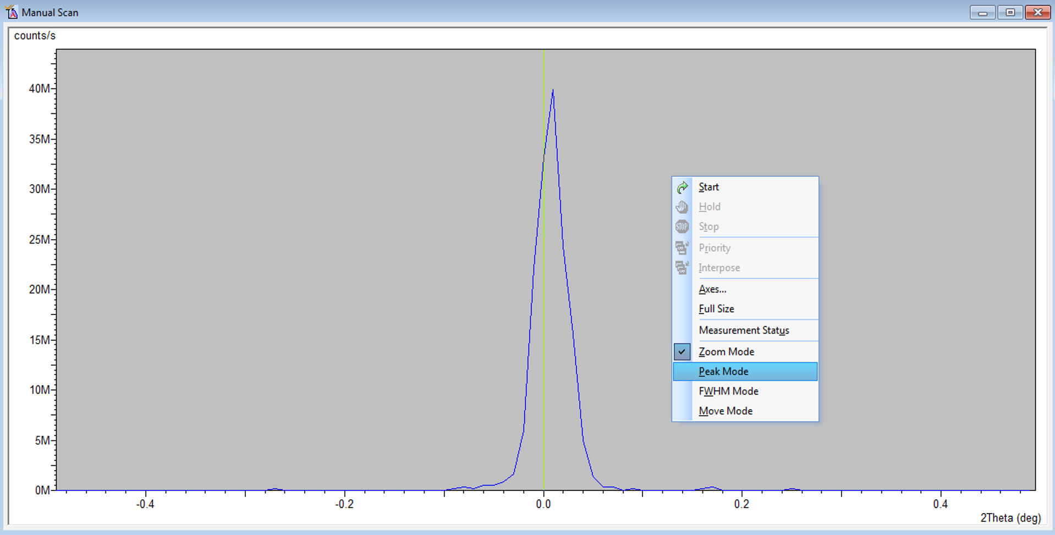
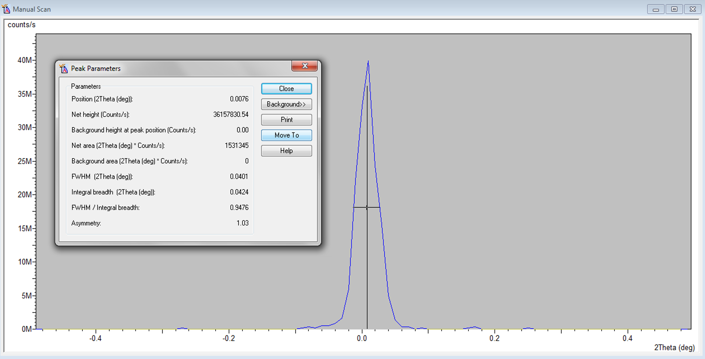
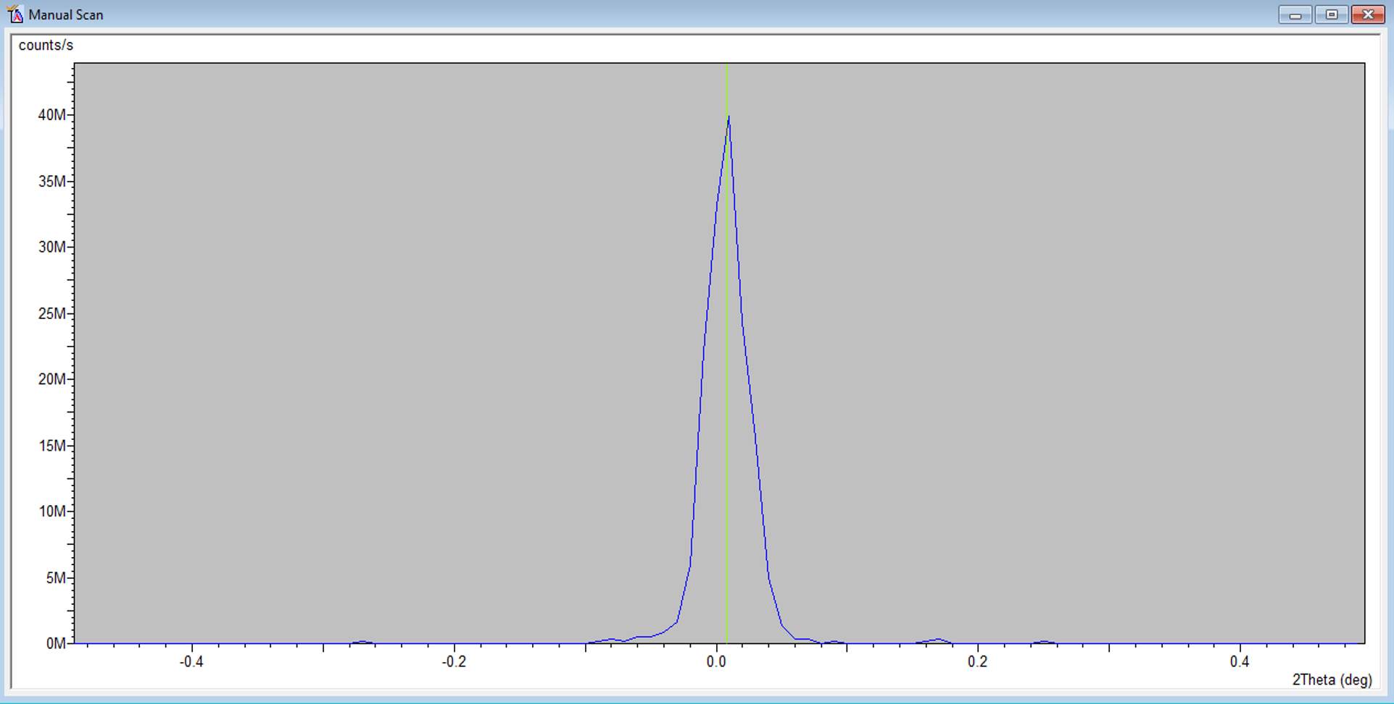

- User Settings Fine Calibration Offsets
  - Click “Set New = 0”
  - Click OK

- Z Alignment Procedure - Rough
  - Under Factory Configuration Window, go to Instrument Settings Window and double click on “Z=0.000 mm”
  - Change Z to 5.5 mm and click “OK”
  - Measure Manual Scan (unless Prepare Manual Scan window is already open)
    - Scan Axis: Z
    - Range: 10
    - Step size: 0.1 (always use 1/100th of the Range for Alignment)
    - Time per step: 0.2
  - After scan, right click on scan window and select “Move Mode.” Move the line to half the maximum intensity (see below). This will move Z to this position.

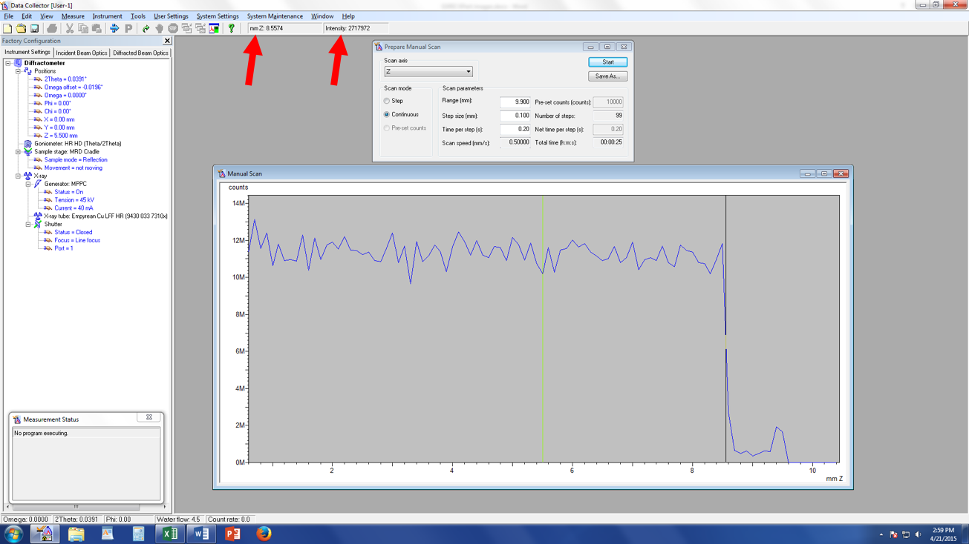

- Z Alignment Procedure - Fine
  - Measure Manual Scan (unless Prepare Manual Scan window is already open)
    - Scan Axis: Z
    - Range: 1 We are scanning over a smaller range to refine the Z position
    - Step size: 0.01 (always use 1/100th of the Range for Alignment)
    - Time per step: 0.2
  - After the scan, zoom in on the approximately correct position. Place your cursor on the blue line so that it is at half of the maximum intensity (in the above example, the cursor should be a little below 6M counts). Instead of just estimating the half-intensity position, use the intensity readout found below “Help” at the top of the screen (see figure above)
  - Note the corresponding Z position (see figure above)
  - In “Instrument Settings,” change the Z position to the value from step c

- ω Alignment Procedure
  - Measure Manual Scan (unless Prepare Manual Scan window is already open)
    - Scan Axis: Omega
    - Range: 1
    - Step size: 0.01 (always use 1/100th of the Range for Alignment)
    - Time per step: 0.2
  - After scan, right click on scan window and select “Move Mode.” Move the cursor to the center of the peak and release. This will move omega to this position.
  - If the Range of 1 is too small and you don’t see a peak, change Range to 3 and Step Size to 0.03.
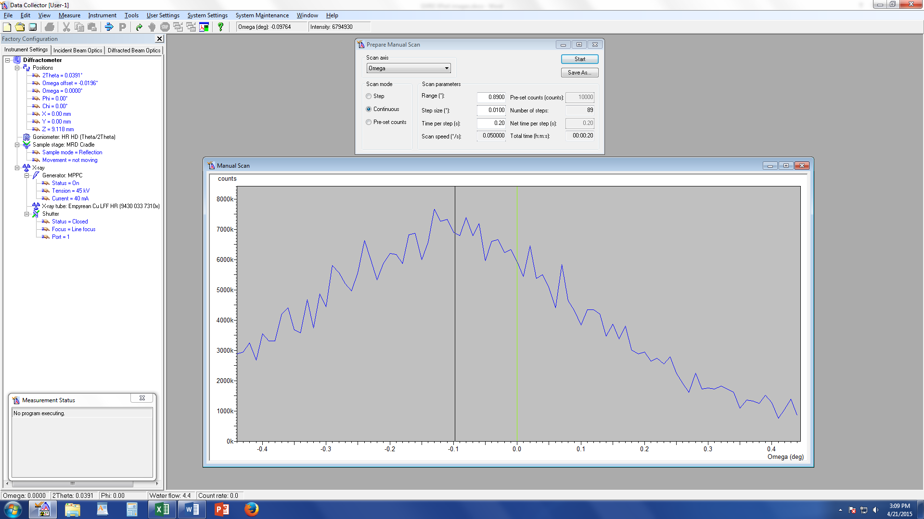

- Repeat Steps 16 & 17 until Z and ω reach their equilibrium values and no longer change. This means the sample is aligned flat with respect to the beam.

- User Settings Sample Offsets
  - ω should be the only angle that has a non-zero current position (a)
  - Put “0” for ω (b), then hit “tab” button on keyboard (c)
  - Click OK

(a) (b) (c)

- Under Factory Configuration Window, go to Instrument Settings Window and double click on anything to open window. Set 2θ to 1.2 and ω-offset to 0

- Rough ω Alignment Procedure
  - Measure Manual Scan (unless Prepare Manual Scan window is already open)
    - Scan Axis: Omega/2theta
    - Range: 1
    - Step size: 0.005
    - Time per step: 0.2
  - Press Start

- Change the y-axis to logarithmic scale
  - Right-click in the Manual Scan window,
  - Select Axes
  - In the resulting window, select logarithmic for the intensity axes.

- If fringes are visible, right click and choose “Move Mode,” then move the green line to the top of the first fringe (see below). If no fringes are visible, just leave the green line where it is.
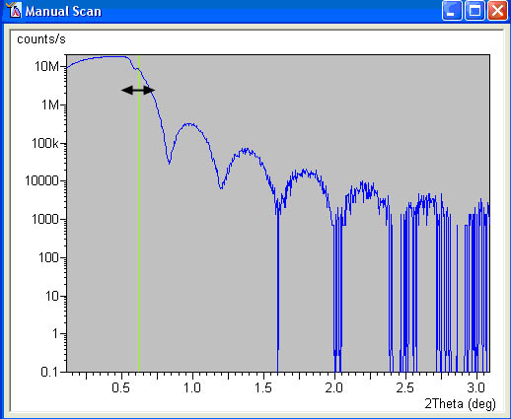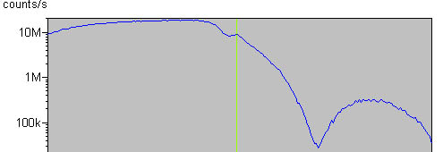

- Change the y-axis to linear scale
  - Right-click in the Manual Scan window,
  - Select Axes
  - In the resulting window, select linear for the intensity axes.

- Optimize ω with a manual scan
  - Measure Manual Scan (unless Prepare Manual Scan window is already open)
    - Scan Axis: Omega
    - Range: 0.5
    - Step size: 0.005
    - Time per step: 0.2
  - Press Start
  - After scan, right click on scan window and select “Peak Mode,” then “Move to,” and close.
    - If the omega scan has only two broad low intensity peaks (called Yoneda wings), then reflectivity on this sample will not be possible due to high interface roughness.
    - If the omega scan has a single sharp peak or a sharp peak (the specular peak) in the middle of two broad peaks, then select the position of the sharp peak in the middle using Peak Mode.
  - This will move the goniometer to the correct position.
  - Do not close the Manual Scan window

- Fine Optimization of Omega using a Manual Scan
  - Scan Axis: Omega
  - Range: 0.1
  - Step size: 0.001
  - Time per step: 0.3
  - Press Start
  - After scan, right click on scan window and select “Peak Mode,” then “Move to,” and close

- Optimize Chi tilt using a Manual Scan
  - Scan Axis: Chi
  - Range: 5
  - Step size: 0.05
  - Time per step: 0.2
  - Press Start
  - After scan, right click on scan window and select “Peak Mode,” then “Move to,” and “Close”

- Optimize Omega using a Manual Scan
  - Scan Axis: Omega
  - Range: 0.3
  - Step size: 0.002
  - Time per step: 0.2
  - Press Start
  - After scan, right click on scan window and select “Peak Mode,” then “Move to,” and “Close”

- Set Sample Offsets
  - Select User Settings Sample Offsets from the main menu
    - Set “Omega” to half the value of the actual 2θ position
    - You may also set “Chi” to 0
    - Press OK. This will apply a sample specific offset for the omega axis

- Attenuation of the beam
  - Select the Diffracted beam optics tab.
  - Double-click on the Beam Attenuator field
  - In the Incident Beam Optics window, set the Beam Attenuator
    - Usage= ‘At preset intensity’.
    - Activate at level = 900,000
    - De-activate at level = 600,000
    - Press the OK button

- Create an Absolute Scan Program
  - If you already have a measurement program, you can skip this step.
  - Select File> New Program
  - Choose “Absolute Scan” from the ‘List programs of type:’ drop-down menu
  - In the Prepare Absolute Scan window, specify the values
    - Scan Axis = Omega/2theta
    - Other gonio angle = Offset = 0
    - Scan Mode = Continuous
    - Start Angle = 0.100
    - End Angle = 4.00
      - 5° is the practical upper limit
    - Step Size= 0.005
      - Step size should be optimized according to the features to be observed
    - Time per step = 1.00
      - The time per step may need to be longer
      - Typical values are between 1 to 5 sec
    - You could improve the high angle signal by using Pre-Set Counts instead of Continuous mode.
      - This would be appropriate for an overnight scan.
      - Typical values for Pre-set counts would be from 10000 to 100000
  - Select File Save As and enter a file name for this scan program
  - Click OK
  - Close the Prepare Absolute Scan window.

- Run Program
  - Measure Program
  - Click “Browse” and open your folder, then your program.
  - Click the Folder icon and change the location where you want to save the file and the filename. All data should be saved on the C drive in the XRD Data Users folder.
  - Press “Ok” and the program will begin to run.

- Running another sample
  - Reset the Sample Offsets
    - Select User Settings >Sample Offsets from the main menu
      - Press the “Clear all offset” button
    - Click OK
    - Do not clear the Fine Calibration offsets!
  - Drive the goniometer to start position
    - In the Instrument Settings tab, double-click on any the items related to Positions
    - Set positions
      - 2Theta = 0°
      - Omega Offset = 0°
      - Omega = 0°
      - Phi = 0°
      - Chi = 0°
    - Press OK
  - Reset the attenuator!!!!
    - Set usage to “Do not Switch” and check the “Activated” box
    - Make sure the attenuation factor is correct (171.2).
  - Go to Step #15 above and repeat with the new sample

- When finished with measurements
  - Return the system to idle state (45 kV and 20 mA) in the “X-ray” tab
  - Click Instrument Disconnect
  - Click OK in the next dialogue box
  - Wait 5 or 10 seconds after disconnecting, and then close the Data Collector

