Sample Requirements: The XYZ stage is typically used with solid samples (pressed pellets or solid chunks of material) that will not fit in our conventional sample holder (over ** mm tall or ** cm in diameter). The use of this stage also requires a special system configuration, so the lab manager will need to set it up for you. Contact Michael Koehler (mrkoehler@gmail.com) when scheduling an experiment so he knows to prepare the system.

- Increasing Voltage and Current:
  - To increase the voltage and current, go to the Instrument Settings tab and double click on any of the blue text
  - Click on “X-ray” tab. The idle state is 45 kV and 20 mA, while the measurement state is 45 kV and 40 mA. If the voltage is not 45 kV, change it to 45 kV and click “Apply.” If the current is already 40 mA, you do not need to do anything.
- Set positions to zero
  - In the same window as step 2, go to the Positions tab and set everything to zero
  - Click OK
- NOTE: After placing your sample in the Empyrean, check to see if the sample is centered using the alignment camera. Tools (Menu) → Alignment Camera and click “Start.” If the crosshairs are not in the center of your sample, right click the center of your sample and choose “Move stage to this position.” Make sure to “Stop” the camera before beginning your measurement.

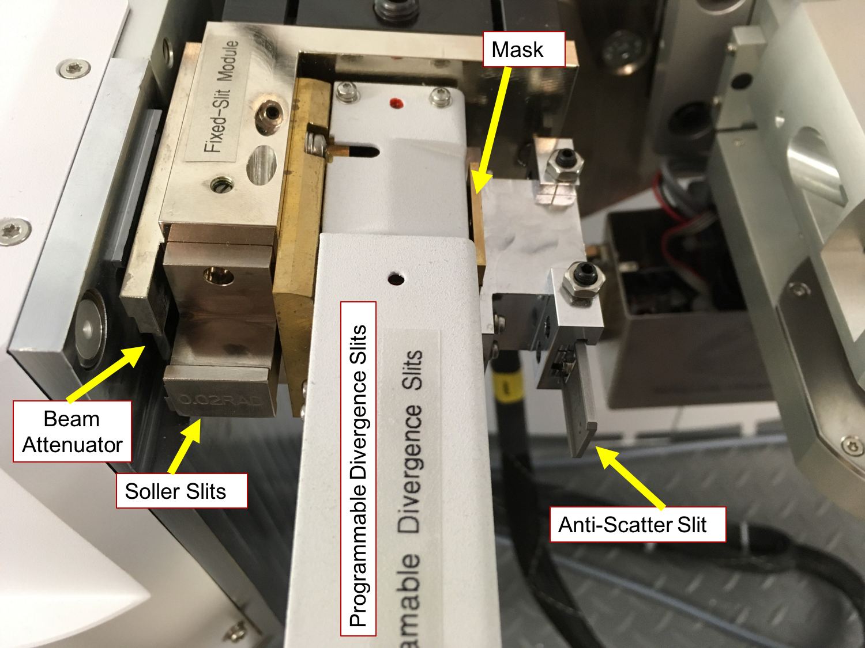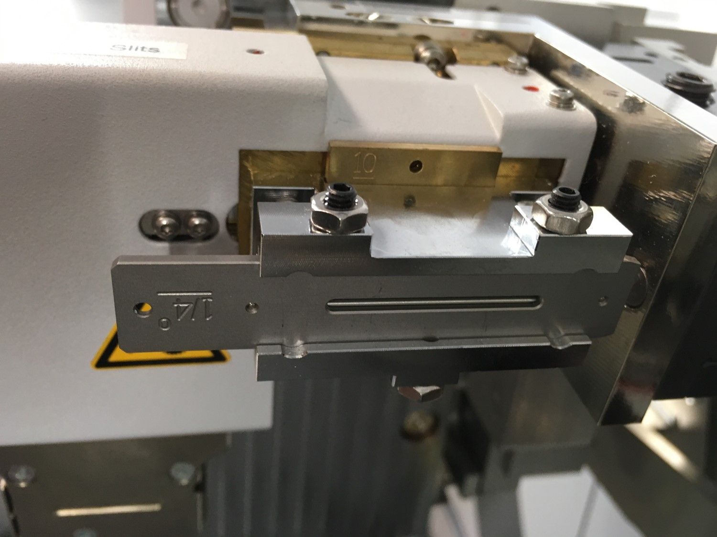
Overview of the incident side Anti-scatter slit orientation

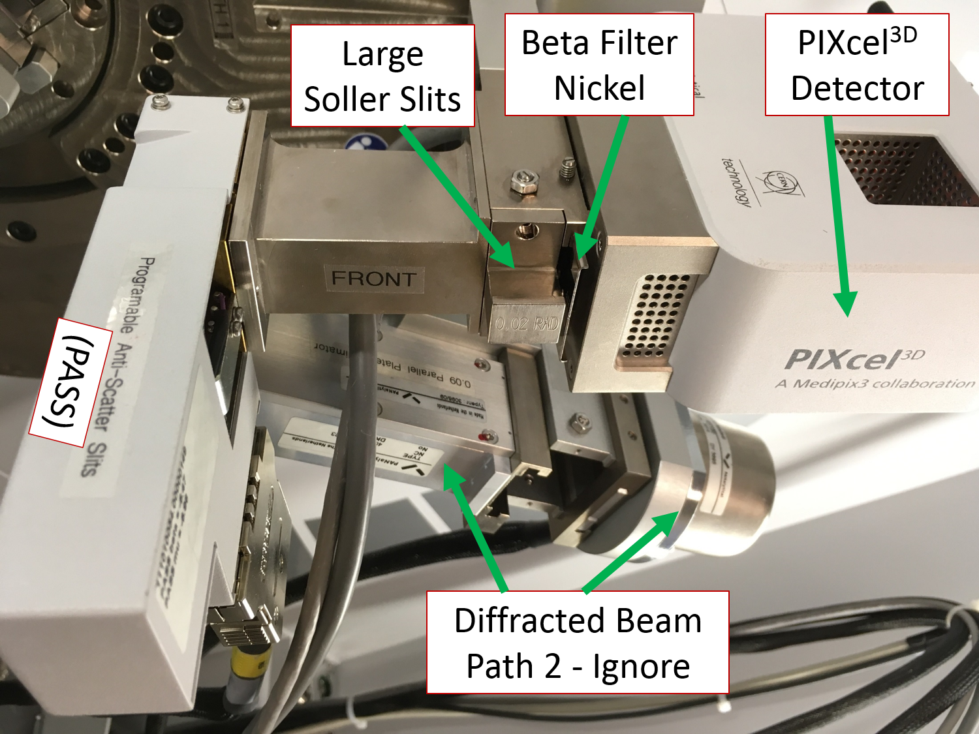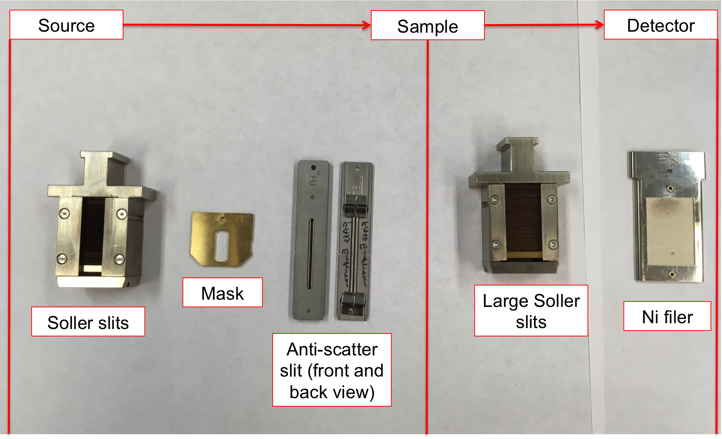
Overview of the diffracted side Overview of measurement optics

- Alignment Optics (see Appendix 1 for effects of different optics):
  - Insert an attenuator (Cu 0.1) to the left of the Soller slits in the PDS module (incident side).
  - Insert the 1/16º antiscatter slit and whichever Soller slits and mask you want to use for your experiment. For the antiscatter slit, push all the way in and then pull back a little until it clicks. For the mask, use the small tool to remove it.
  - Under Incident Beam Optics
    - Under the “Incident Beam Optics” tab, double click on “Radius”
    - Go through each of the tabs in the pop-up window and enter the optics you placed in the system.
      - PreFIX module = “Progr. Divergence slit with anti-scatter slit.” Don’t change the offsets
      - Divergence slit = fixed slit 1/32º
      - Anti-scatter slit = fixed slit 1/16º
      - Mask = “Fixed incident beam mask # mm,” # = whichever mask you have installed
      - Mirror = none
      - Beam knife = none
      - Soller slit = “Soller slits 0.0# rad,” # = whichever Soller slit you have installed
      - Filter = none
      - Beam attenuator = “Beam attenuator mirror Cu 0.1 mm”
        - Attenuation Factor Click “Select”
        - Choose the second line, the one with the factor of 110
        - Click OK
        - Usage = “Do not switch”
        - Make sure the Activated box is checked
      - Monochromator = none
      - Click “OK.” There may be a warning message. This just reminds you to make sure the optics in the computer match the optics in the XRD. Click “OK.” Another message will likely appear, this one reminding you to insert the attenuator. Click OK”
    - Under the “Diffracted Beam Optics” tab, double click on “Radius”
    - Go through each of the tabs in the pop-up window and enter the optics you placed in the system.
      - PreFIX Module = “PIXcel3D-Medipix3 1x1 with PASS,” (do not change offsets)
      - Anti-scatter Slit = “Programmable anti-scatter slit,” fixed, and 1/32º
      - Receiving slit = “none”
      - Filter = “Beta-filter Nickel” (grammatical note, nickel should not be capitalized)
      - Beam Attenuator = “none”
      - Detector =
        - Type = “PIXcel3D-Medpix3 1x1 detector[1]”
        - Usage = “Receiving slit (0D)”
        - Active length = “0.165”
        - Active channels = “3”
        - Used wavelength = K-Alpha1
      - Collimator = “None”
      - Soller slit = “Large Soller slits 0.0# rad,” # = whichever Soller slit you have installed
      - Mask = “none”
      - Click “OK.” There may be a warning message. This just reminds you to make sure the optics in the computer match the optics in the XRD. Click “OK”

- Zero-Beam (2θ) Alignment Procedure
  - Measure Manual Scan
    - Scan Axis: 2Theta
    - Range: 0.25
    - Step size: 0.0025 (always use 1/100th of the Range for Alignment)
    - Time per step: 0.2
  - Click Start
  - After scan, right click on scan window and select “Peak Mode.” Next, click “Move To” to make the program move to the center of the peak. This will move 2Theta to this position. Click “Close”
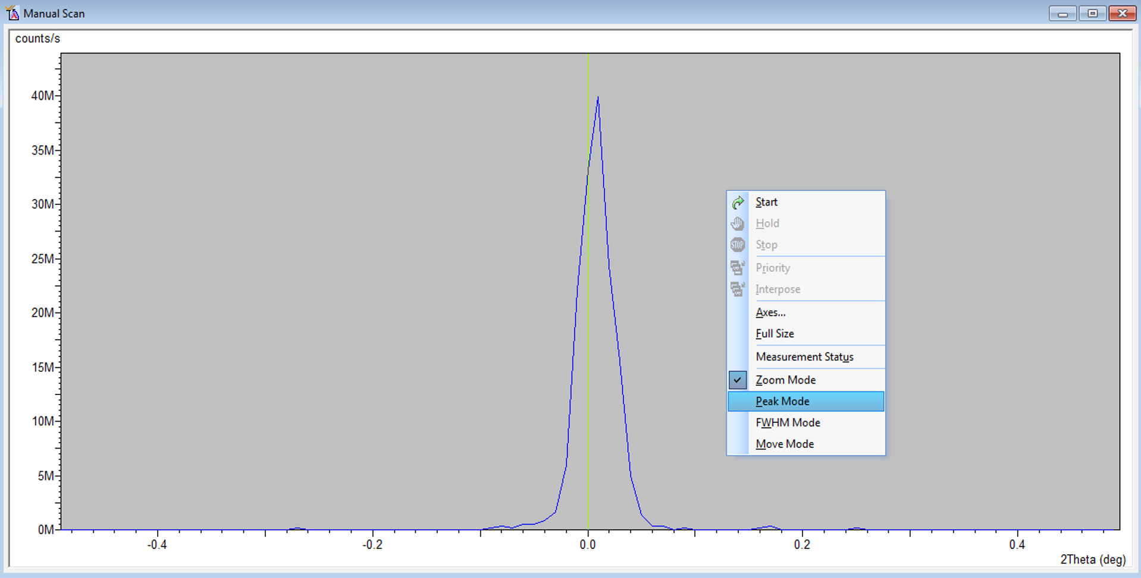
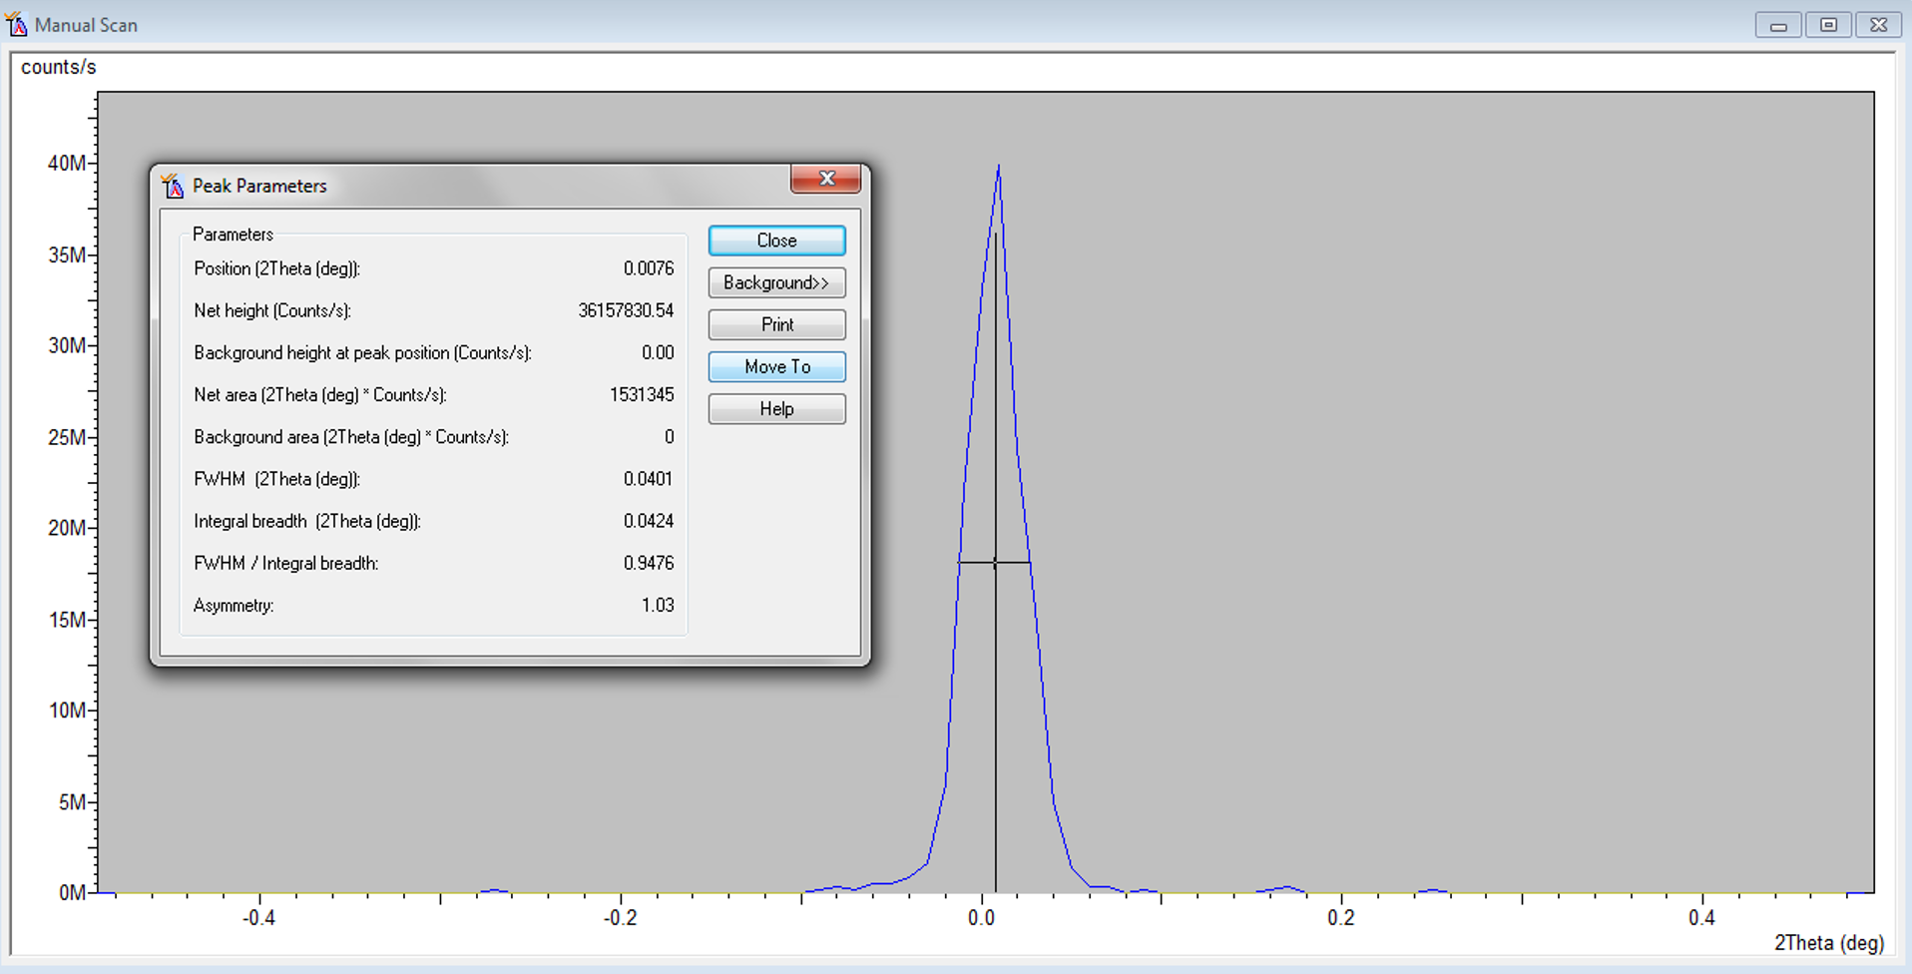
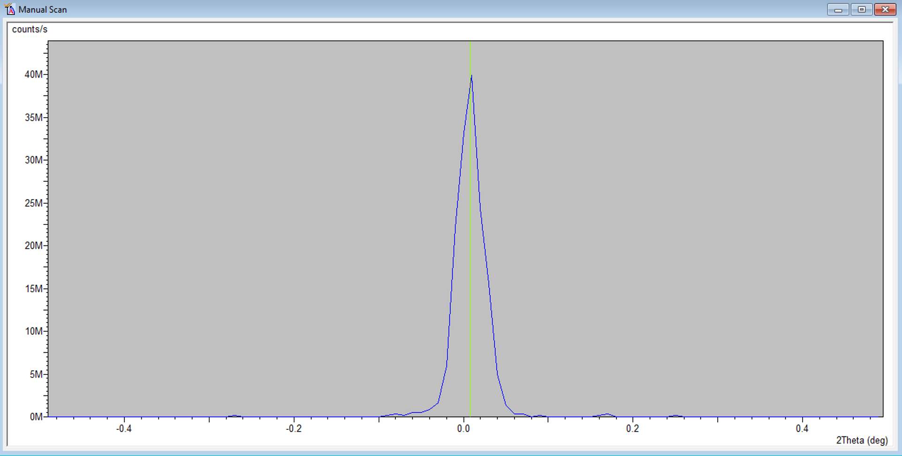
- User Settings Fine Calibration Offsets
  - Click “Set New = 0”
  - Click OK
- Rough Z Alignment (if you already know the approximate Z location, go to Instrument Settings, enter that value, and skip to step 8)
  - Under Factory Configuration Window, go to Instrument Settings Window and double click on “Z=0.000 mm”
  - Change Z to 5.5 mm and click “OK”
  - Measure Manual Scan (unless Prepare Manual Scan window is already open)
    - Scan Axis: Z
    - Range: 10
    - Step size: 0.1 (always use 1/100th of the Range for Alignment)
    - Time per step: 0.2
    - Click Start
  - After scan, right click on scan window and select “Move Mode.” Move the line to half the maximum intensity (see below). This will move Z to this position.
  - If you do not see a drop to zero, go back to the Factory Configuration Window, change Z to 15.5 mm, and run the manual Z scan again

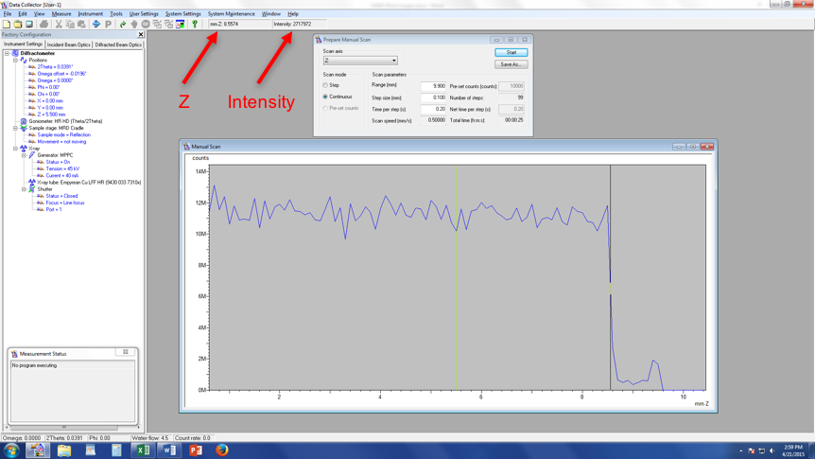

- Fine Z Alignment
    - Scan Axis: Z
    - Range: 1 We are scanning over a smaller range to refine the Z position
    - Step size: 0.01 (always use 1/100th of the Range for Alignment)
    - Time per step: 0.2
    - Click Start
  - After the scan, zoom in on the approximately correct position. Place your cursor on the blue line so that it is at half of the maximum intensity (in the above example, the cursor should be a little below 6M counts). Instead of just estimating the half-intensity position, use the intensity readout found below “Help” at the top of the screen (see figure above)
  - Note the corresponding Z position (see figure above)
  - In “Instrument Settings,” change the Z position to the value from step c
- ω Alignment Procedure
  - Measure Manual Scan (unless Prepare Manual Scan window is already open)
    - Scan Axis: Omega
    - Range: 3
    - Step size: 0.03 (always use 1/100th of the Range for Alignment)
    - Time per step: 0.2
    - Click Start
  - After scan, right click on scan window and select “Peak Mode.” Next, click “Move To” to make the program move to the center of the peak. This will move Omega to this position. Click “Close”
- Repeat Steps 8 & 9 until Z and ω reach their equilibrium values and no longer change. This means the sample is aligned flat with respect to the beam.
- User Settings Sample Offsets
  - Put “0” for ω (b), then hit “tab” button on keyboard (c)
  - Click OK

(a) (b) (c)

- Change Hardware to Measurement Optics
  - Remove the attenuator from beside the Soller slits on the incident side
  - Change the incident anti-scatter slit to be 2x whatever you want your divergence slit to be

- Enter Measurement Optics into Computer
  - Under Incident Beam Optics tab, double click on “Radius”
    - Go through each of the tabs in the pop-up window and enter the optics you placed in the system.
      - PreFIX module = “Progr. Divergence slit with anti-scatter slit.” Don’t change the offsets
      - Divergence slit = fixed slit and whichever value you want to use
      - Anti-scatter slit = fixed slit and whichever slit you have installed
      - Mask = “Fixed incident beam mask # mm,” # = whichever mask you have installed
      - Mirror = none
      - Beam knife = none
      - Soller slit = “Soller slits 0.0# rad,” # = whichever Soller slit you have installed
      - Filter = none
      - Beam attenuator = none
      - Monochromator = none
      - Click “OK.” There may be a warning message. This just reminds you to make sure the optics in the computer match the optics in the XRD. Click “OK”
  - Under the “Diffracted Beam Optics” tab, double click on “Radius”
  - Go through each of the tabs in the pop-up window and enter the optics you placed in the system
    - PreFIX Module = “PIXcel3D-Medipix3 1x1 with PASS,” (do not change offsets)
    - Anti-scatter Slit = “Programmable anti-scatter slit,” fixed, and the value that matches the programmable divergence slit from the incident side
    - Receiving slit = “none”
    - Filter = “Beta-filter Nickel”
    - Beam Attenuator = “none”
    - Detector
      - Type = “PIXcel3D-Medpix3 1x1 detector[1]”
      - Usage = “Scanning line detector (1D)”
      - Active length = “3.3482”
      - Active channels = “255”
      - Used wavelength = K-Alpha1
    - Collimator = “None”
    - Soller slit = “Large Soller slits 0.0# rad,” # = whichever Soller slit you have installed
    - Mask = “none”
    - Click “OK.” There may be a warning message. This just reminds you to make sure the optics in the computer match the optics in the XRD. Click “OK”

- Quick Scan:
  - If you like, start with a quick scan to make sure the scan parameters are ok.
  - Click the “Open Program” icon to open the list of programs. Click “Browse” and select the PXRD program from your folder.
  - Edit scan parameters (range, step size, time per step) such that the scan time is <10 min
  - Close the window. A pop-up window will ask you if you want to save the program. Click “Yes.”
  - Measure Program. Click “Browse” and select your recently modified program from your folder.
  - Click the folder icon to choose the save location and name your data file. Save all data on the C drive in your personal folder found in XRD Data Users folder.
  - You can also enter comments, sample ID, etc. if you like (not required)
  - Click “Ok” and the scan will begin.

- Measurement Scan:
  - Click the “Open Program” icon to open the list of programs. Click “Browse” and select an existing program that used the XYZ stage.
  - Edit scan parameters required to get adequate data on your sample
  - Close the window and save the program
  - Measure Program. Click “Browse” and select your program from your folder.
  - Click the folder icon to choose the save location and name your data file. Save all data on the C drive in your personal folder found in XRD Data Users folder.
  - You can also enter comments, sample ID, etc. if you like (not required)
  - Click “Ok” and the scan will begin.
- Before you leave after finishing your experiments
  - Once all of your measurements are done, make sure to remove your sample (Instrument settings, double click any blue words, go to “Sample” tab, uncheck the box next to “Lift Up,” and click “Apply”). Also return the system to idle state (45 kV and 20 mA) in the “X-ray” tab (no need to go down in steps of 5 mA, just go straight to 20 mA).
  - Click Instrument Disconnect
  - Click OK in the next dialogue box
  - Wait 5 or 10 seconds after disconnecting, and then close the Data Collector.

Appendix 1

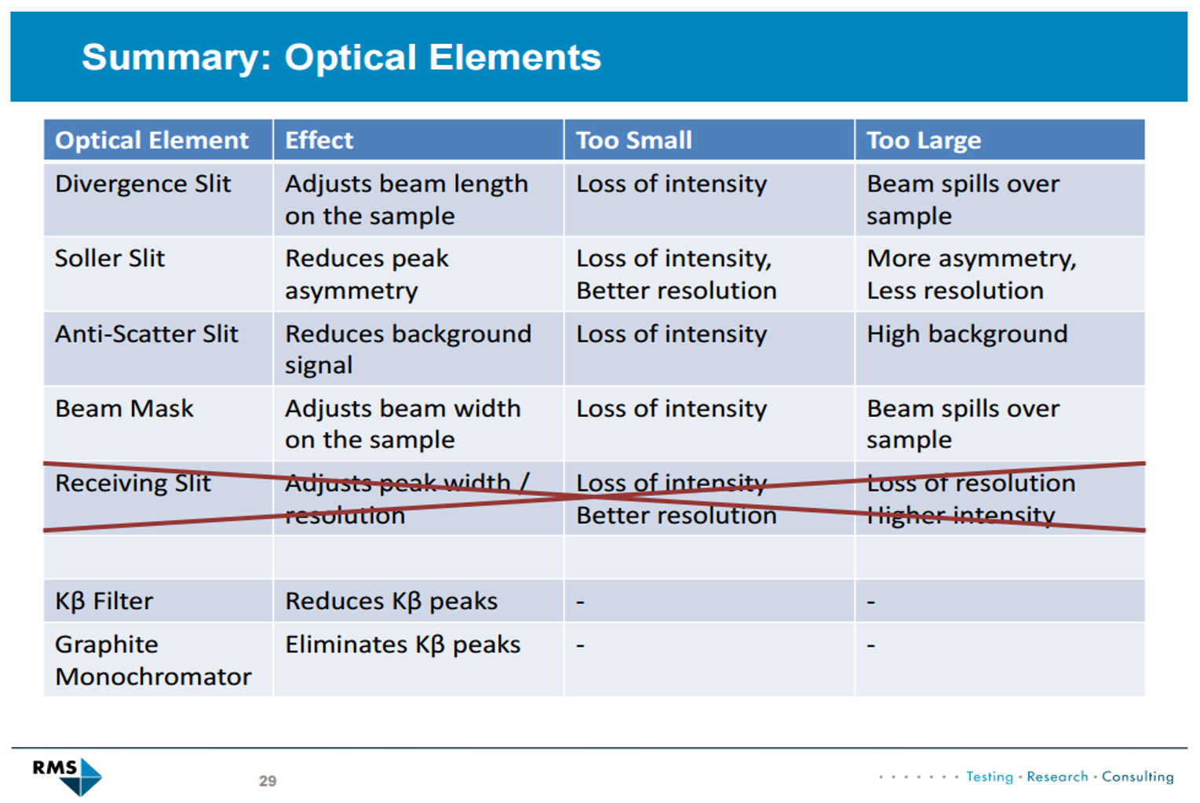

Appendix 2

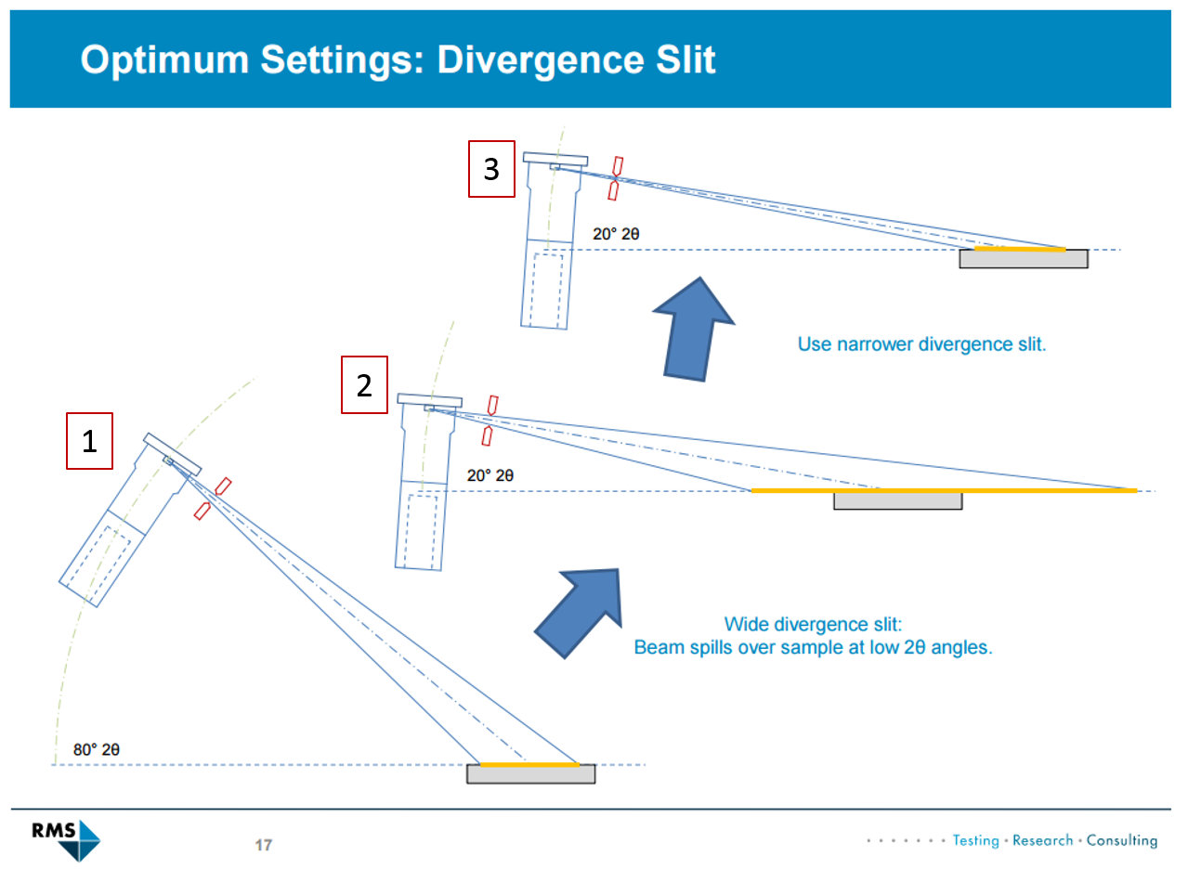

Even if the divergence slit produces a beam that remains fully on the sample at larger 2θ angles (1), the beam can spill over the sample at lower 2θ angles (2). As such, you should use the divergence slit that will be narrow enough to keep the beam on the sample at low angles (3).

Trade-off of divergence slits: Narrower slits slightly increase resolution and keep the beam from spilling off of your sample but decrease the intensity.

