Sample Requirements: Larger area samples will be better.

- The default tube setting is line mode. However, you will need point mode for your texture measurement. Please contact the lab manager (Michael Koehler, mkoehler@utk.edu) to schedule a time for this experiment so that he can prepare the system for you.
- PreFIX Modules and Optics
  - Incident side – Double cross slit collimator with a nickel foil (just drop the foil in, no need to push)
  - Set both masks (width) and divergence slits (height) to 0 mm (see photo) to start
  - Set both masks (width) to 0.1 mm and both divergence slits (height) to 0.1 mm (see photo). Each tick mark is 0.02 mm (rotating from the 0 position to the 1 position is 0.1 mm)
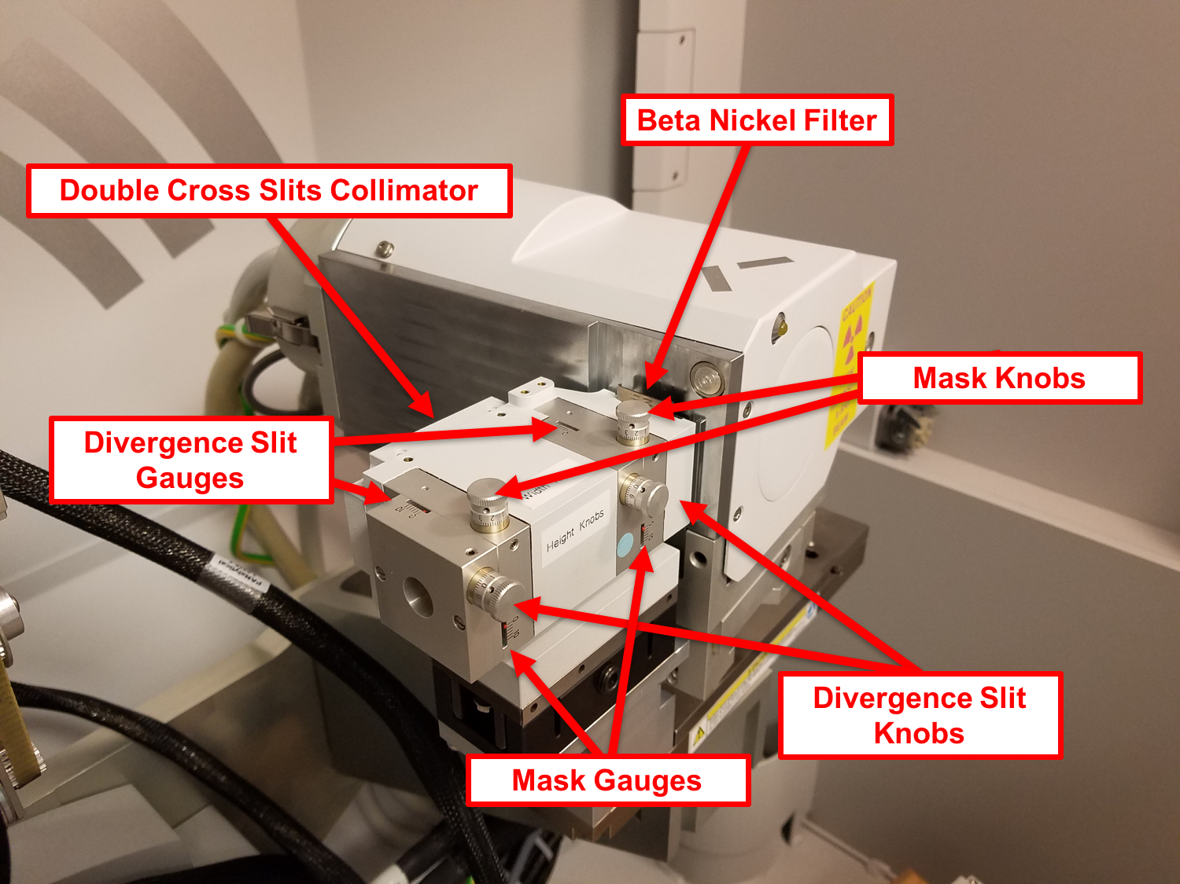

  - Diffracted side – 0.27 parallel plate collimator (PPC). Insert the 0.27º receiving/PPC slit (push all the way down, pull up a little bit until it clicks into place) and the 0.04 rad Soller slits (push slits all the way down), and make sure that the automatic attenuator is present
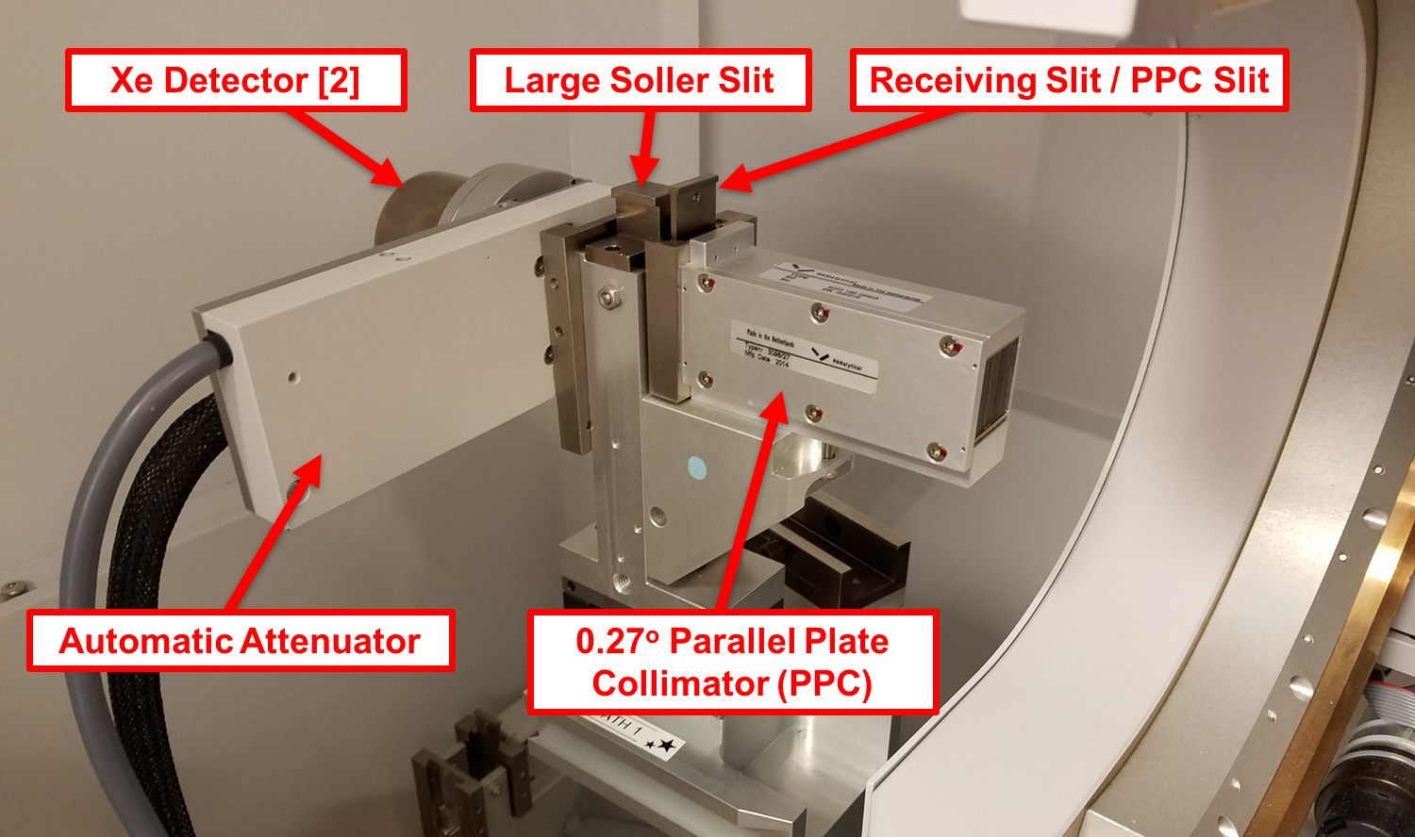

- Make sure that offsets are all cleared
  - User Settings Fine Calibration Offsets Clear All Offsets

  - User Settings Sample Offsets Clear All Offsets

- Prepare Instrument for Alignment
  - Under Factory Configuration Window, go to Instrument Settings tab and double click “2Theta”
  - Under “X-ray” tab, enter Tension = 45 kV and Current = 40 mA, then click “Apply”
  - Under “Position” tab in popup window, enter “0” for everything and then click “OK”
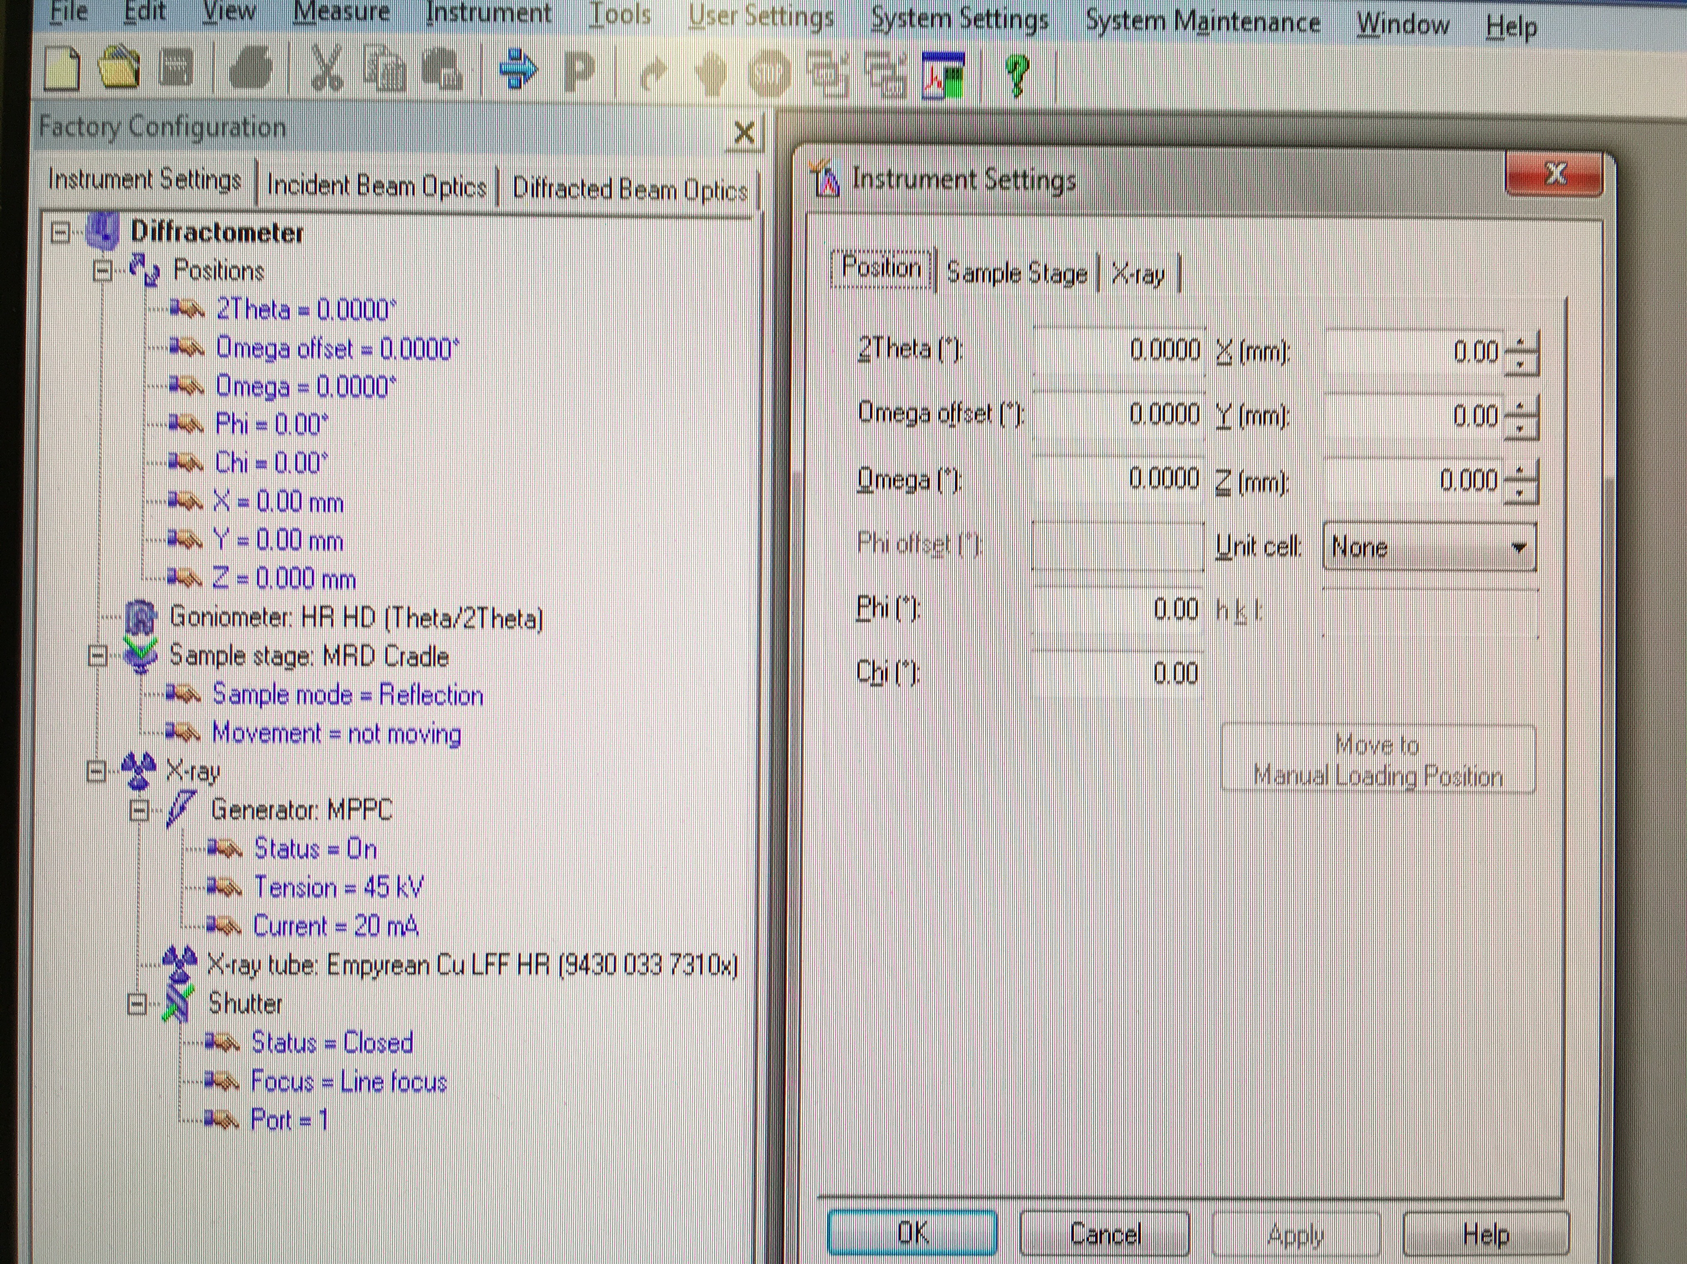

  - Under Factory Configuration Window, go to Incident Beam Optics tab and double click “Radius”
  - Go through each tab and use drop-down menus to change optics in the computer to match the optics you placed in the XRD in Step 4.
    - PreFIX module = “Double crossed slits (Knob adjustable)”
    - Divergence slit = “Double crossed slits (Knob adjustable)”
      - Do not change the distance to sample
      - Set height to 0.1 mm (this is the alignment setting)
    - Anti-scatter slit = none
    - Mask = Set width to 0.1 mm (this is the alignment setting)
    - Soller slits = none
    - Filter = Beta-filter nickel
    - Beam attenuator = none
    - Monochromator = none
    - Mirror = none
    - Click “OK.” There will be a warning messaging if you changed anything. This just reminds you to make sure the optics in the computer match the optics in the diffractometer. Click “OK.”
  - Under Factory Configuration Window, go to Diffracted Beam Optics tab. Make sure the correct beam path is activated (indicated by a yellow light bulb). You will likely want beam path 1. If the correct beam path is not activated, right click on the light bulb and click “Activate.”
    - PreFIX module = Parallel plate collimator 0.27º
    - Anti-scatter slit = none
    - Receiving slit = PPC slit
    - Filter = none
    - Mask = none
    - Beam attenuator = Prog. Attenuator Ni 0.125 mm *****Incredibly important
      - Usage = “Do not switch” that you do this
      - Check the Activated box correctly!*****
    - Detector = “Proportional detector Xe[2]”
    - Collimator = Parallel plate collimator 0.27º
    - Monochromator = none
    - Soller slits = Large Soller slits 0.04 rad
    - Click “OK.” There will be a warning messaging if you changed anything. This just reminds you to make sure the optics in the computer match the optics in the diffractometer. Click “OK.”

- Zero-Beam (2θ) Alignment Procedure
  - Measure Manual Scan
    - Scan Axis: 2Theta
    - Range: 0.25
    - Step size: 0.0025 (always use 1/100th of the Range for Alignment)
    - Time per step: 0.2
  - After scan, right click on scan window and select “Peak Mode.” Next, click “Move To” to make the program move to the center of the peak. This will move 2θ to this position. Click “Closed”
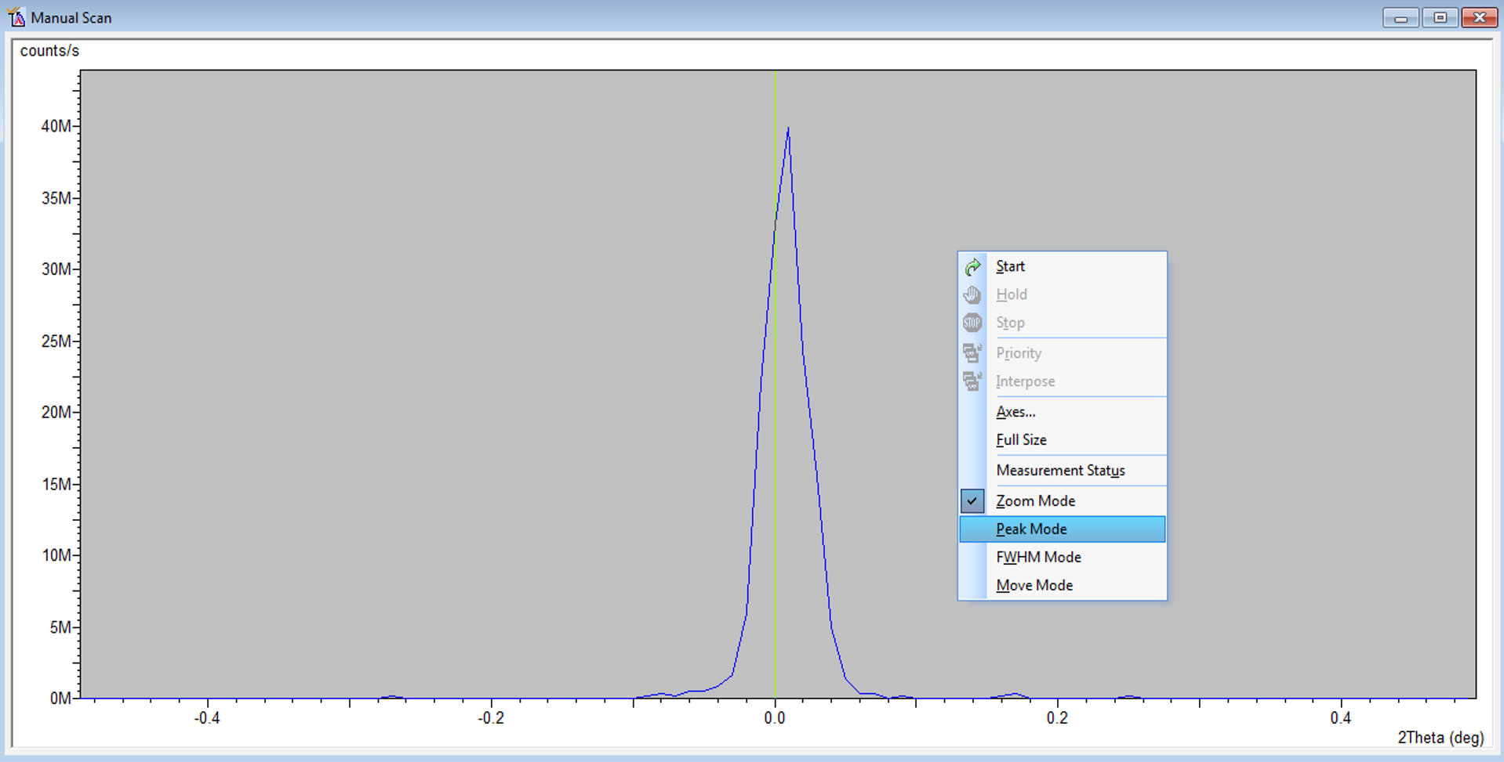
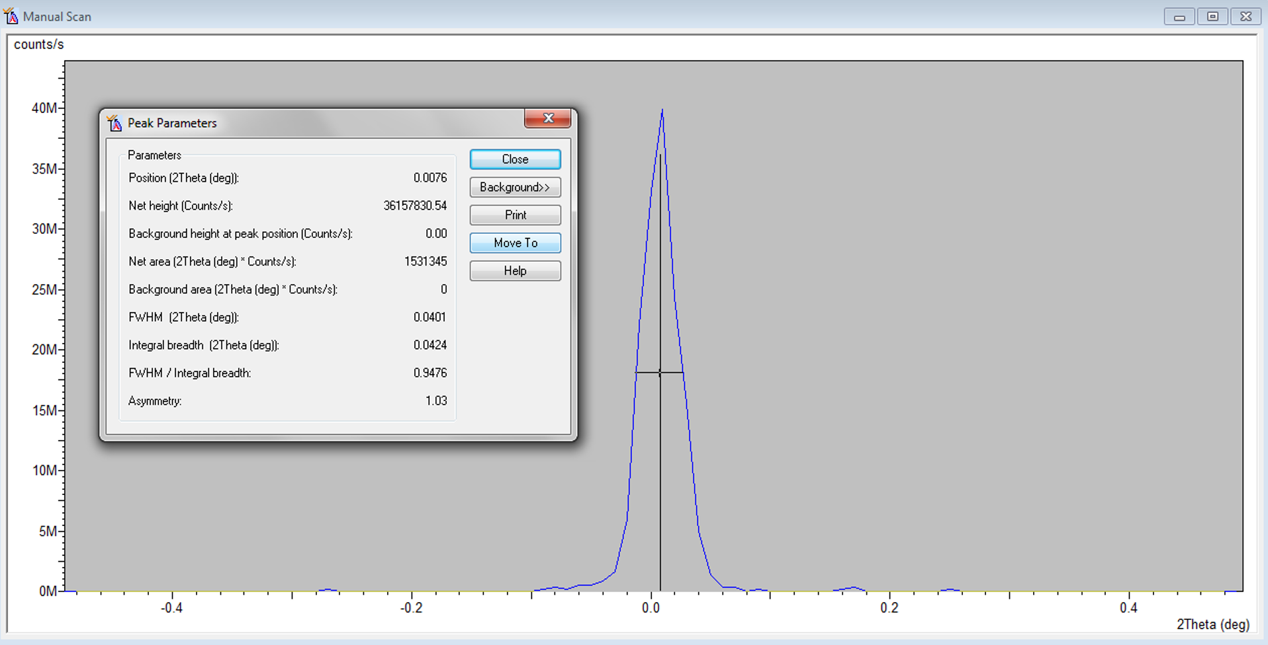
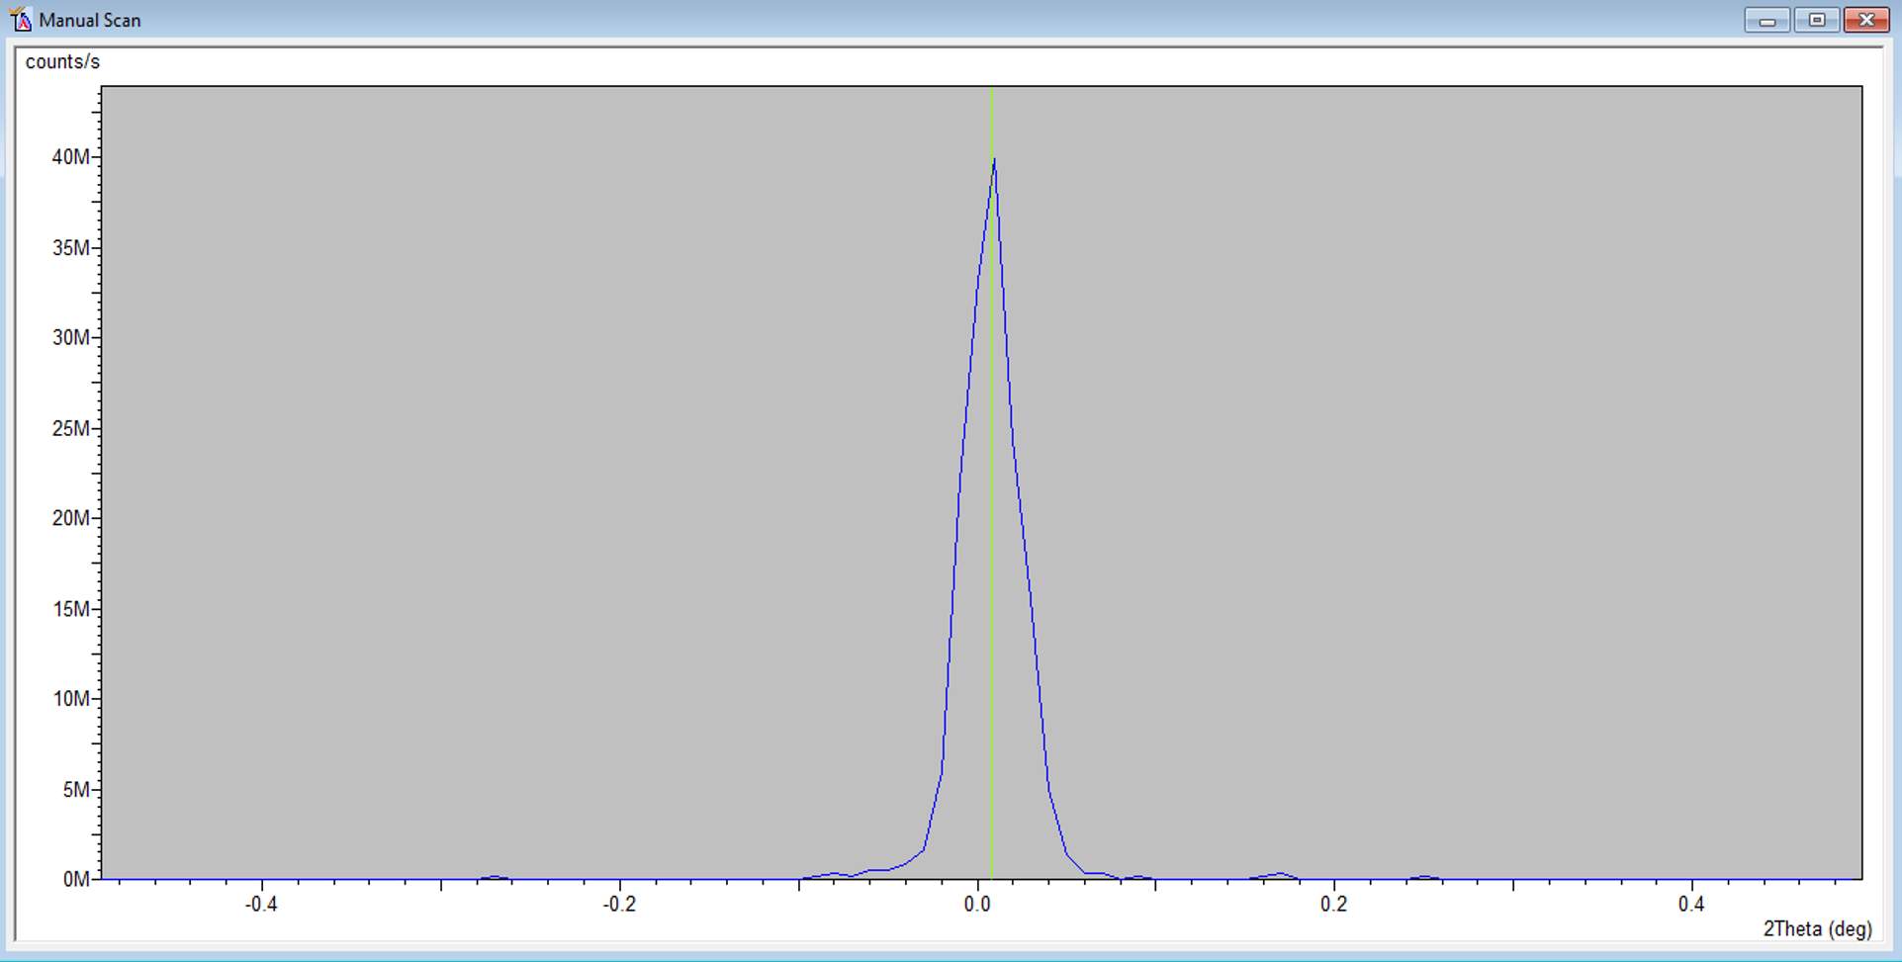

  - User Settings Fine Calibration Offsets
  - Click “Set New = 0”
  - Click OK
- Z Alignment Procedure
  - Under Factory Configuration Window, go to Instrument Settings Window and double click on “Z=0.000 mm”
  - Change Z to 5.5 mm and click “OK”
  - Measure Manual Scan (unless Prepare Manual Scan window is already open)
    - Scan Axis: Z
    - Range: 10
    - Step size: 0.1 (always use 1/100th of the Range for Alignment)
    - Time per step: 0.2
  - After scan, right click on scan window and select “Move Mode.” Move the line to half the maximum intensity (see below). This will move Z to this position.

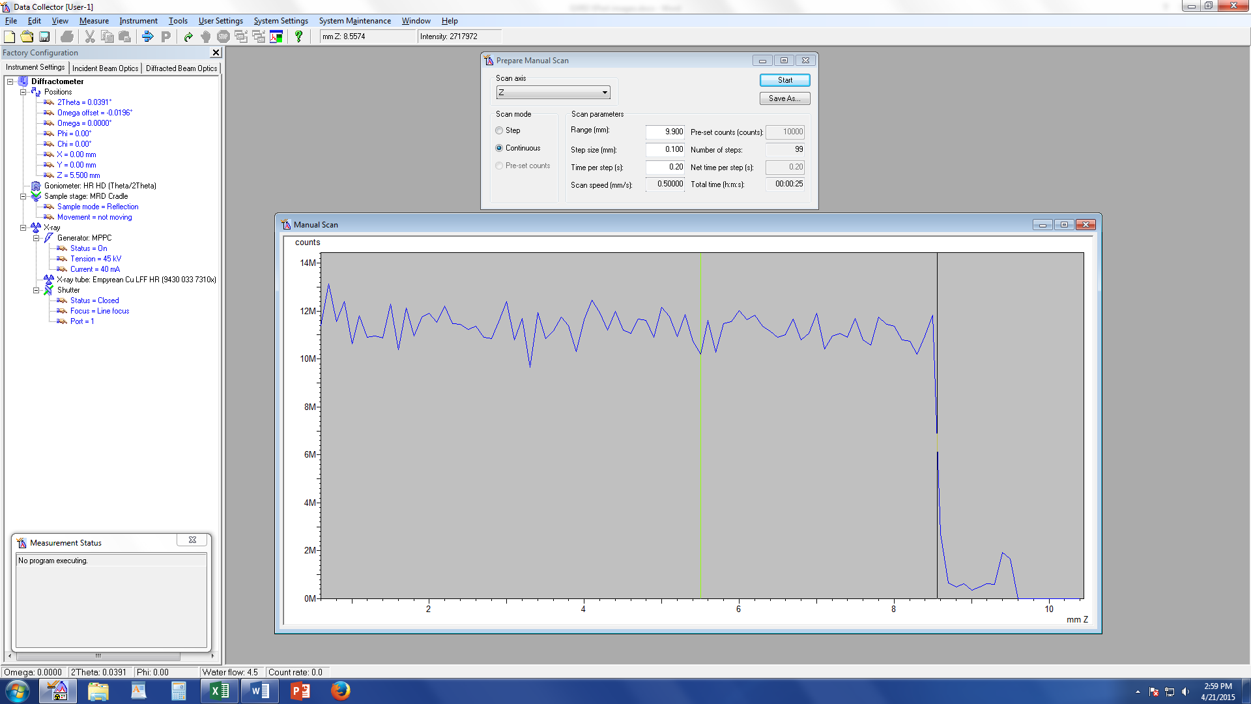

  - Measure Manual Scan (unless Prepare Manual Scan window is already open)
    - Scan Axis: Z
    - Range: 1 We are scanning over a smaller range to refine the Z position
    - Step size: 0.01 (always use 1/100th of the Range for Alignment)
    - Time per step: 0.2
  - After scan, right click on scan window and select “Move Mode.” Move the line to half the maximum intensity. This will move Z to this position.
- ω Alignment Procedure
  - Measure Manual Scan (unless Prepare Manual Scan window is already open)
    - Scan Axis: Omega
    - Range: 1
    - Step size: 0.01 (always use 1/100th of the Range for Alignment)
    - Time per step: 0.2
  - After scan, right click on scan window and select “Move Mode.” Move the cursor to the center of the peak and release. This will move omega to this position.
  - If the Range of 1 is too small and you just see a flat line, change Range to 3 and Step Size to 0.03.
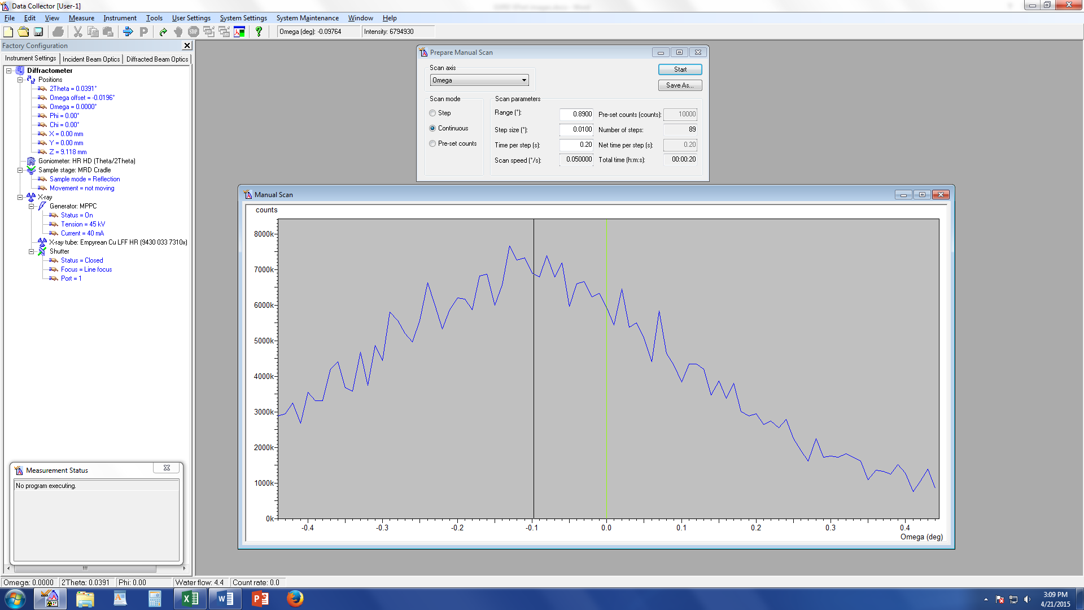
  - Repeat Steps 10 & 11 until Z and ω reach their equilibrium values and no longer change. This means the sample is aligned flat with respect to the beam.
  - User Settings Sample Offsets
  - ω should be the only angle that has a non-zero current position (a)
  - Put “0” for ω (b), then hit “tab” button on keyboard (c)
  - Click OK

(a) (b) (c)
- Check each peak location
  - On the double cross-slits collimator, set each mask and divergence slit to 2 mm
  - Remove the receiving/PPC slit from the diffracted beam optics
  - In Data Collector, go to the Incidence Beam Optics tab and change the mask and divergence slit to 2 mm.
  - In Data Collector, go to the Diffracted Beam Optics tab and change the beam attenuator “Usage” setting to “Pre-set Intensity” and change the receiving slit to “none”
  - In Data Collector, go to Instrument Settings and change the 2θ value to the value of the peak for which you want to measure the pole figure. ω-offset should be 0
  - Go to Measure Manual Scan
    - Gonio scan
    - Range = 2º
    - Step Size = 0.02º
    - Time per step = 1 second
    - Click start
  - Once scan is complete, right-click and choose “Peak Mode,” and then record the peak position for use later in making programs. If you do not see a peak at the expected position, this may be because of the preferred orientation. Move on to the next peak for which you want to make a pole figure. If this peak looks better and is at the expected position, you can simply use the expected position for the missing peak when making your program later in this manual
  - You also need to find a 2θ value close to each peak that is purely background (no peaks and no peak tails). If you see such a position in your 2º scan, record that value as well. If you do not see such a position in your 2º scan, make a bigger scan to find one (maybe 4º).
  - Repeat steps e-g for each pole figure you want to collect.
- Prepare optics for measurement
  - Open the Excel file “Double Cross Slit Collimator Spot Size.xlsx” to determine the irradiated area on the sample based upon the settings of the double-crossed slit collimator
    - In the Excel file, enter the omega value (cell C20) for the diffraction peak that you wish to study (if the diffraction peak occurs at 30º 2θ, you should enter 15º). Enter the chi value (cell C12) that matches the maximum chi you want to go to (likely 70º or 75º).
    - You should know the length and width of your sample. The goal is to make sure that both of your sample dimensions are larger than the diagonal of the beam (cell C25). You will need to change the mask and divergence slit sizes (cells C7 and C19, respectively) to be as large as possible while keeping the beam diagonal (cell C25) smaller than both sample dimensions.
  - Go to Incident Beam Optics in the Data Collector and set the mask (which determines the width) and the divergence slit (which determines height) to match those found in cells C7 and C19
  - The previous step does not change the slits themselves since the slits are not motorized, so you need to go to the double cross slit collimator and set the correct values with the knobs. Set both the left and right slits to the same values.
- Make a pole figure measurement program
  - For the first program, go to New Program, choose “Texture measurements” for Program Type
  - Make sure that you are on the correct beam path
  - Choose “Single pole figure measurement”
  - Enter the 2θ value and h k l that you want
  - Go to Edit use continuous, phi is from 0 – 360º, 5 step size, 1 second per step, enter 0 - the end chi that you decide to use (likely 70-75º), step size = 5
  - Click OK
  - Go to File Save As (save as something like “Cu – 220 PF”)
- Make a background measurement program
  - Change the measurement type to Background measurement
  - Insert a background offset that will put the measurement at a value of 2θ that a peak will not be found. In a previous step, you recorded the peak position and a position that has no peaks or peak tails. Take the difference of those two numbers and enter the result as the background offset
  - Go to Edit use “Step” scan mode, “Phi=0” background mode. For phi, time per chi step = 10 seconds. For chi, use a 0º start angle, 70-75º end angle (this should match your pole figure measurement program setting), and a 5º step size
  - Go to File Save As (save as something like “Cu – 220 bkg”)
- Make pole figure measurement and background measurement programs for each atomic plane you want to test
- Write a batch file
  - File New Program
  - Choose General Batch with Factory Configuration
  - Click Insert Measurement Programs and insert each of the ones you have created above
    - Choose the data folder that you want to save the data in
    - Enter whatever file name you want
  - Go to File Save As
- Measure Program
  - Click the folder icon and open your texture program
  - Change the file names further (if needed) and start your measurement

