Sample Requirements: The pellet must be flat if possible, not necessarily polished. The powder must be ground to a particle size that has a consistency similar to fine sugar, not granular sugar.

- Write your reserved time down in the log notebook. Better to do it now rather than later to make sure you don’t forget.
- There are several different sample holders to use for powder scans. This example will use the,
  - 46 mil open: Used to scan small solid samples (e.g. pressed pellets). During the below mentioned procedure, make sure that the sample is centered on the holder. Form a point extending beyond the height of the sample holder with the modeling clay. Flatten the modeling clad using a glass slide, then place your sample on the modeling clay. Use glass slide to press sample until flush with holder surface (The sample must be flush with the surface of the sample holder since this is the reference sample height).

Examples of solid and powder samples loaded for conventional powder diffraction

  - Zero Background Holder: Used to scan a small amount of powder. Clean Si (zero background) holder with isopropanol. Grind powder in mortar/pestle before placing in sample holder to remove preferred orientation. Put a small amount of powder in the sample holder and a drop of isopropanol. Spread powder evenly using toothpick.
- Open the data collector using the “Data Collector” Icon on the desktop. Enter your username and password.
- In the “Instrument” dropdown menu, select “Connect”.

- A dialog box “Connect” will open:
  - For powder XRD, select the configuration “Config. Stage reflecyion/transmission...”
  - Select “Diffracted beam path1”
  - Wait for the side bar to open. A dialog box with warning signs will open notifying you of the current instrument settings. If you don’t see any items with RED icon then click “OK”
- Increasing Voltage and Current:
  - To increase the voltage and current, go to the Instrument Settings tab and double click on any of the blue text
  - Click on “X-ray” tab. The idle state is 45 kV and 20 mA, while the measurement state is 45 kV and 40 mA. If the voltage is not 45 kV, change it to 45 kV and click “Apply.” If the current is already 40 mA, you do not need to do anything.
- Mounting the Sample Holder:
  - To place the sample in the Empyrean, go to the Instrument Settings tab and double click on any of the blue text
  - Under “Sample Stage” tab, uncheck the box next to “Lift Up” and click “Apply” (you may have to click the “Lift Up” box once, click “Apply,” then repeat those two steps. Sometimes the computer gets confused as to the current state of the sample holder).
  - Mount the sample in the instrument. Take care not to apply force to the sample holder area as it will shut down the entire instrument
  - Under “Sample Stage” tab, check the box next to “Lift Up” and click “Apply.” The doors must be closed to Lift Up.
- NOTE: After placing sample holder for solid samples in the Empyrean, check to see if the sample is centered using the alignment camera. Tools (Menu) → Alignment Camera and click “Start.” Make sure to “Stop” the camera before beginning your measurement.

- Measurement Optics (see Appendix 1 for effects of different optics):
  - Incident Beam - Programmable Divergence Slit (PDS):
    - Insert small 0.02 or 0.04 rad Soller Slits – push all the way in.
    - Insert 10 mm mask (for zero background holder) or appropriate size for solid sample holder – push appropriate mask all the way in. If removing, make sure you do not use the sample stage as a leverage point!!!
    - Choose an anti-scatter slit that is 2x the value you will set the divergence slit to be – Push the slit all the way in, then pull back until you feel a click.
  - Diffracted Beam - Programmable Anti-scatter Slit (PASS):
    - Insert large 0.02 or 0.04 rad Soller slits – push all the way in
    - Insert the Ni filter – push all the way in…it only fits with one orientation

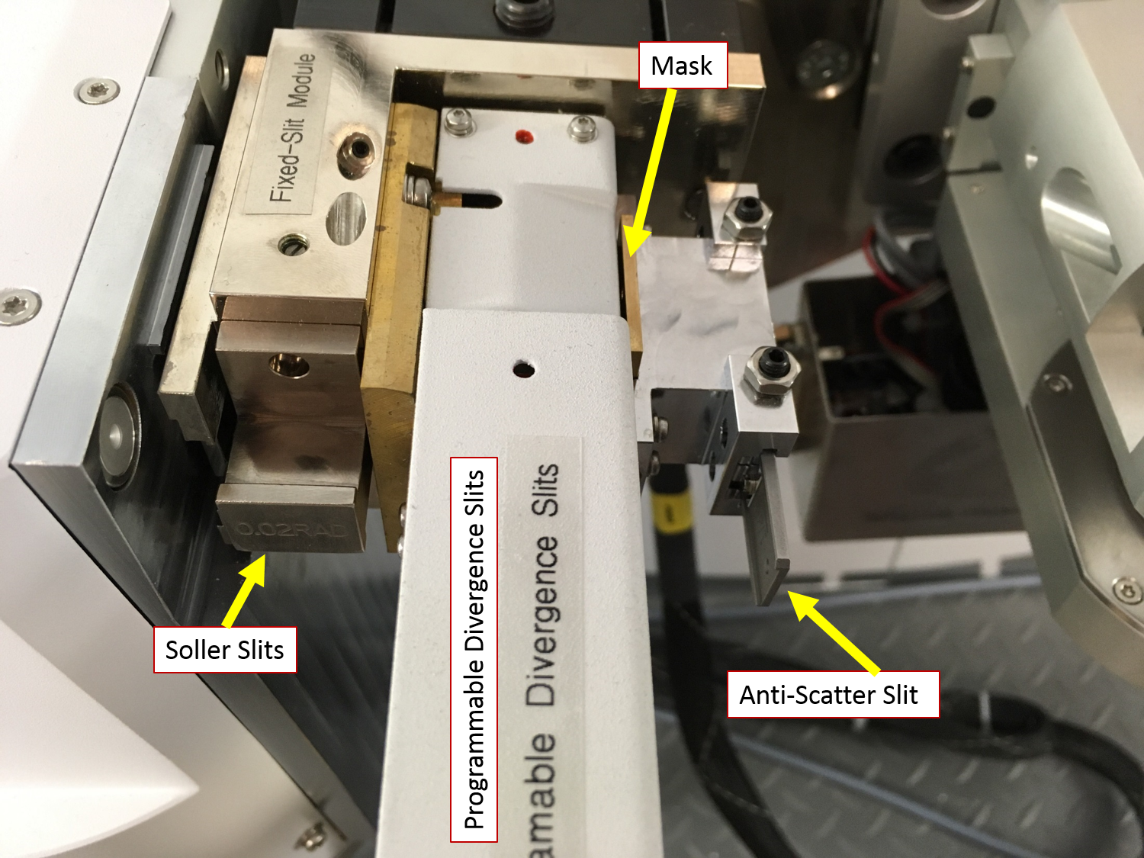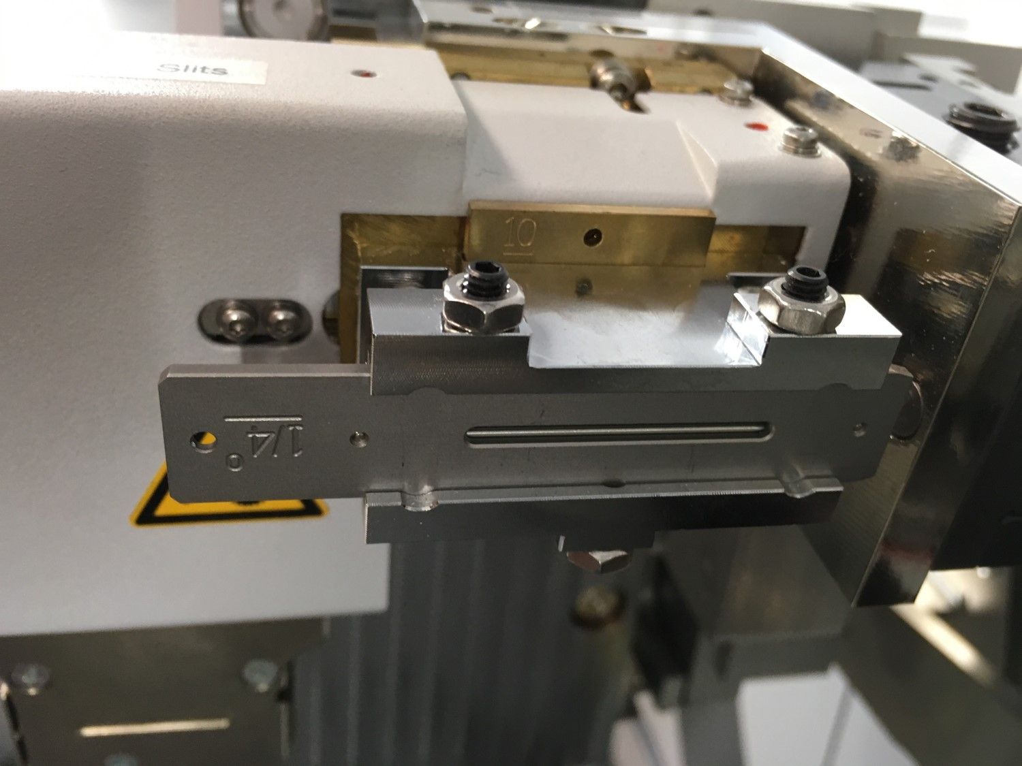
Overview of the incident side Anti-scatter slit orientation

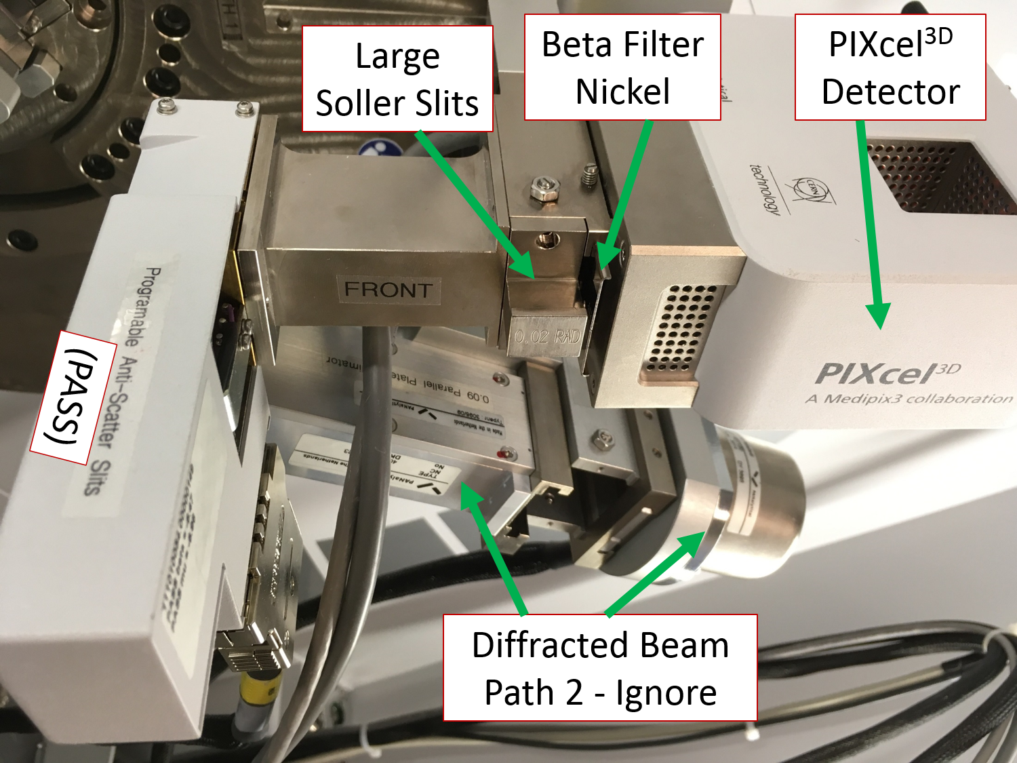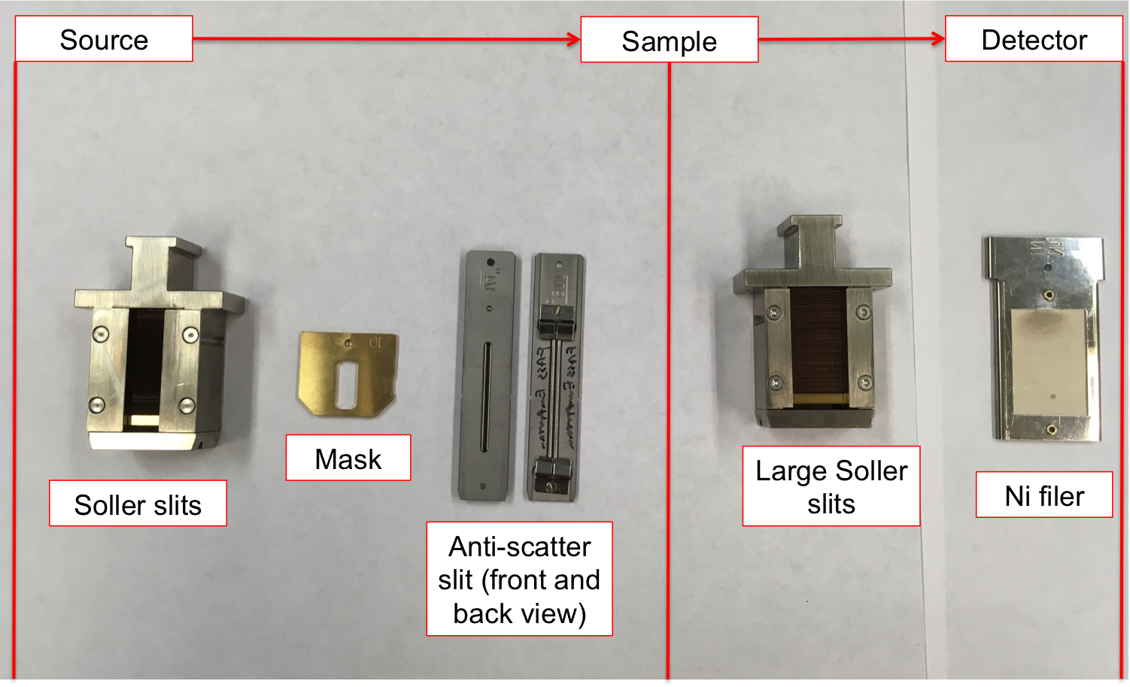
Overview of the diffracted side Overview of all optics

- Entering Instrument Configuration into Computer:
  - Under the “Incident Beam Optics” tab, double click on “Radius”
  - Go through each of the tabs in the pop-up window and enter the optics you placed in the system in Step 8.
    - PreFIX module = “Progr. Divergence slit with anti-scatter slit.” Don’t change the offsets
    - Divergence slit = fixed slit 1/8º (or whatever divergence slit you want to use)
    - Anti-scatter slit = fixed slit of whatever angle you want. It should be 2x your divergence slit
    - Mask = “Fixed incident beam mask # mm,” # = whichever mask you have installed
    - Mirror = none
    - Beam knife = none
    - Soller slit = “Soller slits 0.0# rad,” # = whichever Soller slit you have installed
    - Filter, beam attenuator, and monochromator = none
    - Click “Apply.” There will be a warning message. This just reminds you to make sure the optics in the computer match the optics in the XRD. Click “ok.”
    - Click “Ok.”
  - Under the “Diffracted Beam Optics” tab, make sure that Diffracted Beam Path 1 is activated (yellow light bulb). If it is not, right click on light bulb and click “Activate.”
  - Double click on “Radius”
  - Go through each of the tabs in the pop-up window and enter the optics you placed in the system in Step 8.
    - PreFIX Module = “PIXcel3D-Medipix3 1x1 with PASS,” (do not change offsets)
    - Anti-scatter Slit = “Programmable anti-scatter slit,” fixed, and whatever value matches the programmable divergence slit on the incident side
    - Receiving slit = none
    - Filter = “Beta-filter Nickel” (grammatical note, nickel should not be capitalized)
    - Beam attenuator = none
    - Detector = “PIXcel3d-Medipix3 1x1 detector[1],” usage = “Scanning line detector (1D),” Active length = “3.3482”, Used wavelength = “K-Alpha1”
    - Collimator = none
    - Soller slit = “Large Soller slits 0.0# rad,” # = whichever Soller slit you have installed
    - Mask = none
    - Click “Apply.” There will be a warning message. This just reminds you to make sure the optics in the computer match the optics in the XRD. Click “ok.”
    - Click “Ok.”
- Quick Scan:
  - If you like, start with a quick scan to make sure the scan parameters are ok.
  - Click the “Open Program” icon to open the list of programs. Click “Browse” and select the PXRD program from your folder.
  - Edit scan parameters (range, step size, time per step) such that the scan time is <10 min
  - Close the window. A pop-up window will ask you if you want to save the program. Click “Yes.”
  - Measure Program. Click “Browse” and select your recently modified program from your folder.
  - Click the folder icon to choose the save location and name your data file. Save all data on the C drive in your personal folder found in XRD Data Users folder.
  - You can also enter comments, sample ID, etc. if you like (not required)
  - Click “Ok” and the scan will begin.
- Measurement Scan:
  - Click the “Open Program” icon to open the list of programs. Click “Browse” and select the program that you edited in step 11.
  - Edit scan parameters required to get adequate data on your sample
  - Close the window and save the program
  - Measure Program. Click “Browse” and select your program from your folder.
  - Click the folder icon to choose the save location and name your data file. Save all data on the C drive in your personal folder found in XRD Data Users folder.
  - You can also enter comments, sample ID, etc. if you like (not required)
  - Click “Ok” and the scan will begin.
- Before you leave after finishing your experiments
  - Once all of your measurements are done, make sure to remove your sample (Instrument settings, double click any blue words, go to “Sample” tab, uncheck the box next to “Lift Up,” and click “Apply”). Also return the system to idle state (45 kV and 20 mA) in the “X-ray” tab (no need to go down in steps of 5 mA, just go straight to 20 mA).
  - Click Instrument Disconnect
  - Click OK in the next dialogue box
  - Wait 5 or 10 seconds after disconnecting, and then close the Data Collector.

Appendix 1

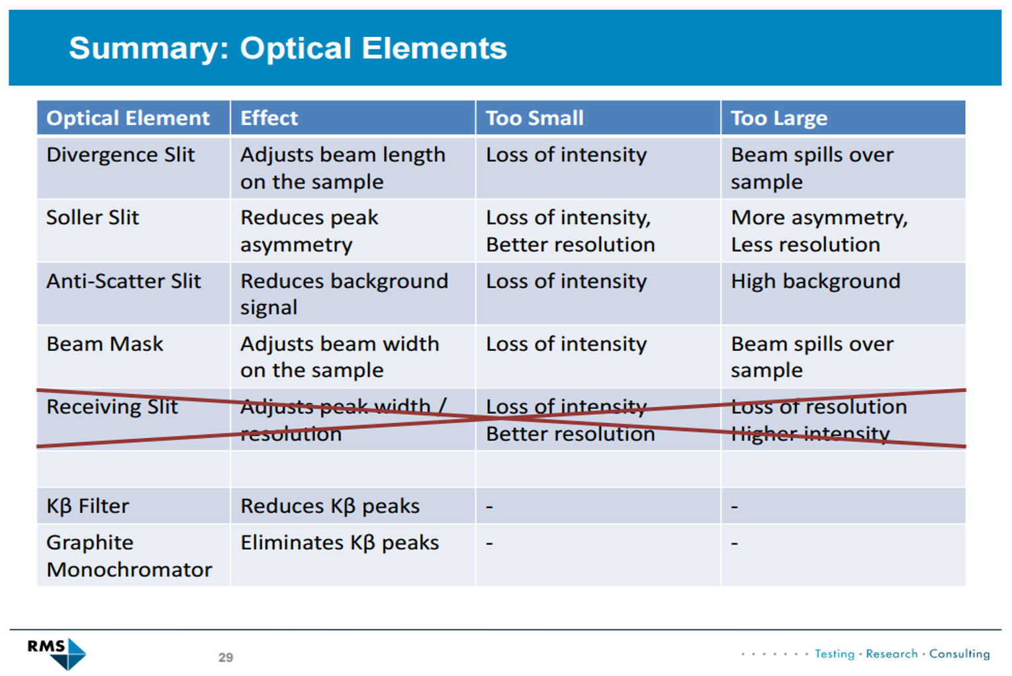

Appendix 2

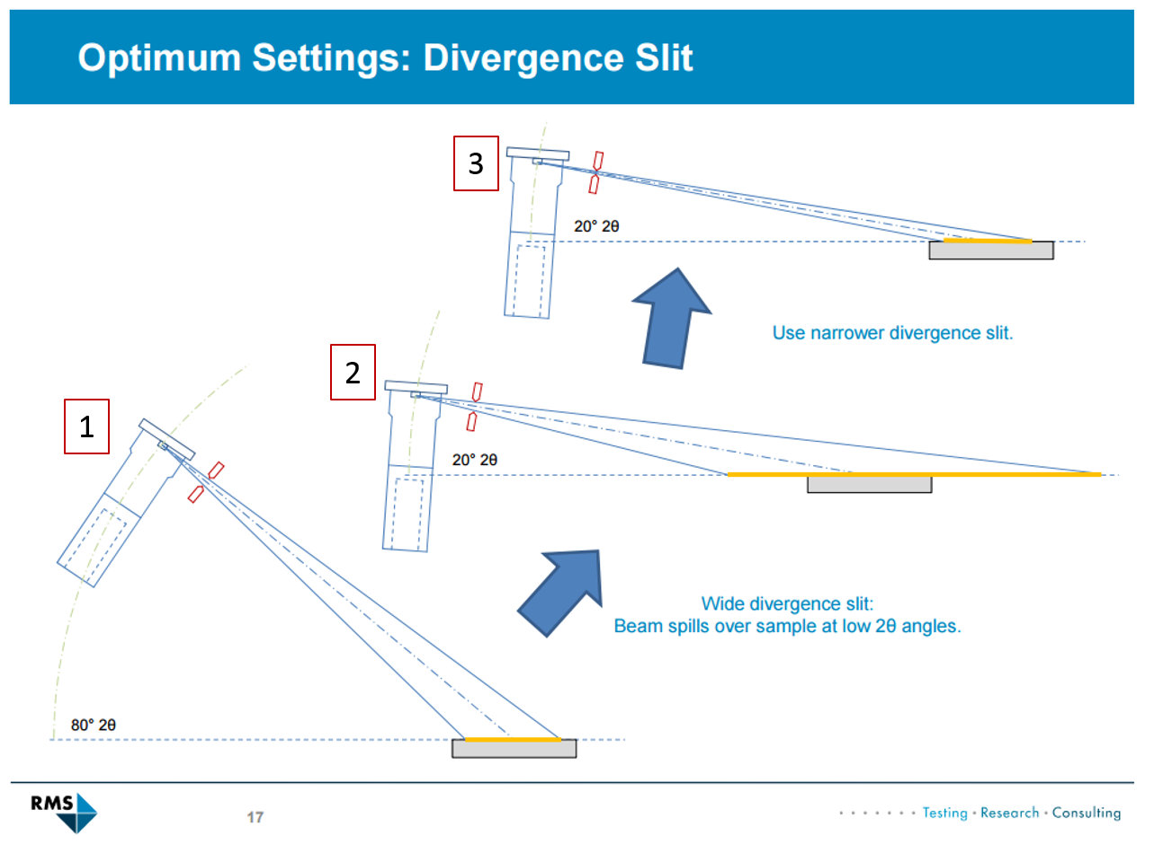

Even if the divergence slit produces a beam that remains fully on the sample at larger 2θ angles (1), the beam can spill over the sample at lower 2θ angles (2). As such, you should use the divergence slit that will be narrow enough to keep the beam on the sample at low angles (3).

Trade-off of divergence slits: Narrower slits slightly increase resolution and keep the beam from spilling off of your sample but decrease the intensity.

