- Connecting the fiber analysis plate
  - The fiber analysis plate for the sample holder is shown in Figure 1.
  - You need to place the fiber analysis plate (with no fiber mounted on it) on the X’Pert3 MRD sample stage. Remove the sample holding plate from the plate ring (see Figure 2). The plate is magnetic, so simply pull it off.
  - Place a large Kimwipe over the whole directly below the sample stage to ensure that screws do not accidentally fall inside.
  - Loosen and remove the three screws shown in Figure 3. Make sure you do not lose these screws and washers! I suggest placing them in the small rectangular area in the left-inside part of the diffractometer (see Figure 4).
  - Using the shorter screws provided with the fiber analysis plate, fix the plate to the sample stage (see Figure 5). Make sure you use the shorter screws (not the longer screws that you removed from the black ring), as the longer ones will damage the sample stage. There are only two screws, so use the top hole and the bottom right hole. Using the bottom left hole will also damage the system.

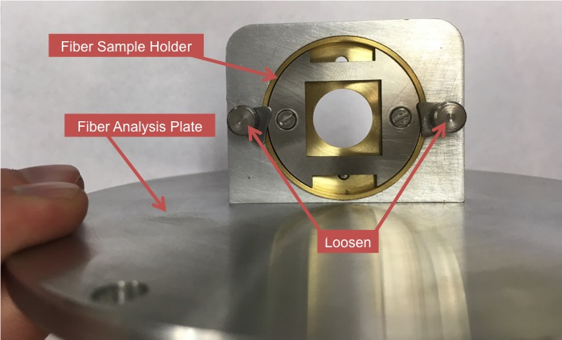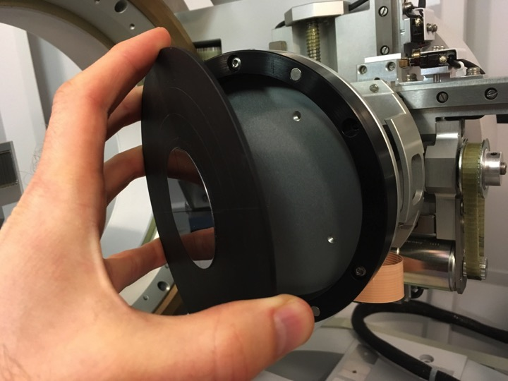
Figure 1 Figure 2

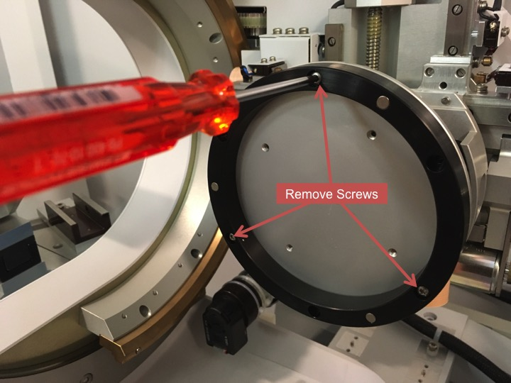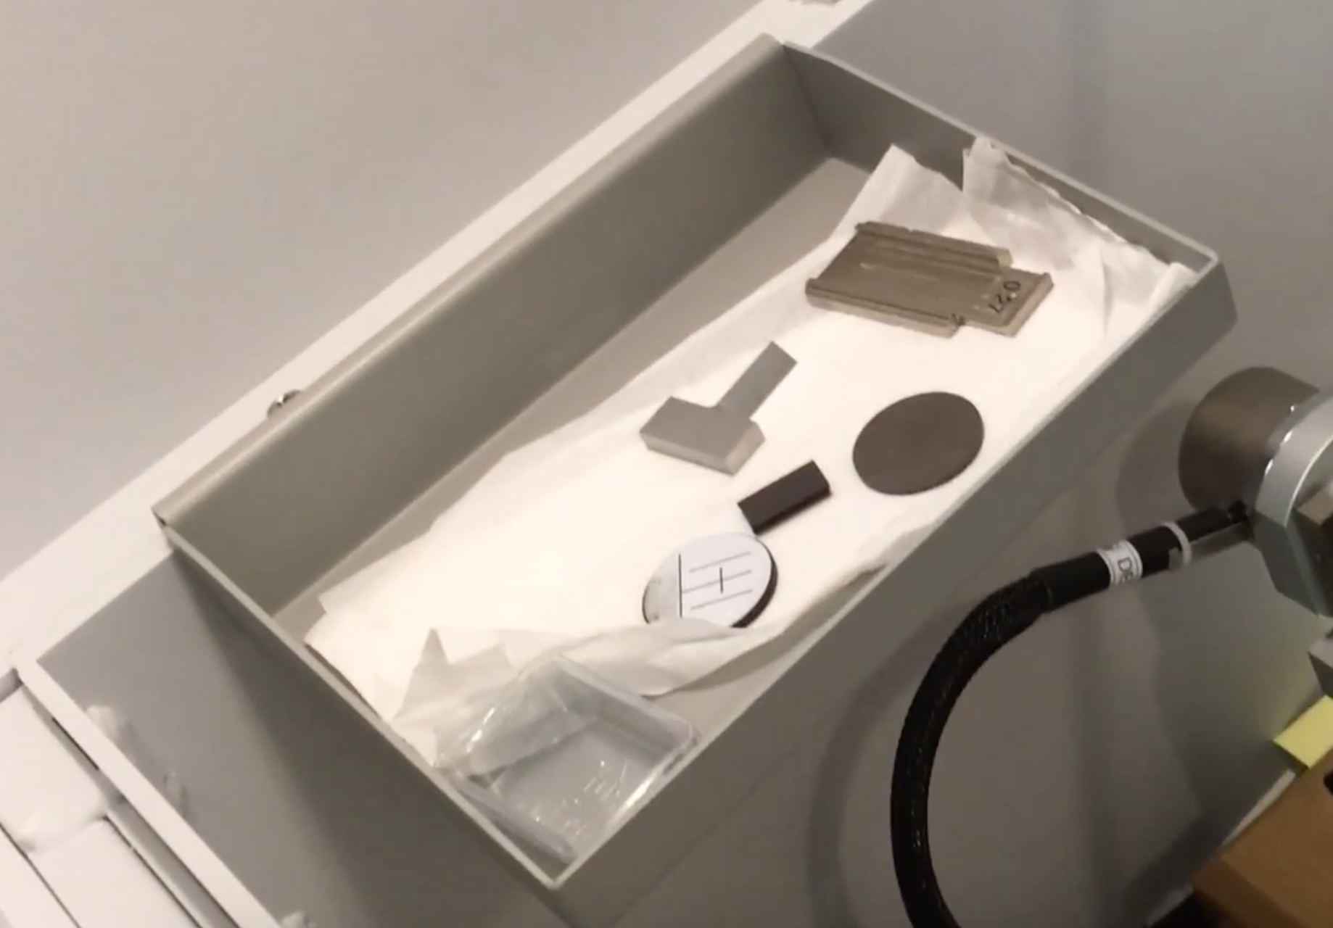
Figure 3 Figure 4

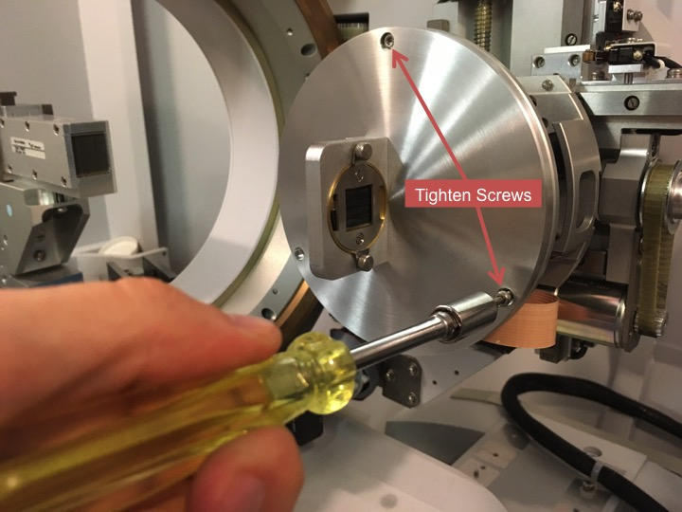
Figure 5

- Alignment optics
  - Incident beam side (mirror)
    - 1/32º divergence slit – push in until it clicks. If you push it too far in and can’t get it out with your fingers, contact Michael Koehler
    - 0.04 rad. Soller slits – push all the way in
    - Whichever mask you will use for your measurement – push all the way in
  - Diffracted beam side (0.27º parallel plate collimator)
    - 0.27º parallel plate collimator receiving slit – push all the way in, pull out a bit until it clicks
    - Large 0.04 rad. Soller slits – push all the way in
    - Programmable attenuator

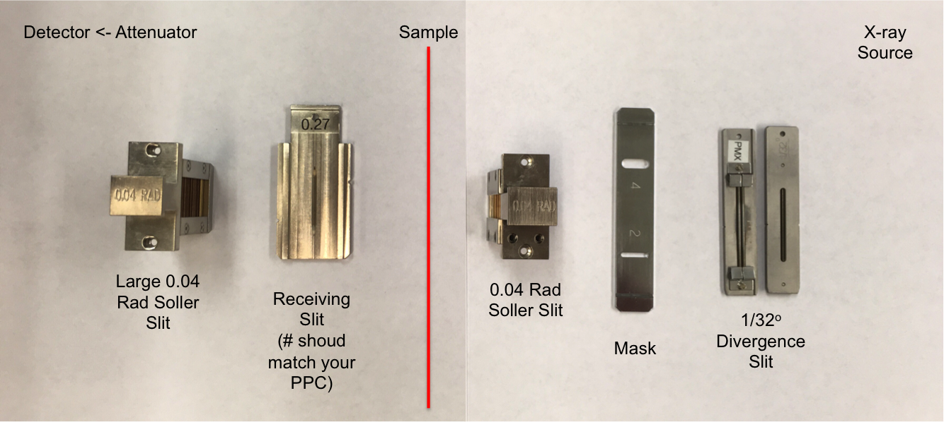
Figure 6: Order of optics. Source is on the right, detector on the left

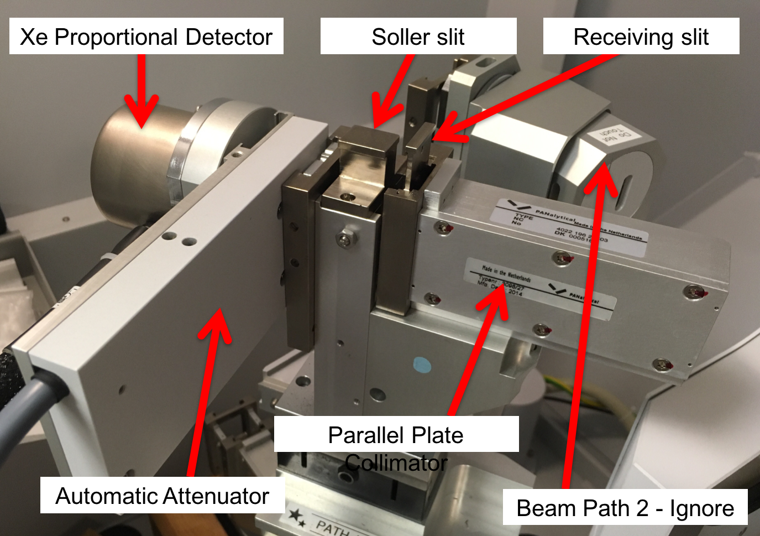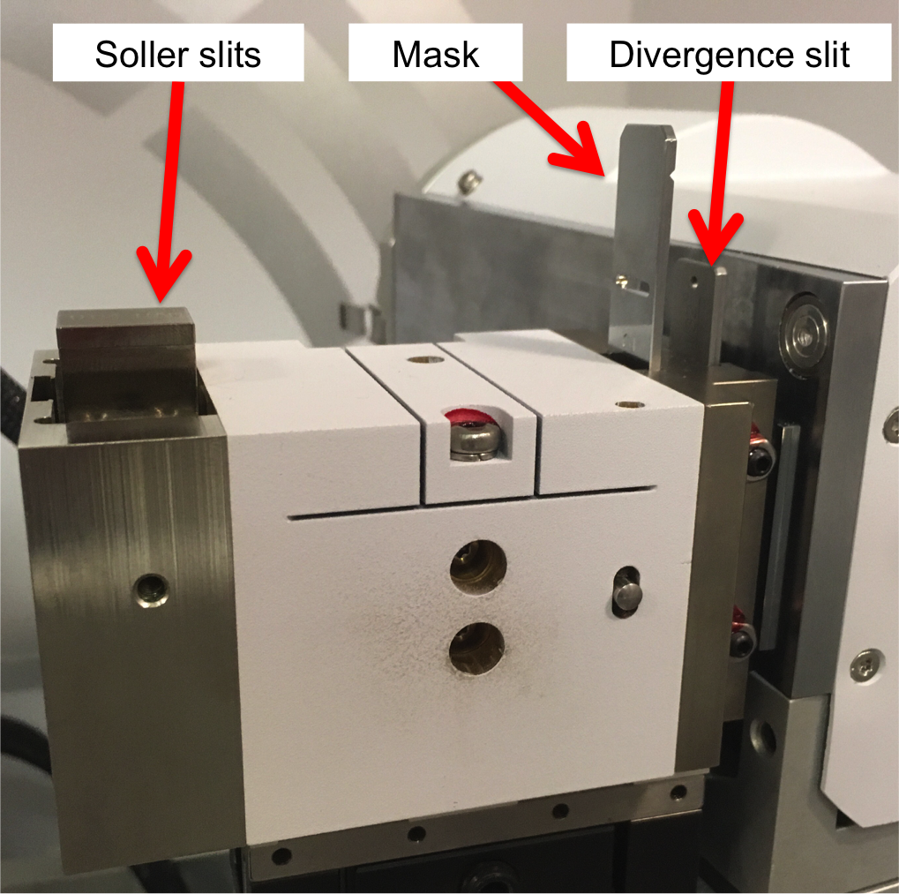
Figure 7: Diffracted Side Figure 8: Incident Side

- Entering the Alignment Instrument Configuration into Computer
  - Open “Data Collector” (desktop icon) on the X’Pert³ PC. Login with your username and password.
  - Instrument Connect. It does not matter which Diffracted Beam Path you select at startup.

  - Say “Ok” to warnings that popup.
Figure 9

  - User Settings Fine Calibration Offsets Clear All Offsets
Figure 10: After clicking “Clear All Offsets,” the “Fine calibration
offset” column should all be 0

  - User Settings Sample Offsets Clear All Offsets

Figure 11: After clicking “Clear All Offsets,” the “Sample offset” column should all be 0

  - Under Factory Configuration Window, go to Instrument Settings tab and double click “2Theta”
    - Under “Position” tab in popup window, enter “0” for everything except X and Z. Set X = -1 and Z = 1.38. Click “Apply”

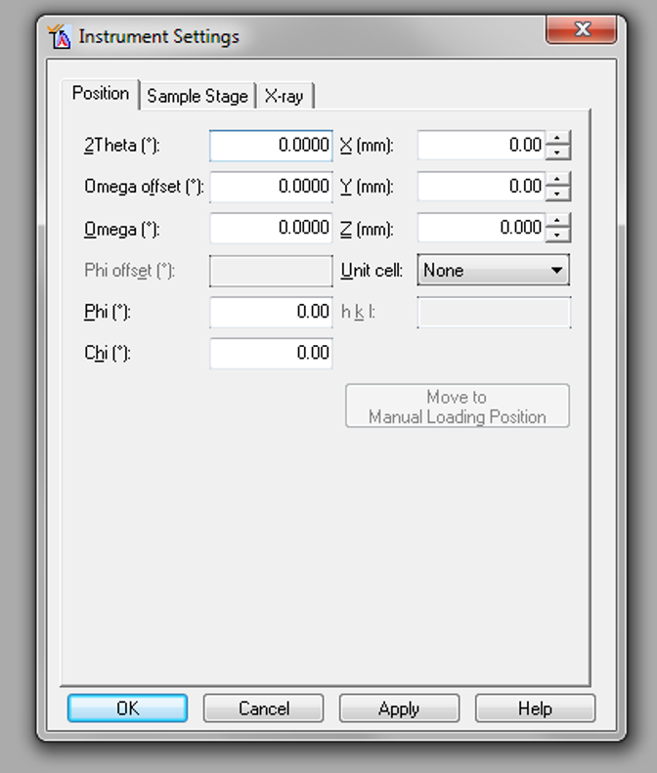
Figure 12: Make all fields zero

    - Under “X-ray” tab, the Tension = 45 kV and Current should be increased from the idle state (which is 20 mA) to 40 mA

  - Under Factory Configuration Window, go to Incident Beam Optics tab and double click “Radius”
    - Go through each tab and use drop-down menus to change optics in the computer to match the optics you placed in the XRD in Step 2.
      - PreFIX Module = “Mirror Cu W/Si (parabolic MRD)”
      - Divergence Slit = “Fixed slit 1/32º”
      - Anti-scatter Slit = “None”
      - Mask = “Fixed mask ** mm” (** = whatever size you have)
      - Soller Slit = “Soller slits 0.04 rad”
      - Filter = “None”
      - Beam Attenuator = “None”
      - Monochromator = “None”
      - Mirror = “Inc. Beam Cu W/Si (parabolic MRD)…you should be unable to change this if you chose “Mirror Cu W/Si (parabolic MRD)” in step (1)
        - Usage = “Standard”
      - Click “OK”
      - There will be a warning messaging. This just reminds you to make sure the optics in the computer match the optics in the XRD. Click “OK”

  - Under Factory Configuration Window, go to Diffracted Beam Optics tab. Diffracted Beam Path 1 should be activated (yellow light bulb). If it is not, right click on light bulb and click “Activate.”
  - Double click “Optic number = 1” in the Diffracted Beam Optics tab.
      - PreFIX Module = “Parallel plate collimator 0.27º”
        - Do not change the offsets
      - Anti-scatter Slit = “None”
      - Receiving Slit = “Parallel plate collimator slit”
      - Filter = “None”
      - Mask = “None”
Step #6
is crucial!!
      - Beam Attenuator = “Progr. beam attenuator Ni 0.125 mm”
        - Usage = “Do not switch”
        - Check the “Activated” box
      - Detector = “Proportional detector Xe[2]”
        - Used wavelength = “K-Alpha1”
      - Collimator = “Parallel plate collimator 0.27º”
      - Monochromator = “None”
      - Soller Slit = “Large Soller slits 0.04 rad”
      - Click “OK”
      - There will be a warning messaging. This just reminds you to make sure the optics in the computer match the optics in the XRD. Click “OK”

- Zero-Beam (2θ) Alignment Procedure
  - Measure Manual Scan
    - Scan Axis: 2Theta
    - Range: 0.5
    - Step size: 0.005 (always use 1/100th of the Range for Alignment)
    - Time per step: 0.2
Figure 13

  - After scan, right click on scan window and select “Peak Mode.” Next, click “Move To” to make the program move to the center of the peak. This will move 2Theta to this position. Click “Closed”
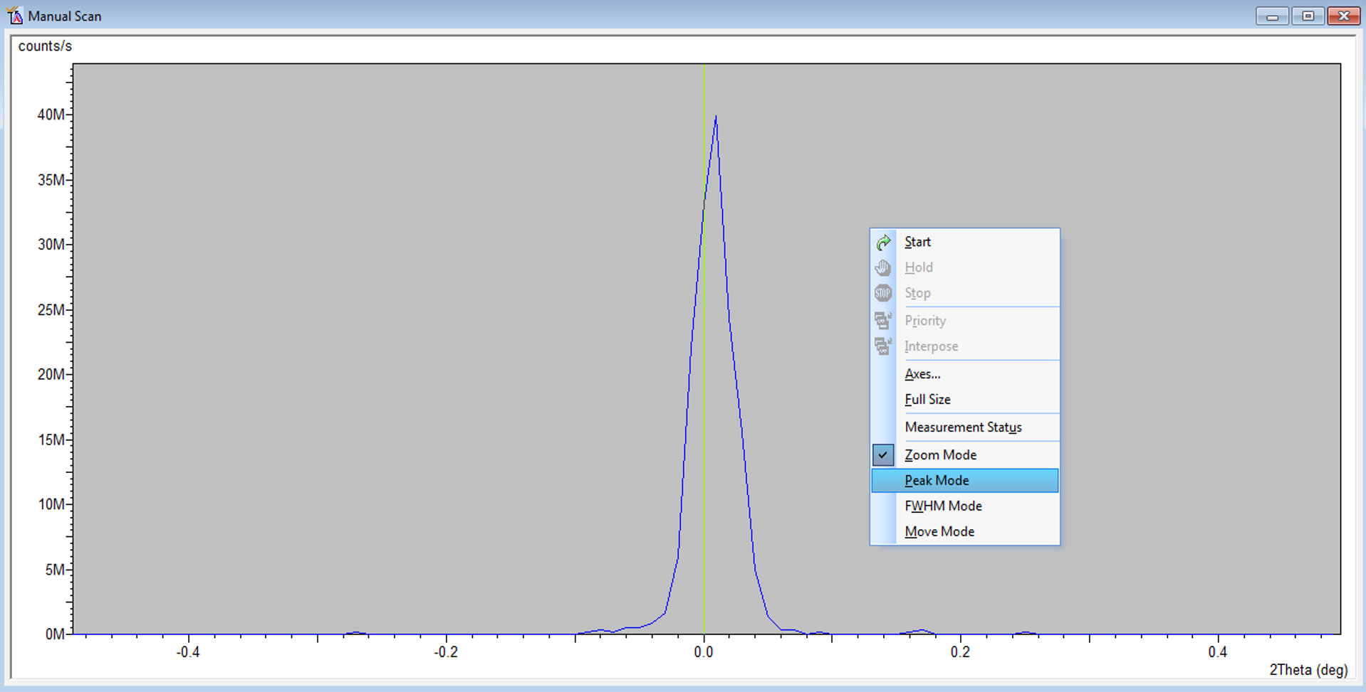
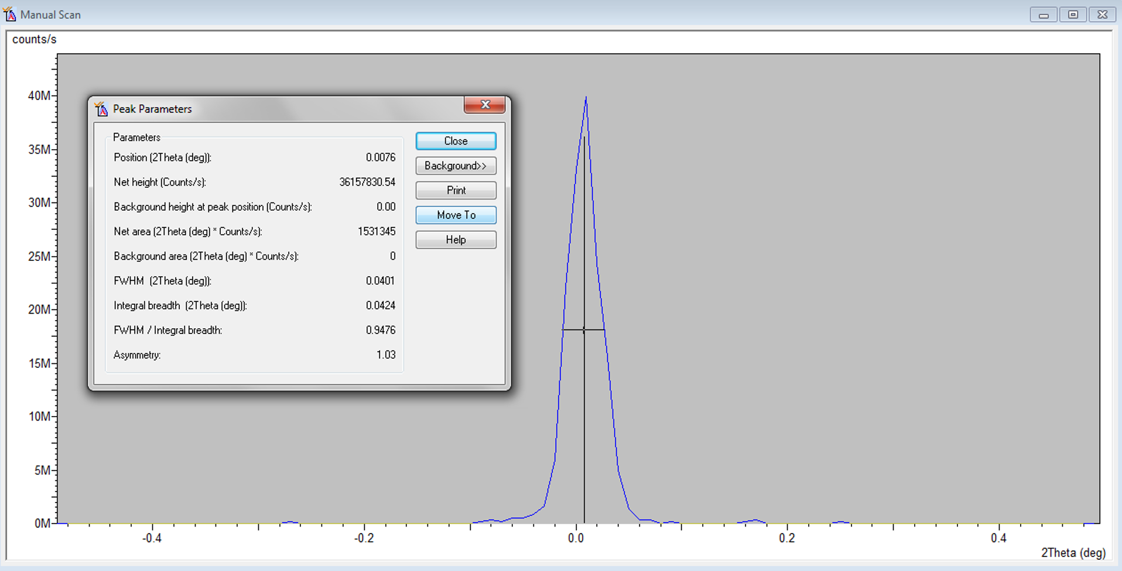
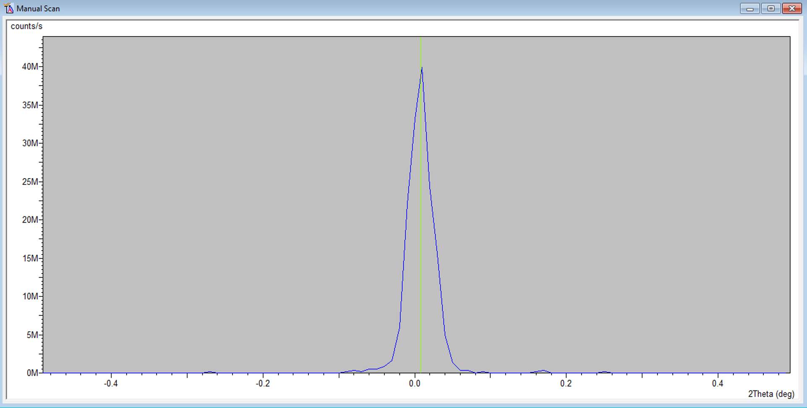
Figure 14

- Go to User Settings Fine Calibration Offsets
  - Click “Set New = 0”
  - Click OK

- Mount your sample in the holder
  - In order to separate the sample holder, loosen (with fingers) the two pieces holding it in place (see Figure 15)
  - The fiber analysis sample holder is shown in Figure 16
  - Remove the two screws shown in Figure 16 to separate the two pieces of the sample holder.
  - Apply thin strips of double-sided tape (the easily removable type) to the two areas shown in Figure 17. Make sure that the tape does not hang off of the metal strips on the inner edge as it may result in extra diffraction peaks (it’s okay if the tape hangs off a bit on the outer edge).
  - Cut your fibers so that they will span the area between the two pieces of tape (including some overhang). You want to completely cover the open area between the two pieces of tape (see Figure 18). If there are gaps between your fibers, this could result in shooting a direct beam into the detector and damaging it. Hold up to light to determine if there are holes (see Figure 19). Large gaps to the left and right of the fibers in Figure 19 are okay because the brass piece will block those outer areas.
  - Place the silver piece of the sample holder back in the brass piece and tighten the screws (see Figure 20). The screws will only tighten in one set of holes (only one set has threads).
  - Place the sample holder back in the fiber analysis plate (see Figure 20), finger tightening the screws that you loosened in step (a)

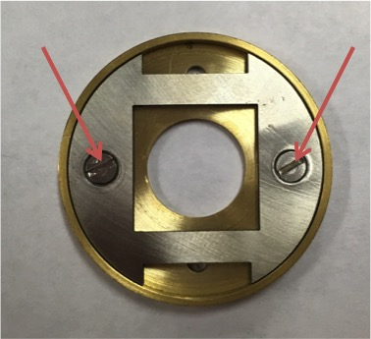
Figure 15 Figure 16

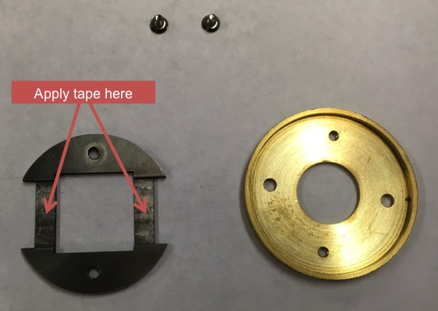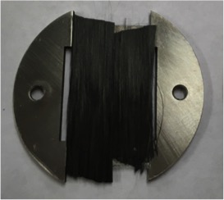
Figure 17 Figure 18

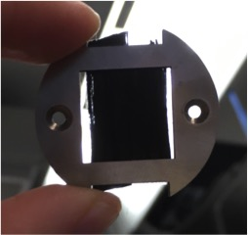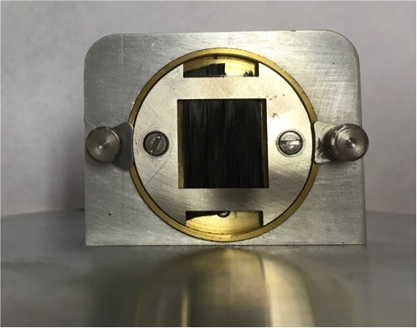
Figure 19 Figure 20

- Change the following optics before starting a measurement on your sample
  - Remove the 1/32º divergence slit and insert the 1/2º divergence slit in the incident side
  - Remove the parallel plate collimator receiving slit from the diffracted side
- Under Incident Beam Optics, make the changes to match what you did in step 7
- Under Diffracted Beam Optics, make the changes to match what you did in step 7 and set the attenuator to “Usage = At pre-set intensity”
- Run CFA-Batch.xrdmp
- Once done with the system, please put the magnetic plate back on the sample stage and set the current to 20 mA.

