Sample Requirements: In order to calculate the penetration depth and determine the resulting grazing angle, the density and chemical composition must be known. The sample should have the analyzed face as parallel as possible to the opposite face.

Grazing-Incidence X-Ray Diffraction Diagram (X’Pert³ only)

- Choosing the Grazing Angle:
  - Open High-Score Plus
  - Tools MAC Calculator
  - Enter Chemical Formula and click “Calculate Penetration Depth”
  - In pop-up box: type experimentally measured density (NOT calculated density from XRD, but the density measured by Archimedes method or similar techniques) into the Density box and leave the packing factor as 1.0.
  - Change the Incident Angle (theta) to find the penetration depth at different grazing angles

- Loading the Sample
  - Place a small piece of double-stick tape in the center of the sample holder and stick sample on tape so that sample is flat
  - Mount sample holder inside the system (magnetic)
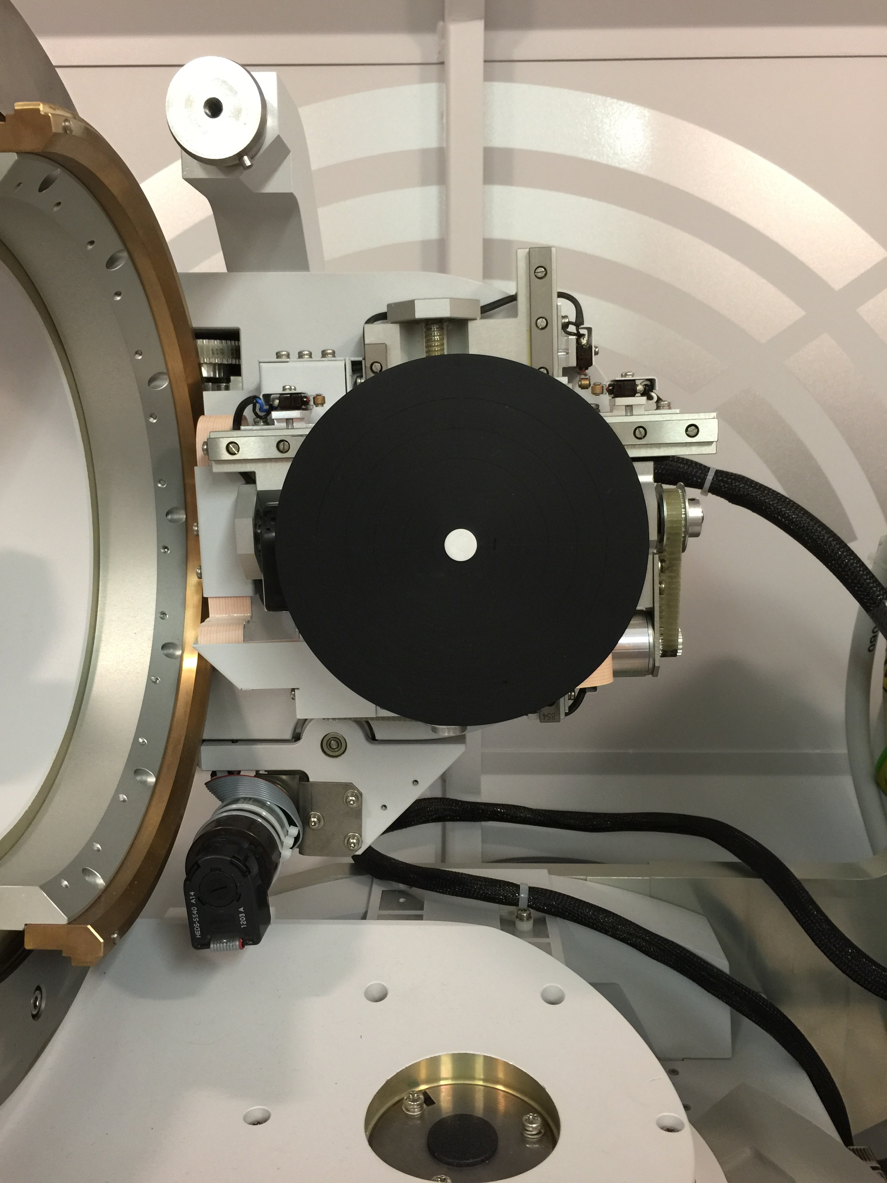
- Prefix Modules
  - Incident beam: parallel beam mirror
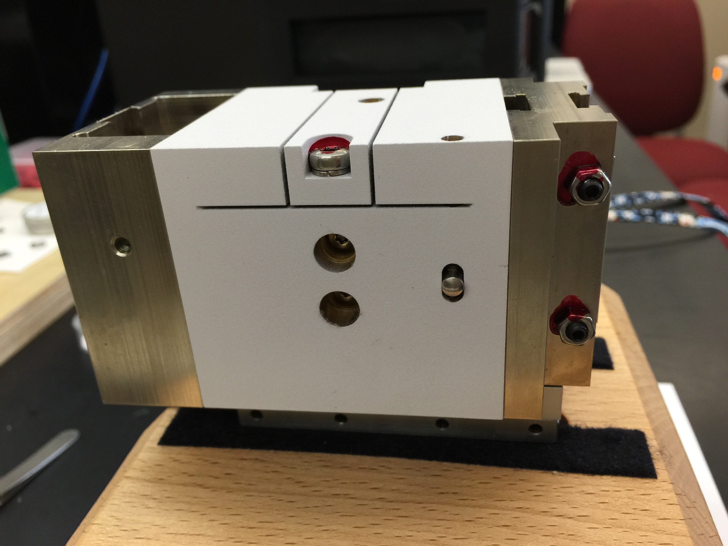
  - Diffracted beam: 0.09 or 0.27 parallel plate collimator (PPC).
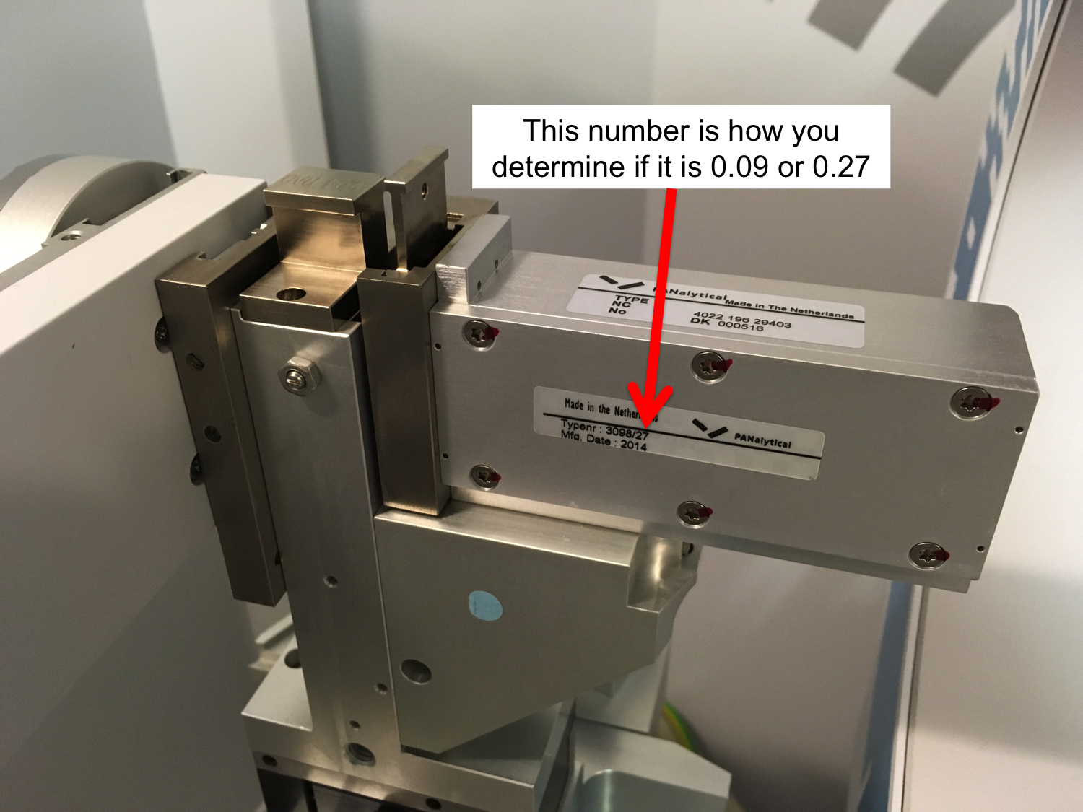

- If you have a sample with a dimension other than thickness on the order of a few millimeters, you may need to make sure that your sample is well centered on the black mounting plate (not an issue for larger samples).
  - Open “Data Collector” (desktop icon) on the X’Pert³ PC. Login with your username and password.
  - Instrument Connect. Choose “Factory Configuration” and “Diffracted beam path1”
  - Say “OK” to warnings that popup.

  - User Settings Fine Calibration Offsets Clear All Offsets

  - User Settings Sample Offsets Clear All Offsets

  - Under Factory Configuration Window, go to Instrument Settings tab and double click “2Theta”
    - Under “X-ray” tab, enter Tension = 45 kV and Current = 40 mA, then click “Apply”
    - Under “Position” tab in popup window, enter “0” for everything and then click “Apply” if you do need to align X and Y or click “OK” if you don’t need to align X and Y
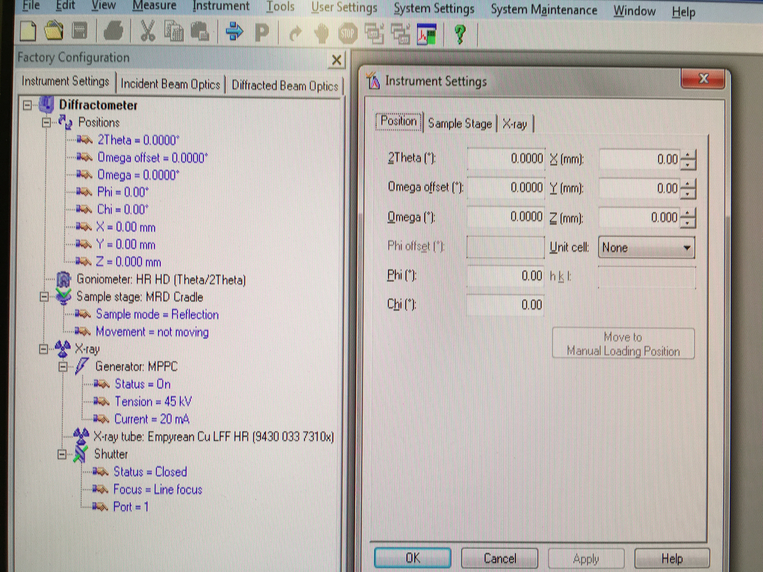

  - This page is only for small samples: attach the alignment gauge as shown below, taking care not to hit your sample as you attach it. If you have put the gauge on correctly, you should have to turn the screw to tighten it quite a few times. If it is not on correctly, the screw will get stuck almost immediately.
  - On the computer, change X and Y as necessary to get your sample aligned with the small piece sticking out of the gauge as shown below. Alignment may be easier if you change Z so that the small piece is closer to your sample, taking care not to move it so far that it impacts your sample and affects the surface. My recommendation is to not increase Z by more than 3 mm at a time.
  - Once your sample is aligned, set Z back to 0 and then remove the position gauge.
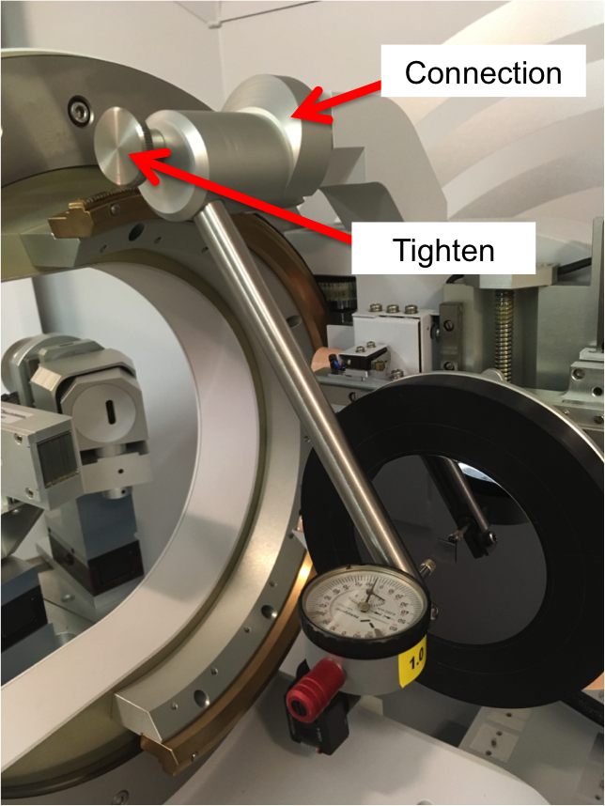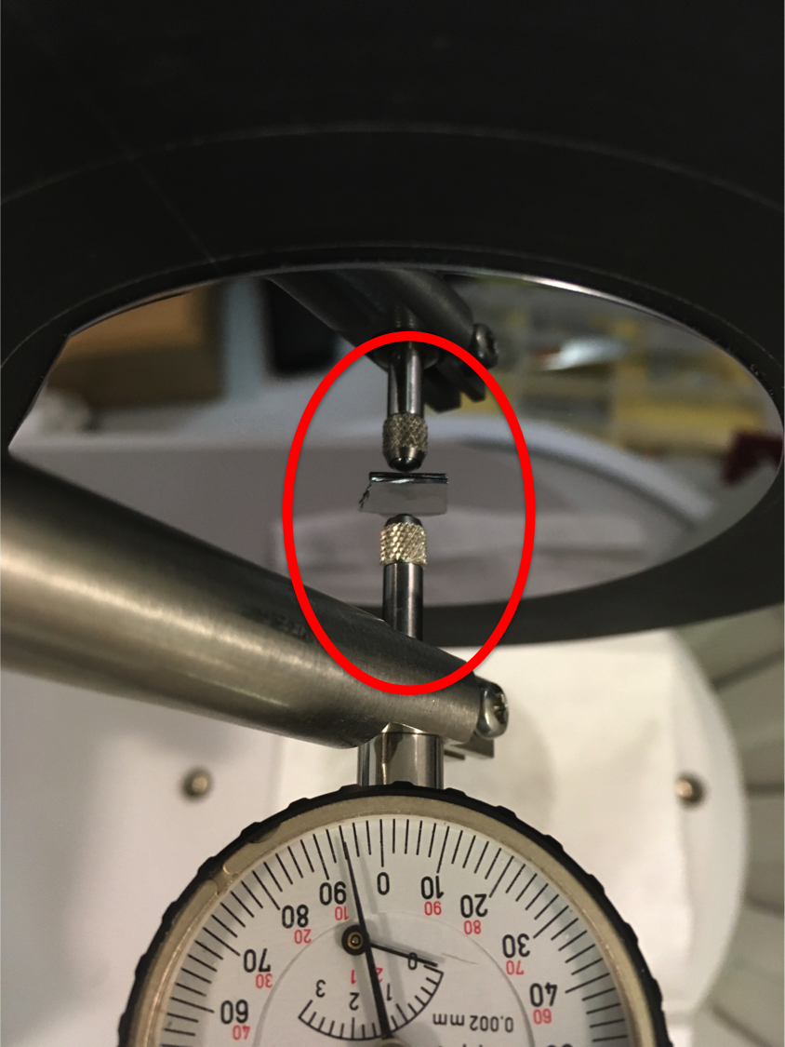
Overview Alignment – top view

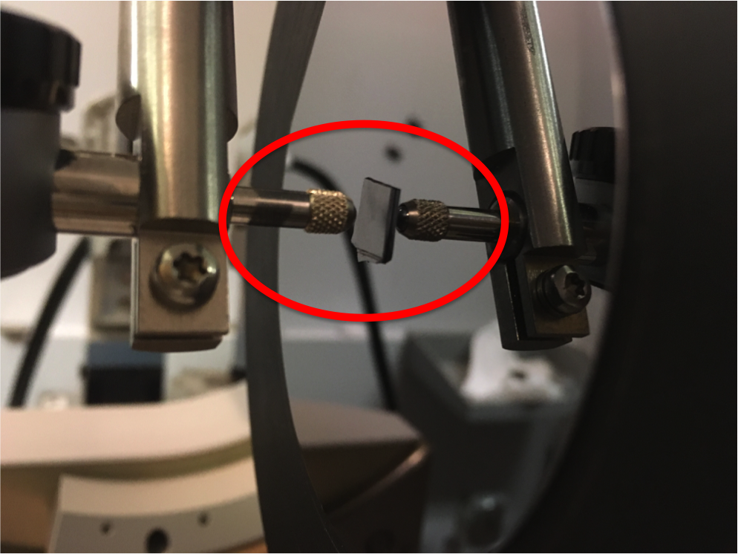
Alignment – side view
It is incredibly important that you insert the correct alignment optics before aligning. If you do not include the attenuator, receiving slit, and divergence slit, you will destroy the detector
- Incident Beam Alignment Optics
  - Insert 0.04 rad Soller slits – push all the way down
  - Insert 1/32nd divergence slit – push down slowly until it clicks (take care not to push too far). The smooth side should face to the left
  - Choose a mask to match the width of the sample. Refer to 0.04 rad Soller Slit, standard column in table “Beam Masks and Irradiated Width for Parallel Beam X-ray Mirrors” on next page – push all the way down, then pull up until it clicks
- Diffracted Beam Alignment Optics
- Insert receiving slit that matches your PPC # - push all the way down, and then pull up a very small amount until it clicks. It only fits in the slot one way, so you can’t put it in the wrong way
- Insert large 0.04 rad Soller slits – push all the way down
- Make sure automatic attenuator is present

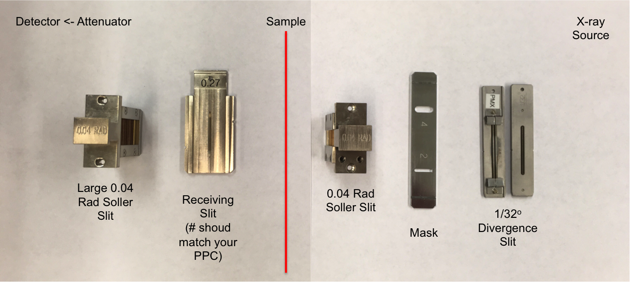

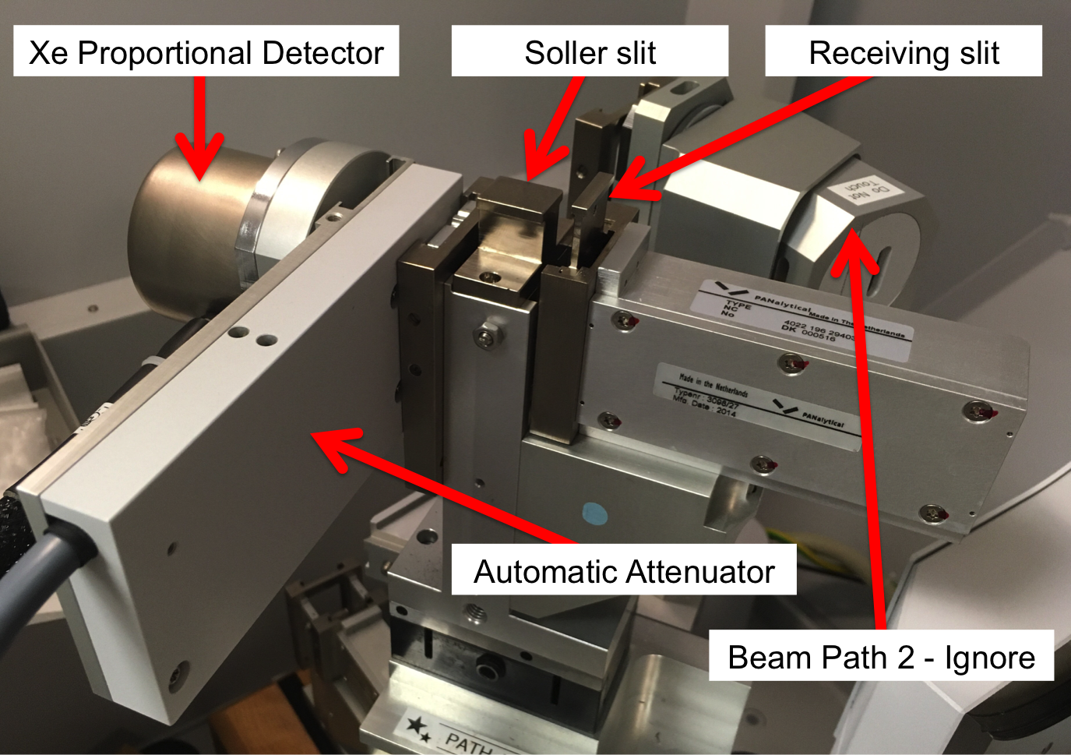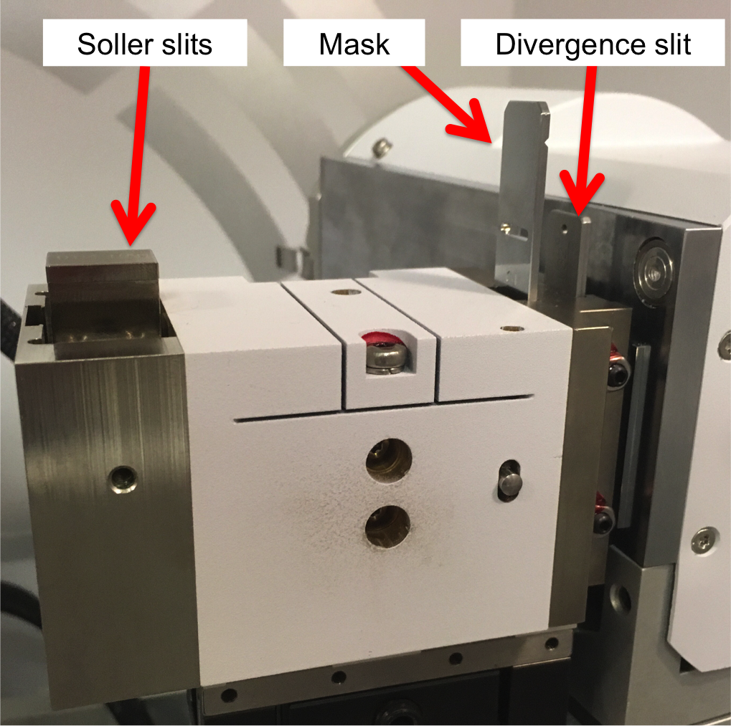

- Using too large of a mask will cause background from the sample holder and possibly cause the X-rays to fall off of your sample

- Entering the Alignment Instrument Configuration into Computer
  - Under Factory Configuration Window, go to Incident Beam Optics tab and double click “Radius”
  - Go through each tab and use drop-down menus to change optics in the computer to match the optics you placed in the XRD in Step 5.
    - PreFIX module = “Mirror Cu W/Si (parabolic MRD)”
    - Divergence slit = fixed slit 1/32º
    - Anti-scatter slit = none
    - Mask = “Fixed mask # mm.” Make sure # matches whatever mask you inserted
    - Soller slit = “Soller slits 0.04 rad”
    - Filter = none
    - Beam attenuator = none
    - Monochromator = none
    - Mirror = “Inc. Beam Cu W/Si (parabolic MRD)” (can’t be changed if you chose the correct PreFIX module in (i) above)
    - Click “OK.” There will be a warning messaging if you changed anything. This just reminds you to make sure the optics in the computer match the optics in the diffractometer. Click “OK.”
  - Under Factory Configuration Window, go to Diffracted Beam Optics tab. Diffracted Beam Path 1 should be activated (yellow light bulb). If it is not, right click on light bulb and click “Activate.”
    - PreFIX module = “Parallel plate collimator 0.27º” or 0.09º (whichever you have)
    - Anti-scatter slit = none
    - Receiving slit = “Parallel plate collimator slit”
    - Filter = none
    - Mask = none
    - Beam attenuator = Prog. Attenuator Ni 0.125 mm *****Incredibly important
      - Usage = “Do not switch” that you do this
      - Check the Activated box correctly!*****
    - Detector = “Proportional detector Xe[2]”
    - Collimator = “Parallel plate collimator 0.27º” or 0.09º (whichever you have)
    - Monochromator = none
    - Soller Slit = “Large Soller slits 0.04 rad”
    - Click “OK.” There will be a warning messaging. This just reminds you to make sure the optics in the computer match the optics in the XRD. Click “OK.”
- Zero-Beam (2θ) Alignment Procedure
  - Measure Manual Scan
    - Scan Axis: 2Theta
    - Range: 0.25
    - Step size: 0.0025 (always use 1/100th of the Range for Alignment)
    - Time per step: 0.2
  - After scan, right click on scan window and select “Peak Mode.” Next, click “Move To” to make the program move to the center of the peak. This will move 2Theta to this position. Click “Closed”
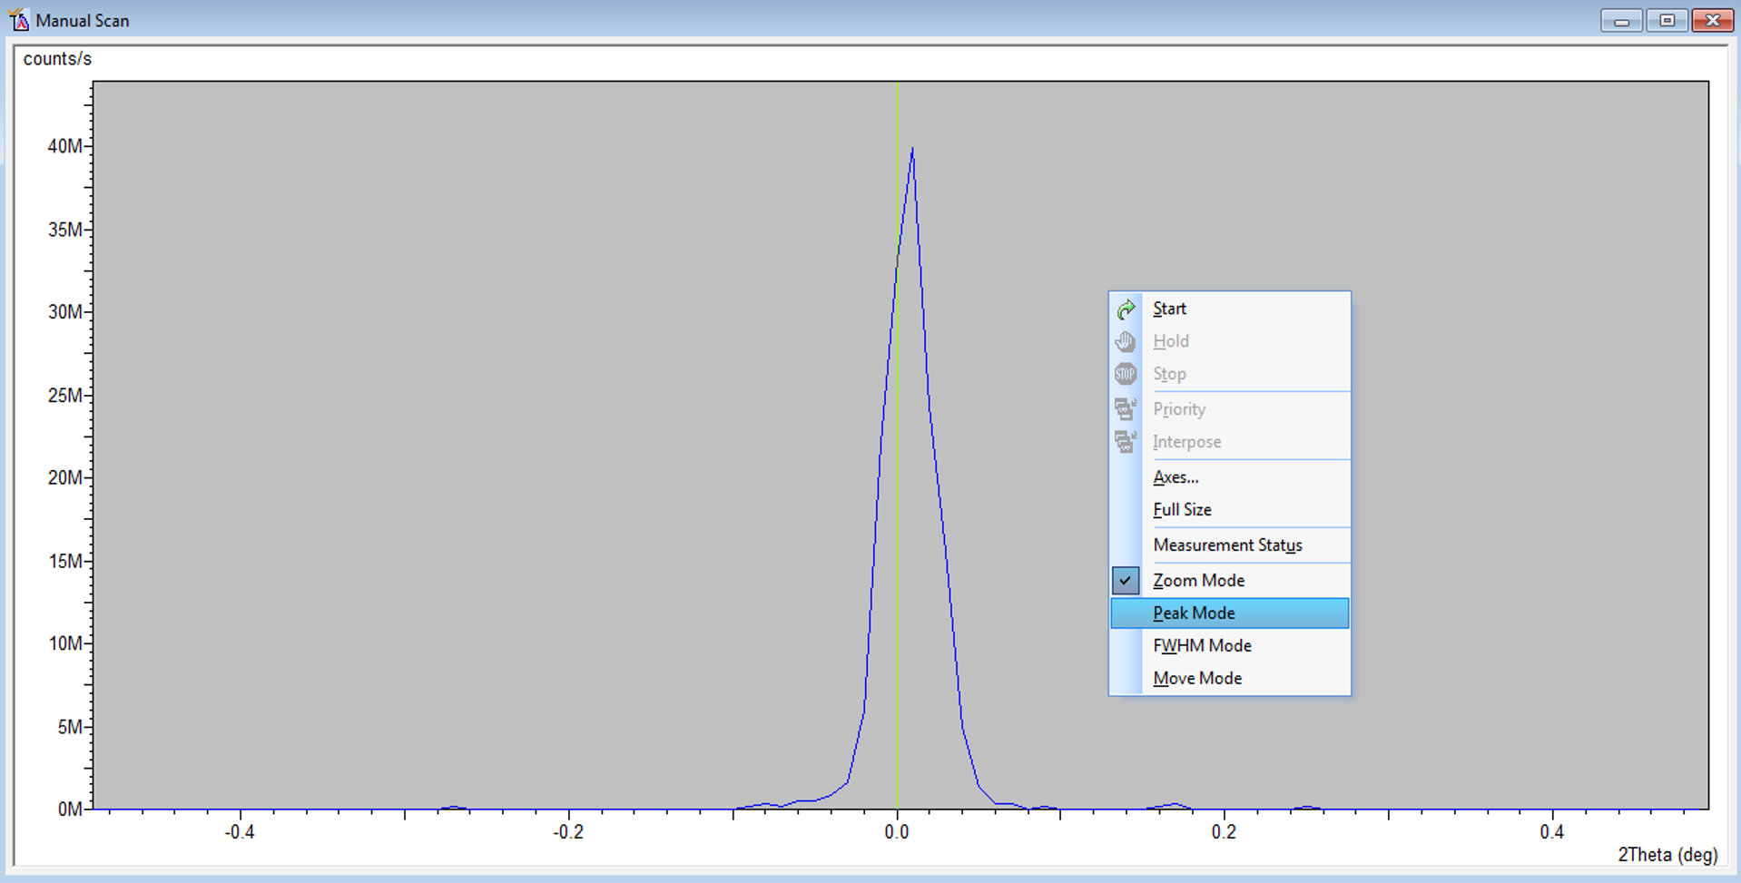
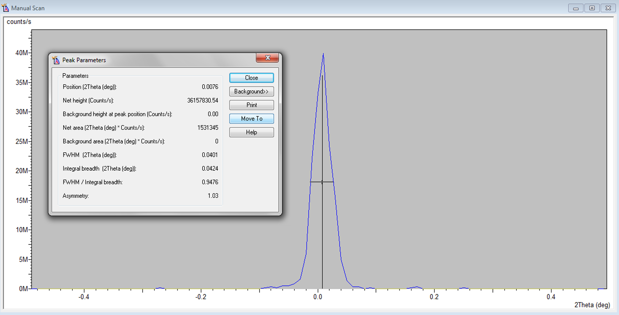
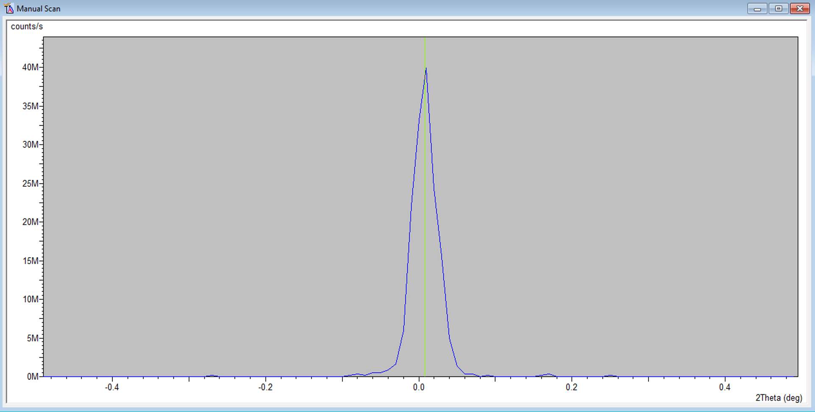

- User Settings Fine Calibration Offsets
  - Click “Set New = 0”
  - Click OK
- Z Alignment Procedure
  - Under Factory Configuration Window, go to Instrument Settings Window and double click on “Z=0.000 mm”
  - Change Z to 5.5 mm and click “OK”
  - Measure Manual Scan (unless Prepare Manual Scan window is already open)
    - Scan Axis: Z
    - Range: 10
    - Step size: 0.1 (always use 1/100th of the Range for Alignment)
    - Time per step: 0.2
  - After scan, right click on scan window and select “Move Mode.” Move the line to half the maximum intensity (see below). This will move Z to this position.

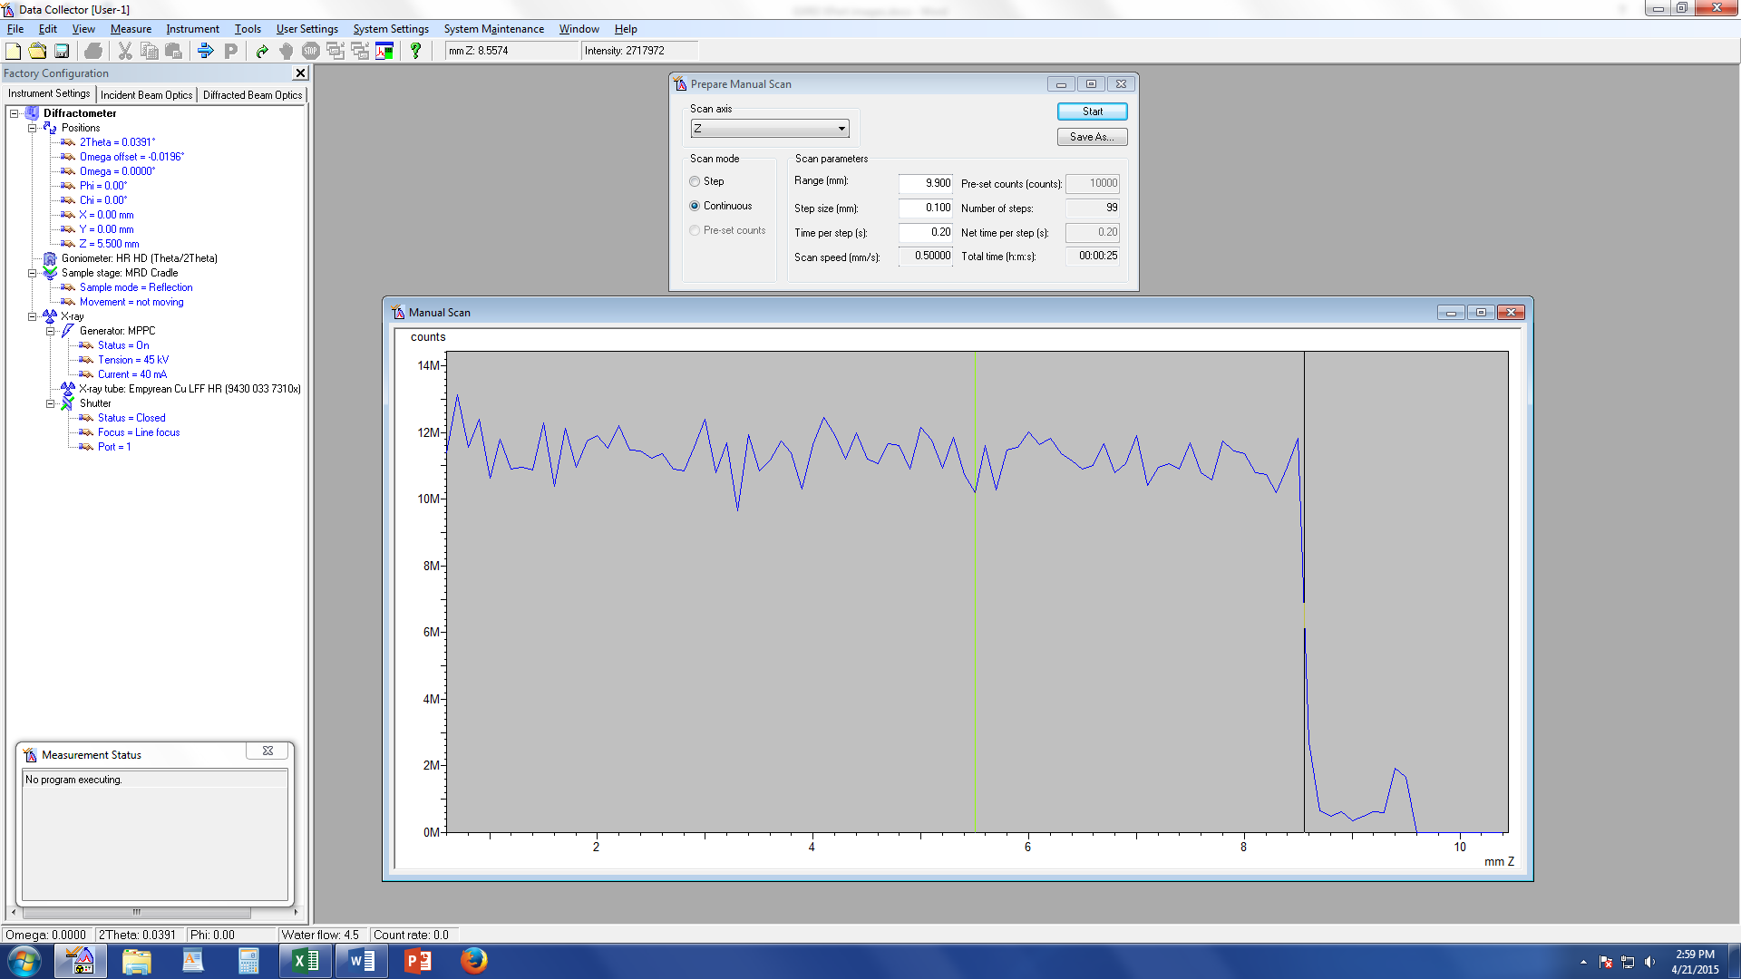

  - Measure Manual Scan (unless Prepare Manual Scan window is already open)
    - Scan Axis: Z
    - Range: 1 We are scanning over a smaller range to refine the Z position
    - Step size: 0.01 (always use 1/100th of the Range for Alignment)
    - Time per step: 0.2
  - After scan, right click on scan window and select “Move Mode.” Move the line to half the maximum intensity. This will move Z to this position.
- ω Alignment Procedure
  - Measure Manual Scan (unless Prepare Manual Scan window is already open)
    - Scan Axis: Omega
    - Range: 1
    - Step size: 0.01 (always use 1/100th of the Range for Alignment)
    - Time per step: 0.2
  - After scan, right click on scan window and select “Move Mode.” Move the cursor to the center of the peak and release. This will move omega to this position.
  - If the Range of 1 is too small and you just see a flat line, change Range to 3 and Step Size to 0.03.
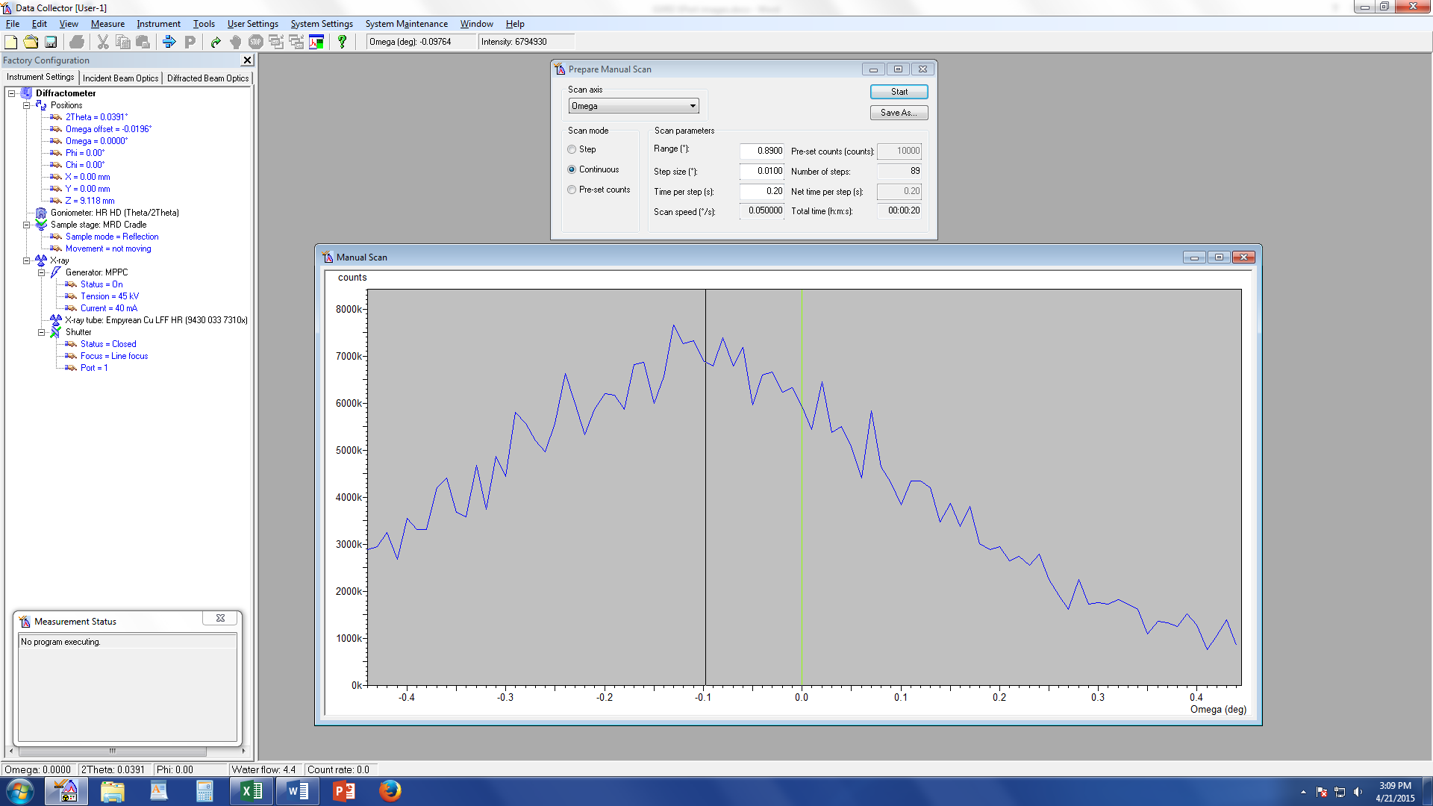
- Repeat Steps 10 & 11 until Z and ω reach their equilibrium values and no longer change. This means the sample is aligned flat with respect to the beam.
- Close all scan windows

- User Settings Sample Offsets
  - ω should be the only angle that has a non-zero current position (a)
  - Put “0” for ω (b), then hit “tab” button on keyboard (c)
  - Click OK

(a) (b) (c)

- Incident Beam Measurement Optics
  - The optics need to be changed from alignment optics to measurement optics
  - Choose a divergence slit such that the beam does not exceed the length of the sample at the lowest grazing angle (determined in Step 1). Refer to Excel spreadsheet “Foot print vs. omega.xlsx.” Push down only until it clicks. If it goes too far and gets stuck, call Michael Koehler (865-256-4951).
  - Keep 0.04 Soller Slit
- Diffracted Beam Measurement Optics
  - Remove PPC slit
  - Keep large 0.04 Soller Slit
- Update the computer with the new hardware settings
  - Under Factory Configuration Window, go to Incident Beam Optics tab and double click any blue words/numbers. Everything should be the same as the alignment settings except
    - Make sure that you change the divergence slit and mask to the options that you installed
  - Under Factory Configuration Window, go to Diffracted Beam Optics tab and double click any blue words/numbers. Everything should be the same as the alignment settings except
    - Receiving slit = none
    - Attenuator = Prog. Attenuator Ni 0.125 mm
      - Usage = At Pre-Set Intensity
      - Activate at 500,000 counts/sec
      - Deactivate at 400,000 counts/sec
- Write Quick Scan Program
  - Do the following to run a quick scan to make sure the data look ok
  - Click “Open Program” icon
  - Click the “Browse” button and select the program you want to run/modify. Click “Open”
  - Change Start, End, Step Size and Time per step values to accommodate your sample (example is shown below). Total time should be <10 min for a quick scan. Do not start below 5º.
    - Start: 10
    - End: 90
    - Step size: 0.02
    - Time per step: 0.10
  - Click “x” to close the window. It will say, “Do you want to save the changes?” Click “yes”
  - Measure Program
  - Click “Browse” and open your program.
  - Click the Folder icon and change the location where you want to save the file and the filename. All data should be saved on the C drive in the XRD Data Users folder.
  - Press “Ok” and the program will begin to run.
- Write Data Collection Program
  - Click “Open Program” icon.
  - Click “Browse” and choose the GIXRD program from your folder.
  - Choose the Start and End Angles (generally 10-90, but don’t go below 5 deg).
  - Choose Step Size (usually ~0.02 deg).
  - Time per step.
  - Save the program file.
- Save a program for each grazing angle
  - Change the grazing angle (Omega) in the program you made in Step 18.
  - Save a different program file for each grazing angle, e.g. “GXRD-10-100-2 Omega” for a grazing angle of 2 degrees.
- Batch Files
  - Batch files allow you to run multiple programs (the ones you may have set up in step 19) in succession without the need to run them individually. This is a great feature to use when you are performing GIXRD experiments with multiple grazing angles. There are many options that you can change when setting up a batch file, so it is probably best to meet with the lab manager so that we can go over batch files together and determine which method for setting them up will work best for you.
- Running a single measurement program
  - If you are only going to run a single measurement program, go to Measure Program Browse, and open your program.
  - Click the folder icon Browse to select the save location and filename. Click Save.
  - Click OK to begin the measurement.
- When finished with measurements
  - Return the system to idle state (45 kV and 20 mA) in the “X-ray” tab (no need to go down in steps of 5 mA, just go straight to 20 mA)
  - Click Instrument Disconnect
  - Click OK in the next dialogue box
  - Wait 5 or 10 seconds after disconnecting, and then close the Data Collector.

