Sample Requirements: If dealing with a powder, you can analyze it in a loose form or pellet form. If you will be testing a pellet or solid “chunk” of material, it should not be more than 7 mm tall.

- Remove the alumina ring from the top of the sample holder (see Figure 1). This is very brittle, so be careful!
- Choose an alumina sample holder that is appropriate for your sample (thicker samples should use a deeper well sample holder) and place it on top of the sample stage (from where you removed the ceramic ring). If your sample falls below the rim of the holder, choose a shallower holder
- For a pellet…
  - Place the sample holder on top of the sample stage
  - Loosely set the ceramic ring on top of the sample holder (see Figure 2)
  - Gently push down on the ceramic securing ring (see Figure 3)
  - Place your sample in the center of the sample holder
- For a powder…
  - Fill the sample holder with your powder
  - Press down on the powder with a glass slide to make it flat. Pull the slide off of the sample holder, don’t lift it straight up
  - Clean the sides and bottom of the sample holder (Q-tips work well) so that there is no loose powder that will touch the sample stage or securing ring
  - Place the sample holder on top of the sample stage
  - Loosely set the ceramic securing ring on top of the sample holder (see Figure 2)
  - Gently push down on the ceramic ring (see Figure 3)
- Figure 4 shows what it looks like when the ring is in the correct position

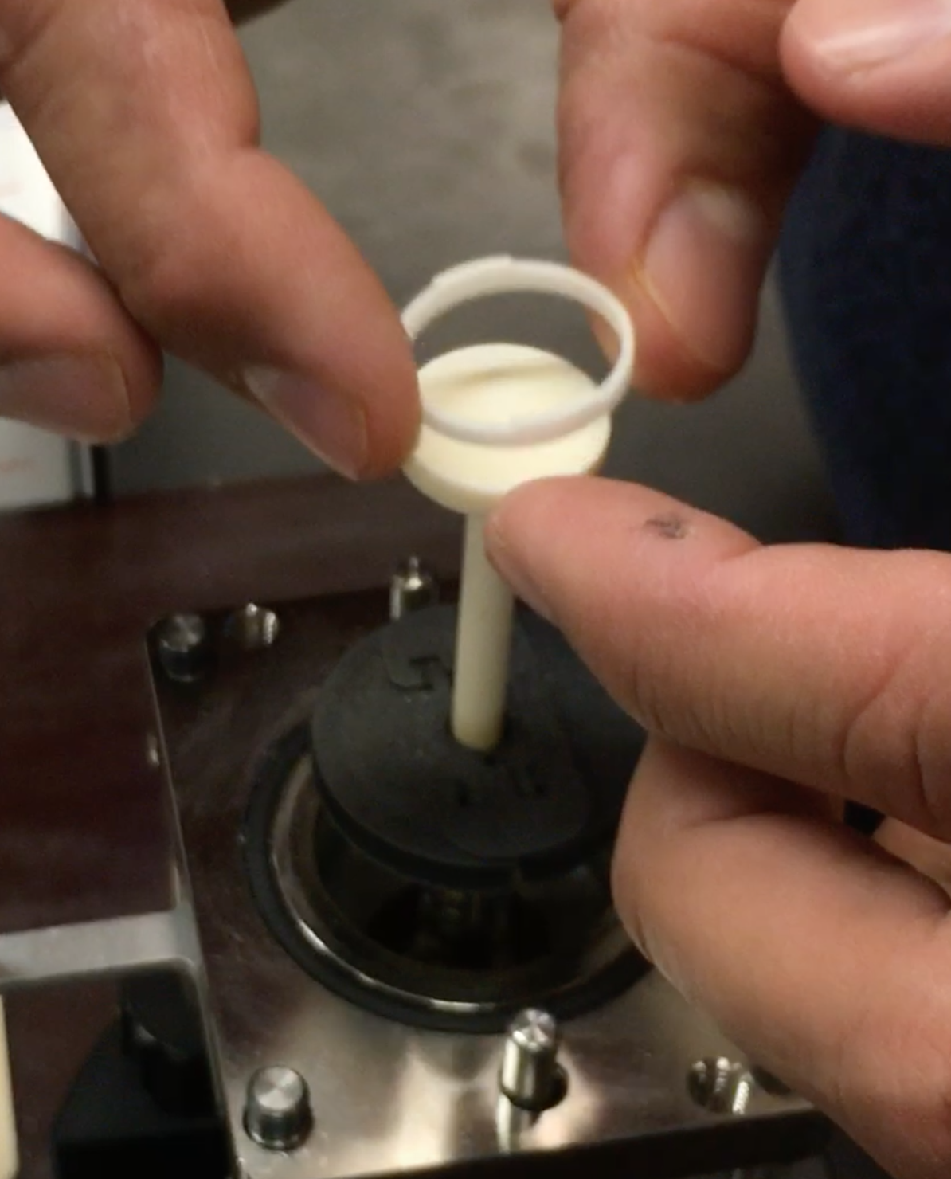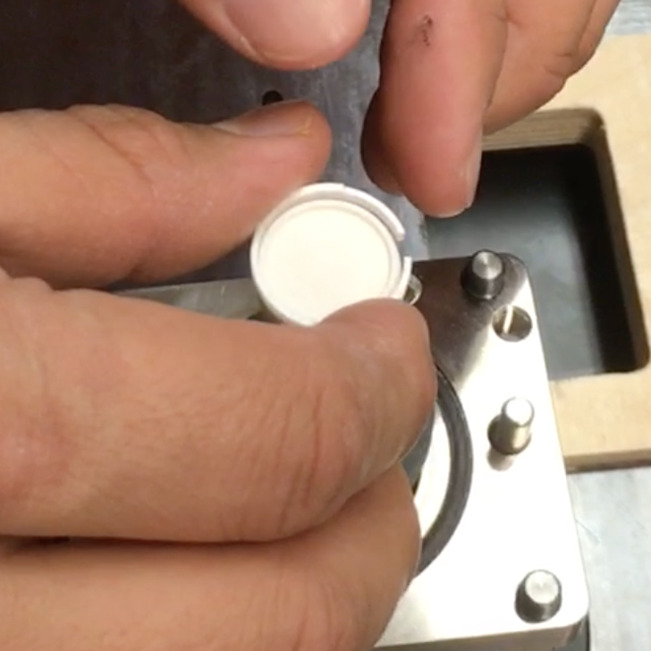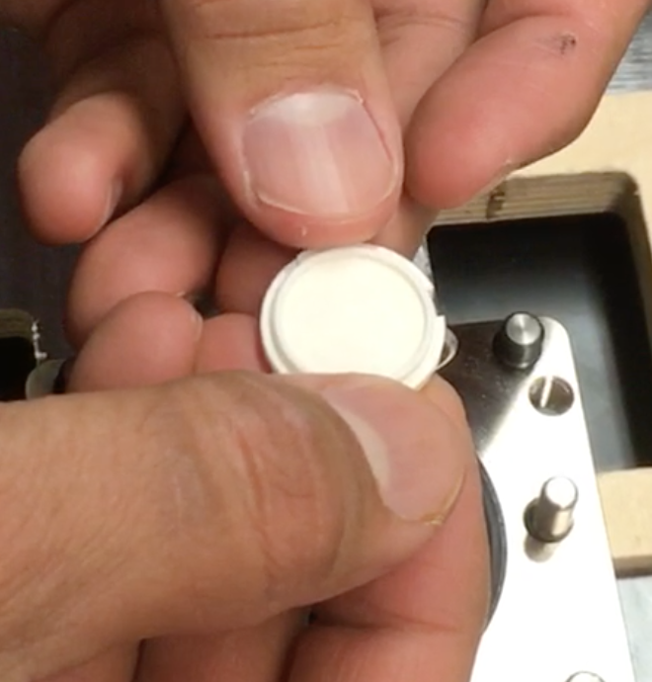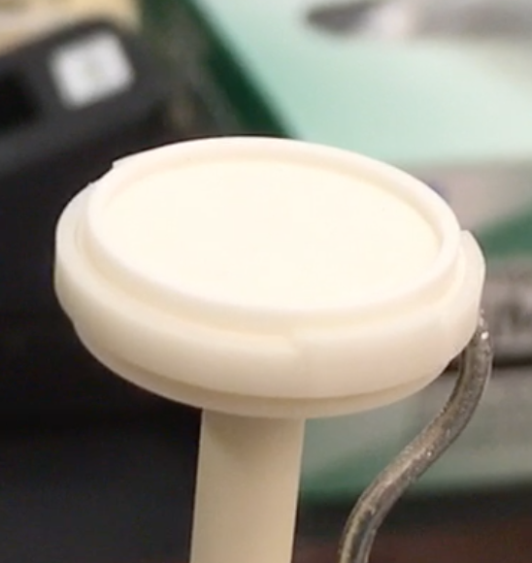
Figure 1 Figure 2 Figure 3 Figure 4

- Carry the whole sample stage holder to the Empyrean and place it below the oven. Make sure that the piece indicated with an arrow in Figure 5 is toward the back of the instrument
- Lift the sample holder to the oven. Looking at Figure 6, make sure that the two rods go into the two holes (you don’t need to look at the sample to make sure it is going into the oven)
- Slide the sample holder all the way up (see Figure 7) and very gently tighten the four screws (one of which is shown in Figure 7). Remember, when tightening, start with one, and then tighten the one opposite along the diagonal. This is a best practice for vacuum systems. Keep going to each of the four screws, tightening a bit each time. Do not apply a large amount of force to keep tightening.
- Now connect the thermocouple cable (orange), as shown in Figure 8, making sure that the cable is positioned so that the lines from the X-ray source will not pull it as the source rotates upwards (see Figure 9)
- Turn on the temperature controller, wait for the temperature to appear on the controller screen, then hit the “Heater” button to stop the light by “Heater” from flashing

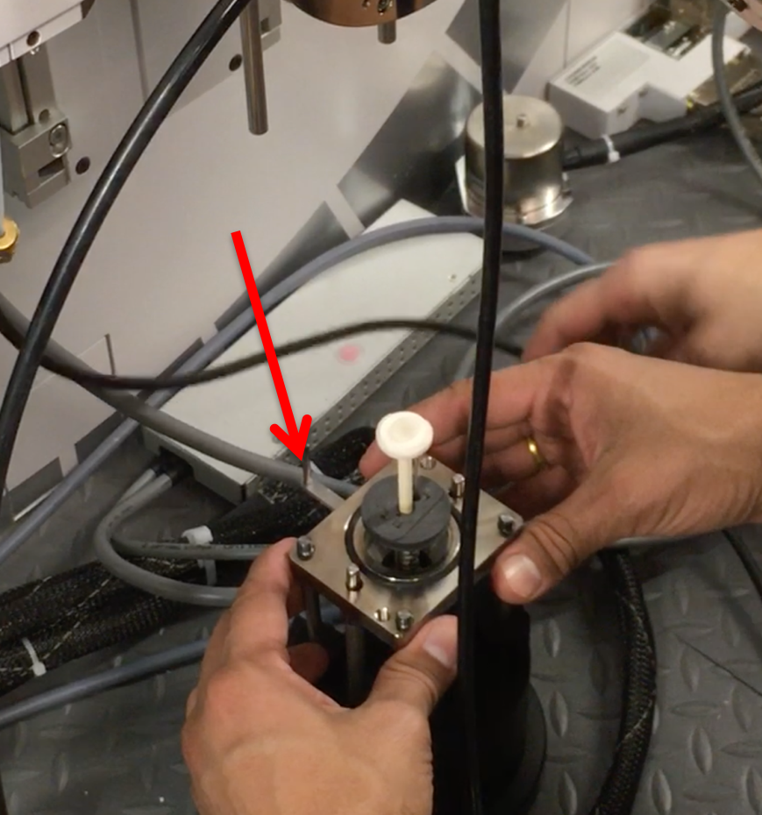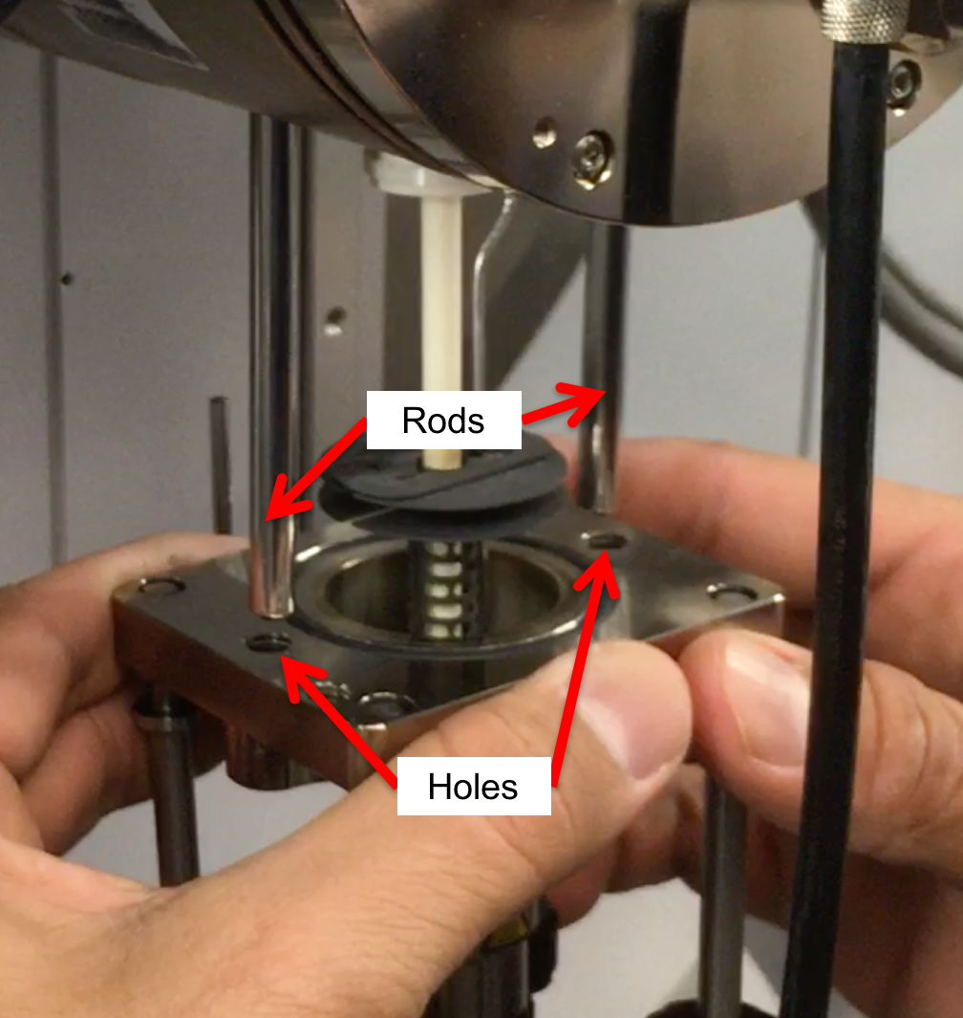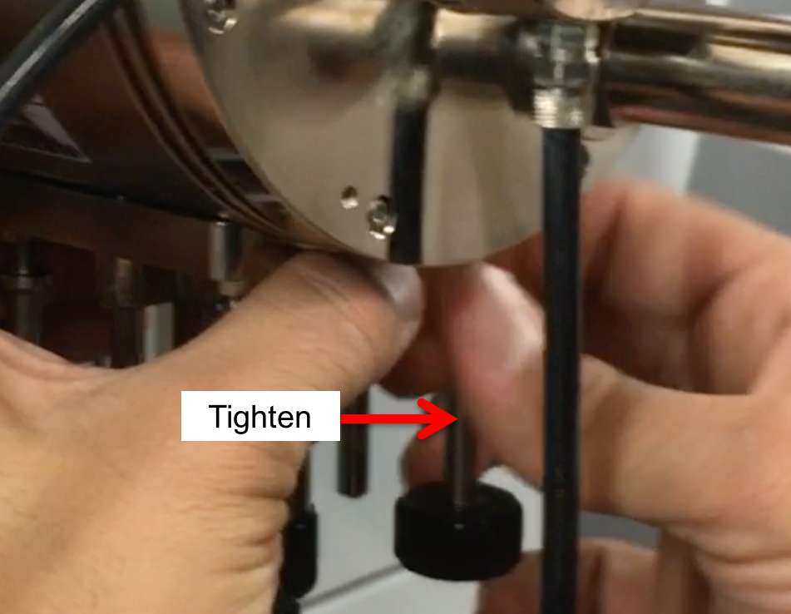
Figure 5 Figure 6 Figure 7

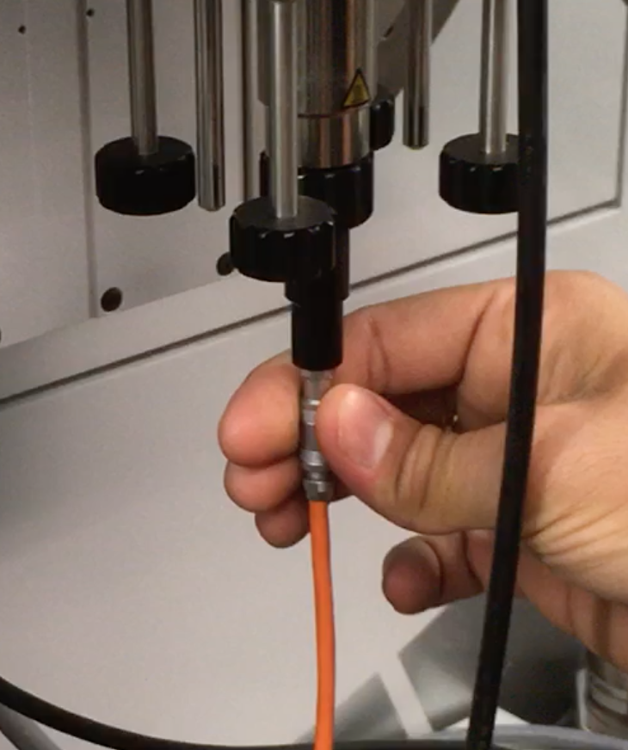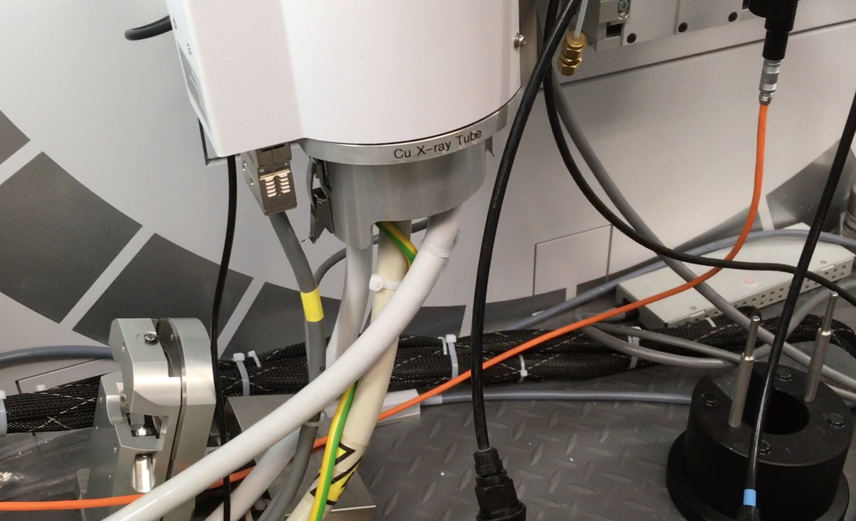
Figure 8 Figure 9

- If the computer and temperature controller are not connected (see “Connection Status” in Figure 10), then go to Tools Controller Connection and click the box next to “Connect” to put a checkmark in it. The connection status should then change
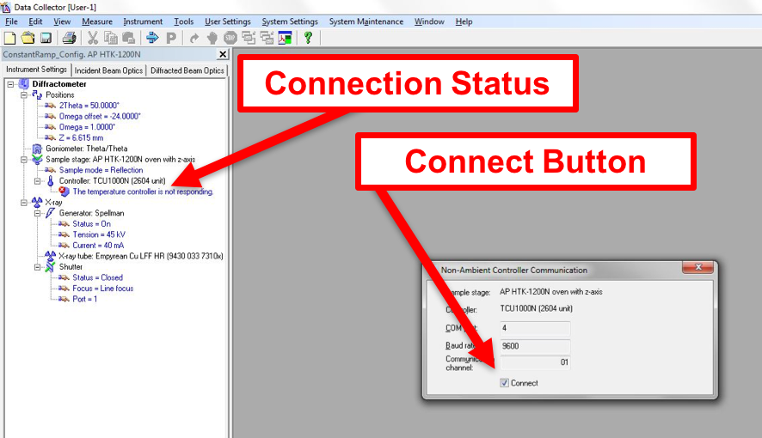
Figure 10

Alignment Optics
- With the system in the configuration that you want it (either with the pump or just the oven), the next step is to insert an attenuator (Cu 0.1) next to the Soller slits in the PDS module (incident side)
- Insert the 1/16º antiscatter slit and whichever Soller slits and mask you want to use for your experiment
- Under Incident Beam Optics, double click on “Radius”
  - Go through each of the tabs in the pop-up window and enter the optics you placed in the system
    - PreFIX module = “Progr. Divergence slit with anti-scatter slit.” Don’t change the offsets
    - Divergence slit = fixed slit 1/32º
    - Anti-scatter slit = fixed slit 1/16º
    - Mask = “Fixed incident beam mask # mm,” # = whichever mask you have installed
    - Mirror = none
    - Beam knife = none
    - Soller slit = “Soller slits 0.0# rad,” # = whichever Soller slit you have installed
    - Filter = none
    - Beam attenuator = “Beam attenuator mirror Cu 0.1 mm”
      - Attenuation Factor Click “Select”
        - Choose the second line, the one with the factor of 110
        - Click OK
      - Usage = “Do not switch”
      - Make sure the Activated box is checked
    - Monochromator = none
    - Click “OK.” There may be a warning message. This just reminds you to make sure the optics in the computer match the optics in the XRD. Click “OK.” You should get another message telling you to insert the attenuator. Just click “OK” again
  - Under the “Diffracted Beam Optics” tab, double click on “Radius”
  - Go through each of the tabs in the pop-up window and enter the optics you placed in the system
    - PreFIX Module = “PIXcel3D-Medipix3 1x1 with FASS” (don’t change offsets)
    - Anti-scatter Slit = “AS slit 5.0 mm (PIXcel Non Ambient & MRD)”
    - Receiving slit = “none”
    - Filter = “Beta-filter Nickel”
    - Beam Attenuator = “none”
    - Detector =
      - Type = “PIXcel3D-Medpix3 1x1 detector[1]”
      - Usage = “Receiving slit (0D)”
      - Active length = “0.165”
      - Active channels = “3”
      - Used wavelength = K-Alpha1
    - Collimator = “None”
    - Soller slit = “Large Soller slits 0.0# rad,” # = whichever Soller slit you have installed
    - Mask = “none”
    - Click “OK.” There may be a warning message. This just reminds you to make sure the optics in the computer match the optics in the XRD. Click “OK”
  - Go to Instrument Settings tab, double click on any blue letters/numbers, go to Position, set everything to zero. Click OK.
- Zero-Beam (2θ) Alignment Procedure
  - Measure Manual Scan
    - Scan Axis: 2Theta
    - Range: 0.25
    - Step size: 0.0025 (always use 1/100th of the Range for Alignment)
    - Time per step: 0.2
  - After scan, right click on scan window and select “Peak Mode.” Next, click “Move To” to make the program move to the center of the peak. This will move 2Theta to this position. Click “Close”
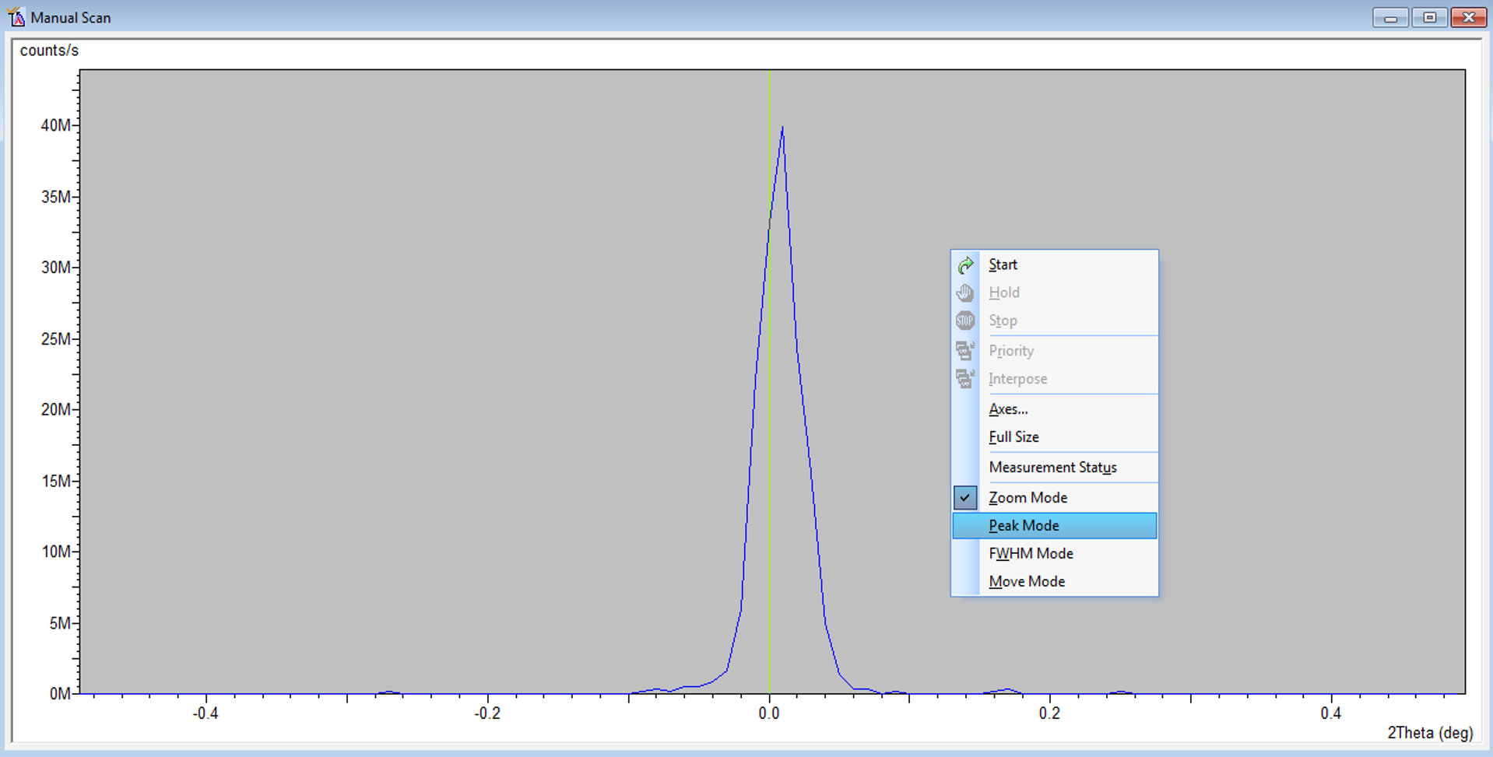
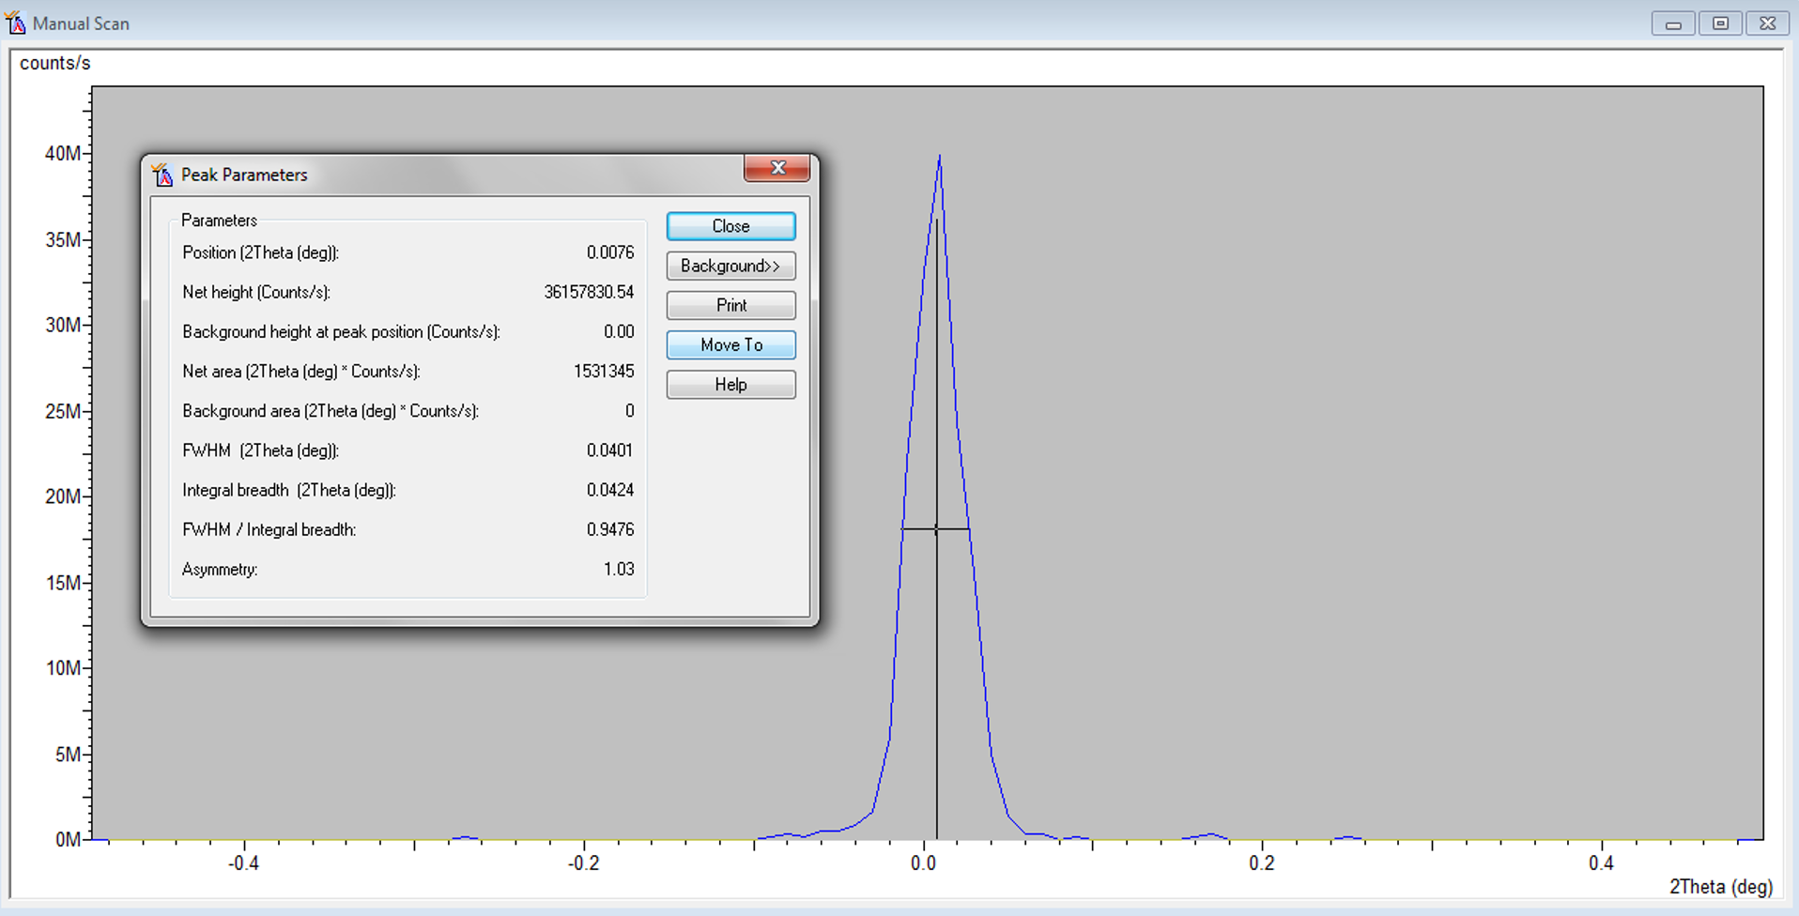
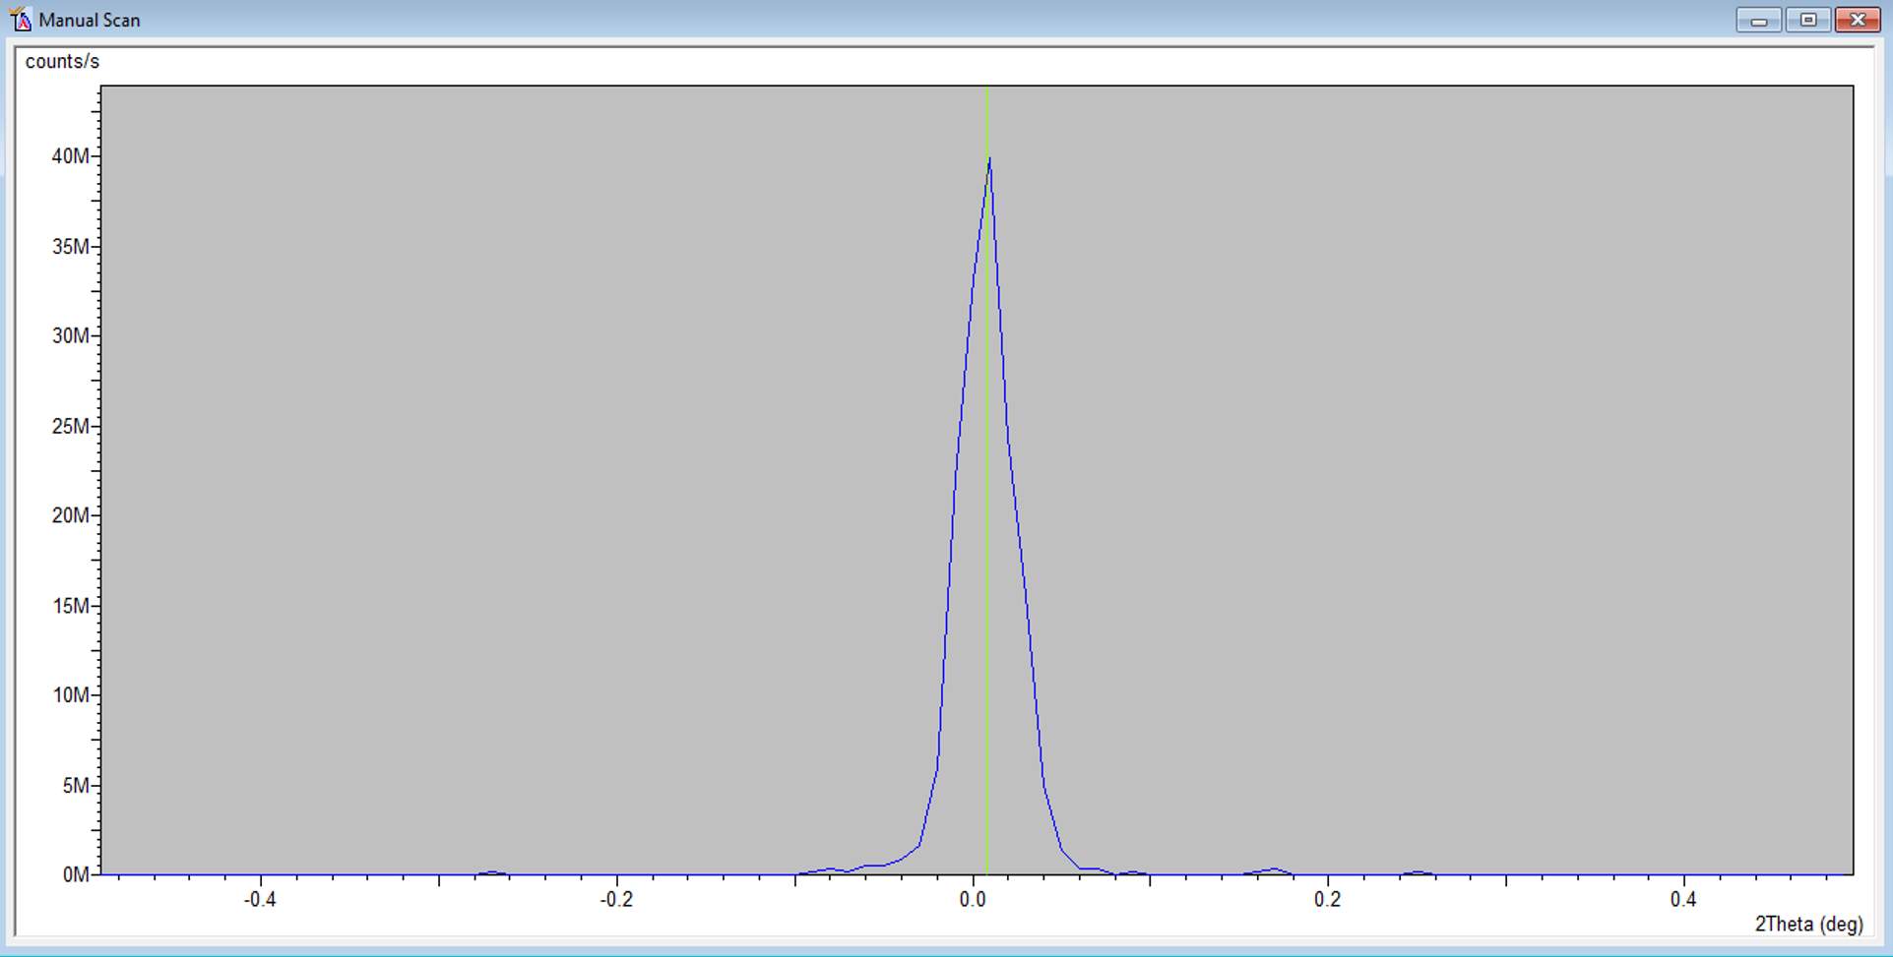

- User Settings Fine Calibration Offsets
  - Click “Set New = 0”
  - Click OK
- Rough Z Alignment (if you already know the approximate Z location, go to Instrument Settings, enter that value, and skip to step 7)
  - Under Factory Configuration Window, go to Instrument Settings Window and double click on “Z=0.000 mm”
  - Change Z to 5.5 mm and click “OK”
  - Measure Manual Scan (unless Prepare Manual Scan window is already open)
    - Scan Axis: Z
    - Range: 10
    - Step size: 0.1 (always use 1/100th of the Range for Alignment)
    - Time per step: 0.2
  - After the scan, right click on scan window and select “Move Mode.” Move the line to half the maximum intensity (see below). This will move Z to this position.

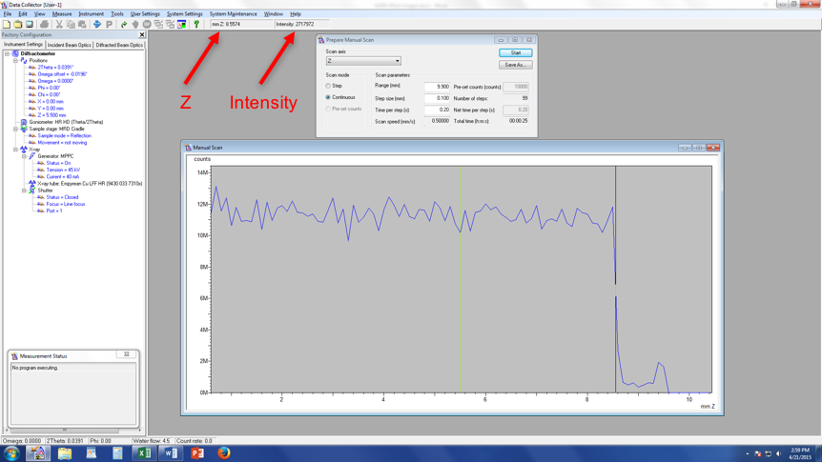

- Fine Z Alignment
    - Scan Axis: Z
    - Range: 1 We are scanning over a smaller range to refine the Z position
    - Step size: 0.01 (always use 1/100th of the Range for Alignment)
    - Time per step: 0.2
  - After the scan, zoom in on the approximately correct position. Place your cursor on the blue line so that it is at half of the maximum intensity (in the above example, the cursor should be a little below 6M counts). Instead of just estimating the half-intensity position, use the intensity readout found below “Help” at the top of the screen (see figure above)
  - Note the corresponding Z position (see figure above)
  - In “Instrument Settings,” change the Z position to the value from step c

- ω Alignment Procedure
  - Measure Manual Scan (unless Prepare Manual Scan window is already open)
    - Scan Axis: Omega
    - Range: 3
    - Step size: 0.03 (always use 1/100th of the Range for Alignment)
    - Time per step: 0.2
  - After the scan, right click on scan window and select “Peak Mode.” Next, click “Move To” to make the program move to the center of the peak. This will move Omega to this position. Click “Close”
- Repeat Steps 7 & 8 until Z and ω reach their equilibrium values and no longer change. This means the sample is aligned flat with respect to the beam.

- User Settings Sample Offsets
  - In the “Current position” column, (a) highlight the value for omega, (b) make that value 0, (c) hit “Tab” on the keyboard to see the “Sample offset” change, and then click OK

(a) (b) (c)

- Change Hardware to Measurement Optics
  - Remove the attenuator from beside the Soller slits on the incident side
  - Change the anti-scatter slit to be 2x whatever you want your divergence slit to be
- Enter Measurement Optics into Computer
  - Under Incident Beam Optics tab, double click on “Radius”
    - Go through each of the tabs in the pop-up window and enter the optics you placed in the system.
      - PreFIX module = “Progr. Divergence slit with anti-scatter slit.” Don’t change the offsets
      - Divergence slit = fixed slit 1/#º , # = whichever slit you want
      - Anti-scatter slit = fixed slit 1/#º , # = whichever slit you have installed (should be 2x the divergence slit)
      - Mask = “Fixed incident beam mask # mm,” # = whichever mask you have installed
      - Mirror = none
      - Beam knife = none
      - Soller slit = “Soller slits 0.0# rad,” # = whichever Soller slit you have installed
      - Filter = “Beta-filter Nickel”
      - Beam attenuator = none
      - Monochromator = none
      - Click “OK.” There may be a warning message. This just reminds you to make sure the optics in the computer match the optics in the XRD. Click “OK”
  - Under the “Diffracted Beam Optics” tab, double click on “Radius”
  - Go through each of the tabs in the pop-up window and enter the optics you placed in the system in Step 7.
    - PreFIX Module = “PIXcel3D-Medipix3 1x1 with FASS” (don’t change offsets)
    - Anti-scatter Slit = “AS slit 5.0 mm (PIXcel Non Ambient & MRD)”
    - Receiving slit = “none”
    - Filter = “none”
    - Beam Attenuator = “none”
    - Detector =
      - For GIXRD using the PIXcel
        - Type = “PIXcel3D-Medpix3 1x1 detector[1]”
        - Usage = “Scanning line detector (1D)”
        - Active length = “3.3482”
        - Active channels = “255”
        - Used wavelength = K-Alpha1
    - Collimator = “None”
    - Soller slit = “Large Soller slits 0.0# rad,” # = whichever Soller slit you have installed
    - Mask = “none”
    - Click “OK.” There may be a warning message. This just reminds you to make sure the optics in the computer match the optics in the XRD. Click “OK”
  - Go to Instrument Settings tab, double click on any blue letters/numbers, go to Position, set everything to zero. Click OK.
- Account for thermal expansion of sample holder
  - You can close the manual scan window
  - Go to instrument settings double click any blue Sample Stage tab Select automatic height control mode = “AP HTK-1200N Oven (air)” or “AP HTK-1200N Oven (vacuum),” depending upon what atmosphere you are using (if using gas, just use the air option) click OK. See Figure 11. This locks the Z in place and also takes into account the thermal expansion of the alumina holder on which the sample is sitting
  - Make sure you check the status of the automatic height adjustment after setting as described above. It should say “Active” (see Figure 12). If it says “Not Active,” let the lab manager (Michael Koehler) know. This happens very rarely, but you want to make sure you catch it if it does
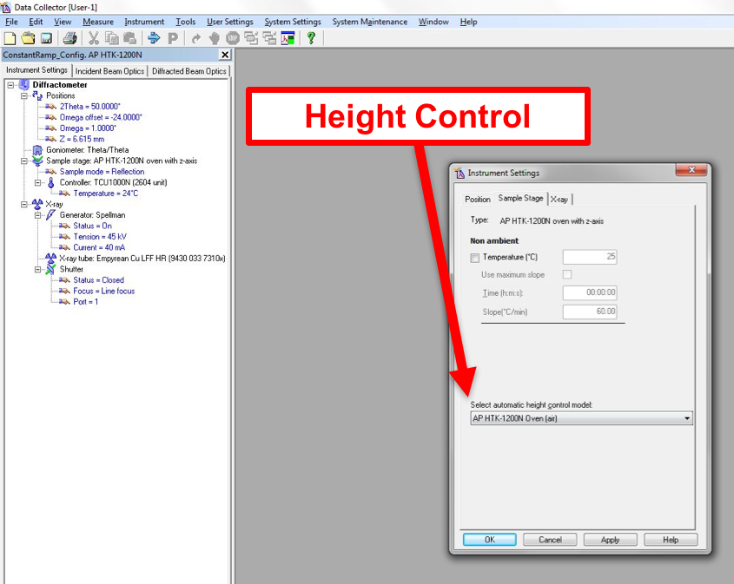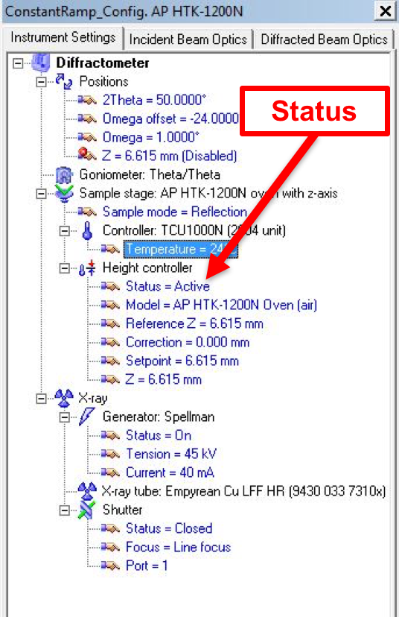
Figure 11 Figure 12

- Modify and/or start your measurement program
  - If you need to modify an old program, go to File Open, click Browse, and find either your single scan file or batch file. Modify as needed.
  - Some information about modifying batch files (we likely created one together the first time you performed HTXRD, so just modify that as needed)
    - If you want to change the setting of a certain row, just double click it
    - Whenever you insert a new row, it will be arranged above whichever row is currently highlighted black
    - Insert options
      - Measurement Program (Figure 13) – this is used to insert an individual scan program that you have already made. You don’t need to worry about the data file settings, we will take care of that later. Just insert your program with the “Browse” button
      - Non-ambient Setting (Figure 14) – this is used to change the temperature. You can enter either the amount of time you want the change to take or you can enter the rate
      - Timer Setting (Figure 15) – this is used to tell the program to wait for a specified length of time. You’ll probably want to wait about 10 minutes (as shown in the figure) to allow the system to reach equilibrium

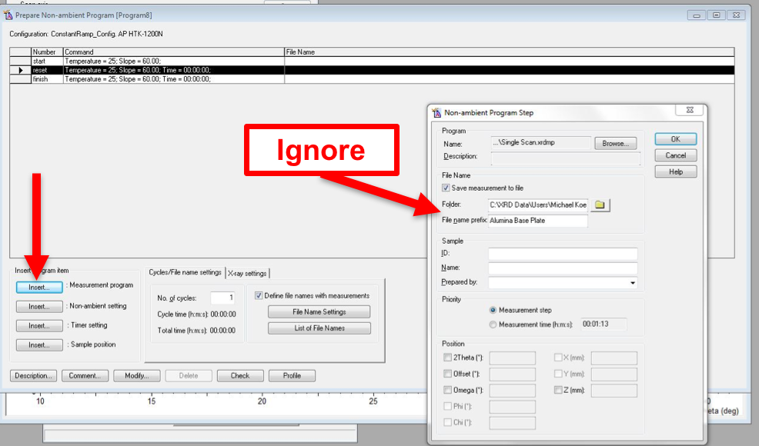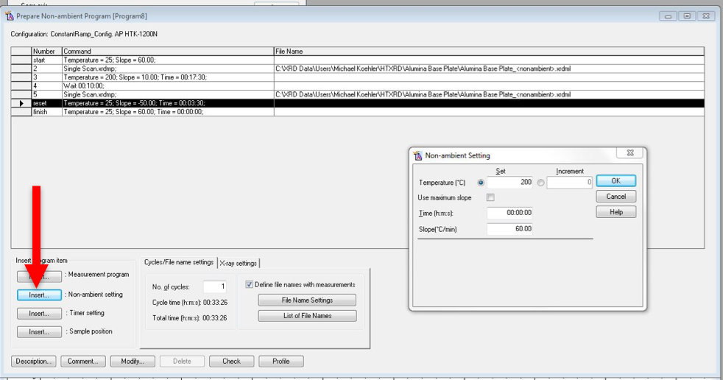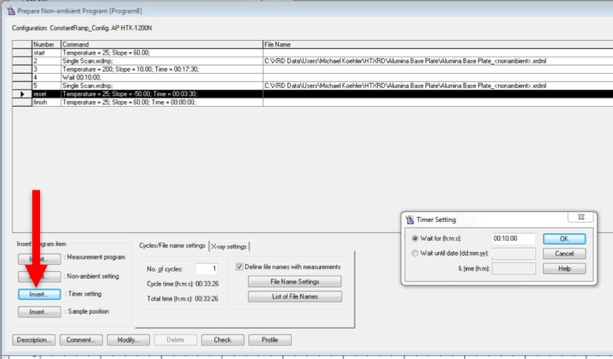
Figure 13: Measurement Figure 14: Non-ambient Figure 15: Timer Setting
    - File Name Settings (Figure 16)
      - This button allows you to change all file names in your batch file. You can change the folder that all data files will be saved in (“Folder” in Figure 16) and the beginning of all file names (“Prefix” in Figure 16)
      - If you place a checkmark in the box labeled “Item #” in Figure 16, it will enter the row number into each scan name (I recommend this). In the batch program window, it will look like “I2” for the second row
      - If you place a checkmark in the box labeled “Temperature” in Figure 16, it will enter the temperature at which the pattern was collected in the scan name (I recommend this). In the batch program window, it will look like “<nonambient>” but will show the actual temperature once the data file is saved
      - Clicking the “Profile” button at the bottom of the batch program window will show you the temperature profile of your experiment (e.g., Figure 17). Yellow represents data collection, and blue represents temperature change and waiting

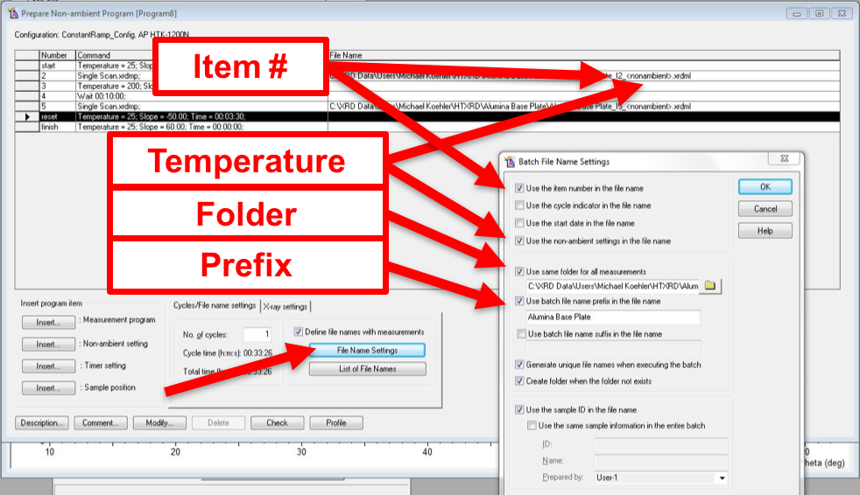
Figure 16: File Name Settings Figure 17: Profile

Appendix 1

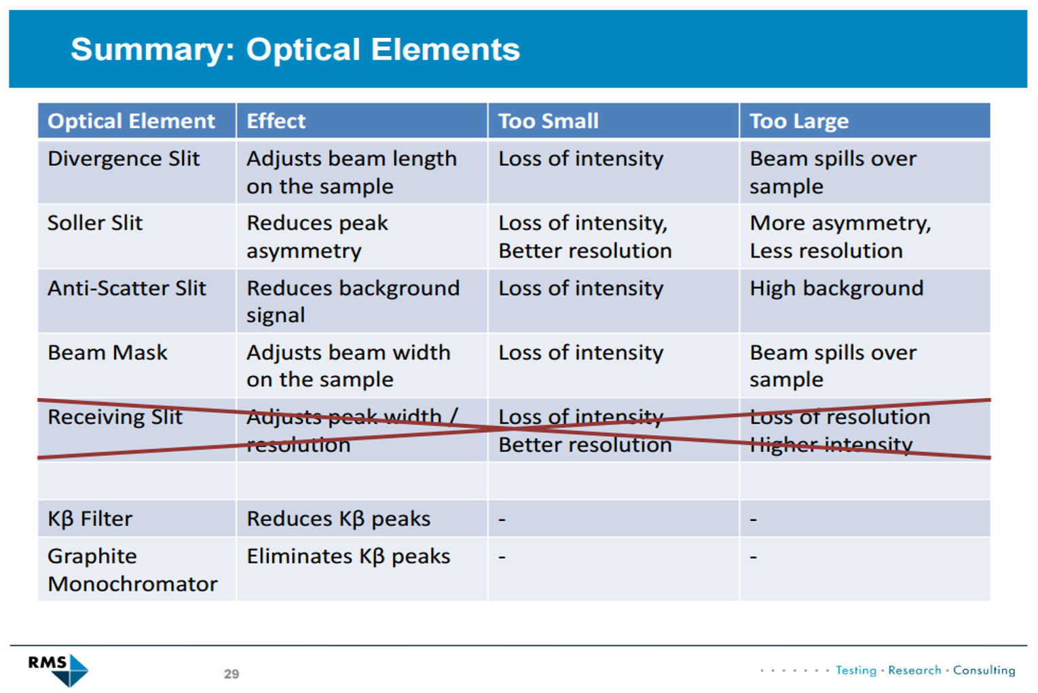

Appendix 2

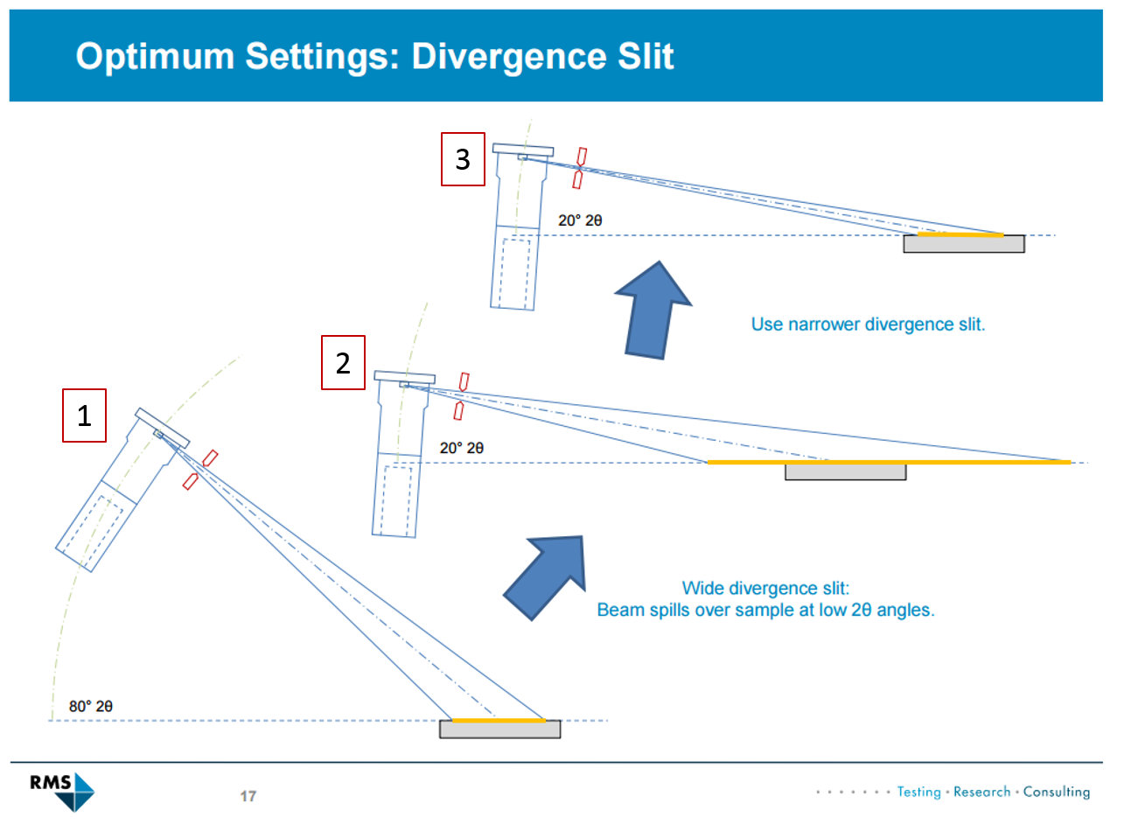
Figure A-1

Figure A-1: Even if the divergence slit produces a beam that remains fully on the sample at larger 2θ angles (1), the beam can spill over the sample at lower 2θ angles (2). As such, you should use the divergence slit that will be narrow enough to keep the beam on the sample at low angles (3).

Trade-off of divergence slits: Narrower slits slightly increase resolution and keep the beam from spilling off of your sample but decrease the intensity.

